

Viktoriia Krupelnytska
28088

The Influence of Music on
Consumer Behavior

Master’s Dissertation
prepared under supervision of
Jolanta Tkaczyk, PhD

Warsaw 2018

Author of the dissertation: Viktoriia Krupelnytska
Title of the dissertation: The Influence of Music on Consumer Behavior

Abstract

The master thesis aims to determine the influence of music on the behavior of consumers, mainly while doing shopping in stores. The critical issues are covered in the theoretical part, including the concept of music, its evolution, application, the role in relation to consumer behavior and existing experiments on this topic. The research part comprises conscious opinions of potential consumers on the subject of in-store music playback, and unconscious behavior while being exposed to various music genres.

The primary objectives of the dissertation are:

- Define the evolution and leading role of music in the society;
- Analyze the effects of music on the human brain and continuous behavior;
- Determine the concept of consumer behavior and its main components;
- Evaluate existing experiments on the usage of music for influencing consumers;
- Interpret own research results gathered from questionnaire and observation;
- Specify the recipe for perfect music playback in a store.

In conclusion, there is a summary of all analyzed insights, research results, and specified recommendations for the very topic. Music is a substantial instrument that helps people and businesses in daily lives, and its capabilities are limitless.

Key words: Music, consumer behavior, decision-making process, in-store environment, musical genres, human brain, emotions, musical components

Field code in the program “Erasmus for all”: 04000

Table of Contents
Introduction 6
Chapter 1: Music, its functions and evolution 7
1.1 About music 7
1.2 Evolution of music 10
1.3 Advantages of music 13
1.4 Music and the brain 16
1.4.1 The Mozart effeсt 18
1.4.2 Musical components and emotions 19
Chapter 2: The Relation of Music to Consumer Behavior 23
2.1 The concept of consumer behavior 23
2.1.1 Theoretical approaches 23
2.1.2 Decision-making process 25
2.2 Music and consumer behavior 29
2.2.1 Conducted researches and experiments 30
3. Research 32
3.1 Research Objectives 32
3.2 Research Method 32
3.2.1 Research Design 33
3.2.2 Timescale and Resources 35
3.3 Research Sample 37
3.4 Research Results 39
3.4.1 Attention of consumers to in-store music 40
3.4.2 Disposition to in-store music 40
3.4.3 In-store environment 43
3.4.4 Outcomes of music playback in stores 43
3.4.5 The relation of in-store music to brand and store concept 47
3.4.6 Musical components 48
3.4.6 Results of the Qualitative Study 50
3.6 Discussion 53
3.6.1 Research Limitations 53
4. Conclusion 54
5. Bibliography 57
6. List of figures 63
7. List of tables 64
8. List of graphs 65
9. Appendixes 66

Introduction
The main aim of the dissertation is to examine the influence of music on the behavior of consumers. For decades, music has been playing a key role in the society. In the present time, music is not only a powerful tool that can make people experience versatile emotions, social unity, psychological and physiological well-being, but it works as one of the most interesting marketing tools for in-store stimuli creation, and satisfaction of customers. Music plays a substantial role in businesses by creating a unique experience for customers, supporting brand positioning, and stimulating sales growth when wisely selected (Galic, 2016). Whereas some companies are successfully using music for fulfilling their goals, others do not even consider music as a powerful business instrument. “The wider relationship between music and marketing has been extensively researched by academics and professionals across a range of disciplines, including economics, music, sociology and psychology” (Kubacki and Croft, 2004, p.580). The dissertation will examine existing relationships and studies on the topic, and propose own findings based on the conducted research. In general, the master thesis consists of four parts. The first part examines the concept of music, musical genres, advantages to people, musical evolution and its important role for various generations, and defines neurological mechanisms that work when music influences human brain and behavior. In the second part of the literature review, it is essential to pay attention to the study of consumer behavior and its main components. In addition, this part defines the relation of music to consumer behavior, and varied experiments conducted for this topic. In the research part, there are two data collection methods, including questionnaire and natural observations. The natural observations were conducted in the retail shop “Fashion Plus” for analyzing the unconscious consumer behavior under the effect of in-store music from three different genres, including lounge-jazz, pop and classical. The second data collection method was the online questionnaire that was aimed to define the conscious consumer behavior in relation to in-store music. Furthermore, there are several research questions that are mainly focused on consumers’ attention, opinions and behavior to music playback in a store. The questions are intended to define outcomes of listening to different in-store music and measure what musical components are important to consumers. The dissertation uses multiple sources of data, including books, academic articles and online platforms.

Chapter 1: Music, its functions and evolution

About music

“Music is essential to many of our lives. We listen to it when waking up, while in transit, at work, and with our friends. For many, music is like a constant companion. It can bring us joy and motivate us, accompany us through difficult times, and alleviate our worries” (Greenberg, 2016). From the theoretical perspective, music can be described as a sequence of sounds that contain such elements as rhythm, melody and harmony (Simplifyingtheory.com, n.d.). Generally speaking, music is considered to be as a universal human trait. The history shows that people from all cultures have been creating music and enjoying it afterwards. Hence, for most of the time music is called cultural invention that has appeared spontaneously in vast majority of nations. In the modern world, there are around 17 music genres and several hundreds of subgenres. These genres are country, jazz, blues, western swing, house, noise, rock & roll, power pop, jazz-rock, punk-rock, ska, reggae, disco, jazz-rap, etc. Despite such a broad difference between genres, each group has its followers and loyal fans (Cooper, 2013). Heriot-Watt University has conducted a major study on a linkage between the taste of music and type of personality. The research has revealed that our preferred genre of music is intimately related to our nature. More than 36 000 participants from around 60 countries took part in the very research for determining a decent amount of musical styles according to people’s preferences alongside with questionnaires of personality measurement (Cooper, 2013). The table 1.1 below shows the summarized results of the study.
Music genre | Personal qualities
Blues | high self-esteem, creative, outgoing, gentle, cheerful
Jazz | high self-esteem, creative, outgoing, cheerful
Classical Music | high self-esteem, creative, introvert, cheerful
Rap | high self-esteem, outgoing
Opera | high self-esteem, creative, gentle
Country & Western | hardworking, amiable
Reggae | high self-esteem, creative, not hard-working, amiable, gentle, cheerful
Dance | creative, outgoing, not gentle
Indie | low self-esteem, creative, not hard working, not gentle
Bollywood | creative, amiable
Rock/heavy metal | low self-esteem, creative, not hard-working, not outgoing, gentle, and cheerful
Chart pop | high self-esteem, hard-working, outgoing, gentle, not creative and not cheerful
Soul | high self-esteem, creative, outgoing, gentle, cheerful
Table 1.1. Music genres and personal qualities. Source: https://blog.bufferapp.com/music-and-the-brain (Accessed: 14 March 2018)
According to the table, there are 13 musical genres and matching personal qualities. As we can see, people who prefer listening to blues, jazz, classical music and soul have nearly similar characteristics, such as high self-esteem, creative minds, outgoing personality, gentle manners and cheerful disposition. Rap fans are expected to be outgoing with high self-esteem. Opera lovers also demonstrate high self-esteem alongside with being gentle and creative. If we look at country genre listeners, the research identifies them to be hardworking and amiable. At the same time, reggae fans tend to be not hardworking. Besides, they have high self-esteem, creativity, cheerfulness and gentle manners. Simultaneously, dance music lovers are being characterized as not gentle, but creative and outgoing. Indie fans demonstrate low self-esteem, lack of hard work and gentle manners, at the same time having high creativity. Bollywood listeners are creative and amiable, which can be explained by bright tones and rhythmic type of music. People that prefer heavy metal and rock music have low self-esteem, not hard working and outgoing personality, while being gentle, creative and cheerful. Finally, the last genre is chart pop, which attracts listeners with high self-esteem, hardworking personality, outgoing and gentle manners. Nevertheless, they usually lack creativity and cheerfulness. Hence, with the help of this research it is possible to see how musical genres match to different personalities of listeners. “People may define their musical identity by wearing particular clothes, going to certain pubs, and using certain types of slang. So, it’s not so surprising that personality should be related to musical preference” (Collingwood, 2016). This study also mentioned human ability of forming tribes by shared musical tastes, and can be bonded by music (Collingwood, 2016). This information can be useful for marketing purposes and deeper understanding of potential customers. However, before current “agiotage” of examining tight connection between music and human beings, the evolution of this phenomenon was the most interesting topic in the past times.

Evolution of music

For many years, the world has tried to find out about the origins of music and its evolution. “That music is an especially powerful stimulus for affecting moods is no revelation; it is attested to throughout history by poets, playwrights, composers, and, in the last two centuries, researchers” (Bruner, 1990, p.94). The majority of theories, analyses and thoughts have emerged due to increased interest in the very topic. One of the most common versions is that music has arisen spontaneously in all human societies at the same time. There are many beliefs that music has always been around us, even before the creation of musical instruments. People heard different sounds and perceived them to be sad or happy, fast and slow, loud or quiet. Hence, this could have led to the imitation of these sounds by crooning bird singing or wind sound. Afterward, people were gathering into tribes and performed learned sounds. Hence, this could have led to the birth of the first song and the basis of musical art, respectively (Laky, 2017).
According to Isabelle Peretz, music has antique origins rather than new roots of a single mentality by exceeding cultural changes, place and time. For example, there are many shreds of evidence for musical instruments existence in ancient time. “The few available Upper Paleolithic musical instruments provide a series of glimpses between 30,000 and 10,000 years ago of musical tradition and related activities. Continuities and changes in the techniques of instrument manufacture and in the way, they were played probably reflect variation in the tradition of sound production and associated practices” (d’Errico et al., 2003).
This information gives us a thought that music is a powerful instrument that has been tested by our ancestors over the centuries. Besides, many sources have assumed that there is an essential relationship among music and Darwin’s Theory of Evolution. “Evolution theory is first and foremost a theory about biology. It can be suggested that biology has no explanatory value for music, taking the position that “music” is simply a social construct: a discursive category with an identity dependent on its opposition to the other categories of discourse that we employ in the linguistic taxonomies that we have developed—largely in the West—to describe or talk about types of human behaviors. If this is indeed the case, given that humans share a common biology as members of a single species, then whatever constitutes “music” across cultures may reflect some general processes of thought and behavior that should, in principle, be a proper focus of exploration in terms of evolutionary theory” (Cross, Hallam and Thaut, 2016). Between the 19th and 20th centuries, the evolutionary theory has been widely used among people who study musical theory, history, and anthropology to find an explanation for the value of music, its change and difference. Darwin proposes that music is an evolved human capacity that is a predecessor of language capacity due to emotional expressions in vocal form mainly being used in the ways of sexual selection, strong jealousy passions, competition and glory (Cross, Hallam and Thaut, 2016). Indeed, Charles Darwin was the connoisseur of music and his famous sayings proof this fact: “If I had to live my life again I would have made a rule to read some poetry and listen to some music at least once a week; for perhaps the parts of my brain now atrophied could thus have been kept active through use” (Bennet and Bennet, 2008). Furthermore, to investigate the topic of music evolution, Herbert Spencer proposed different perspective than Darwin’s idea. Even though, both Darwin and Spencer proposed evolutionary evidence on musical roots, which is tightly connected with the development of human mind and mental processes (see Pictures 1.1-1.2). Spencer’s idea embodied music to be the outcome of emotional expressions that is inherited from animals, especially in the period of their expressive exaltation. Hence, the use of vocal with musical elements led to the most advanced emotional states. The study of Darwin is viewed to be narrower as he perceived vocalizing ability to be intrinsic. “Music then evolved secondarily with sexual selection as the primary mechanism shaping its development. They largely talked past one another, as Spencer’s approach was to deduce explanations from fundamental principles while Darwin carefully gathered observations as he tested his hypotheses” (Kleinman, 2015).
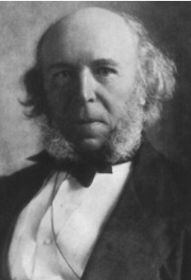


Figure 1.2. Herbert Spencer. Source: https://www.iep.utm.edu/spencer/ (Accessed: 19 March 2018)
Figure 1.1. Charles Darwin. Source: https://www.iep.utm.edu/evolutio/ (Accessed: 19 March 2018)

These two approaches can be classified into adaptationist and non-adaptationist. Darwin’s method is characterized to be more adaptationist as he explains music to be directly connected to the survival of our species, especially during sexual selection, maternal care, social unity in tribes and the relationship between music and language. The core idea of non-adaptationist approach created by Spencer lies in the perception of music as exceptional invention of humans without any biological influences (Patel, 2010). These two different views on the evolution of music have led to more in-depth investigations on musical origins and its connection to mental processes. In the contemporary world, there are many other versions on the roots of music that contradict both Darwin and Spencer. For example, Patel believes that humans invented music for better life transformation. He compares music to other transformative technologies created by humans, such as aircrafts or Internet. After developing and experiencing techniques it is hard to resist from them in the future. Moreover, Patel explains music to be universal as it is jointly valued by people around the globe. “Similarly, music is universal because it transforms our lives in ways we value deeply, for example, in terms of emotional and aesthetic experience and identity formation” (Patel, 2010). Another view on origins of music came from Eckart Altenmuller. He believes that music comes from strong and esthetic emotions. “The esthetic emotions are relatively recent, in an evolutionary sense, without strong physical correlates and, as such, this aspect of music is a “transformative technology of mind.” But the strong emotions elicit such physiological responses as chills down the spine, and so “point towards an evolutionary old acoustic communication system we share with many other nonhuman animals” (Kleinman, 2015). Other researchers believe that music appeared from emotional signals with the primary mission of stimulating reactions of further listeners. In the ancient time, music was mainly exploited as signaling system of mammals. However, in the modern world, it is more related to aesthetic emotions, social cohesion and both psychological and physiological prosperity (Altenmuller, 2015). Even though humans cannot indeed define authentic origins of music yet, it is evident that this powerful instrument plays an essential role in our everyday lives, and fills our days with numerous advantages.

Advantages of music

The advantages of music and positive influence on human well-being are countless. These strong effects are primarily devoted to the improvement of physiological and psychological states of people. Below, there is a list of consequences that music brings to our lives.
- Music enhances social cohesion
It is proven that music significantly enhances our social cohesion. The research has shown that during mutual singing, kids were able to cooperate more actively and help each other (Altenmuller, 2015).
- Music increases memory
The experimentation with college students has indicated that learning neuroanatomical terms embodied in a song leads to rapid memorization and recall after ten days (Altenmuller, 2015).
- Music helps in the medical treatment
Also, musical therapy is extensively used in medicine by reducing anxiety, depression and improving the condition of mood (Altenmuller, 2015).
- Music increases language abilities, logical thinking, and motor skills
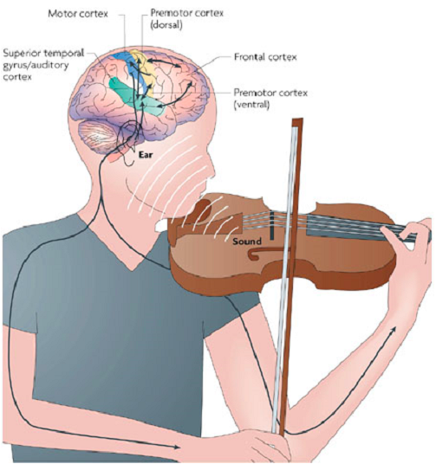
The connection of music to language suggests that language abilities can increase due to musical training. Moreover, learning music and playing on instruments favorably effects further development of a kid in the early ages.

Figure 1.3. Active processes while playing musical instrument. Source: https://blog.bufferapp.com/music-and-the-brain
(Accessed: 19 March 2018)

The research by Marie Forgeard, Ellen Winner and Andrea Norton has shown that kids who had musical training over 15 months significantly transcend their peers regarding logical thinking, motor and auditory skills, vocabulary and perception of information. Figure 1.3 shows all the processes involved while playing a musical instrument.
- Music affects cognitive functioning and evokes the release of hormones
Music significantly affects human cognitive functioning alongside with the release of hormones. It is known that listening to favorite musical compositions stimulates a vast quantity of dopamine production, which evokes similar reactions as tasty food, feelings of comfort and intimacy (Cooper, 2013).
- Music brings creativity
It was proven that average noise level could be a catalyst for human creativity by complicating the information processing. Background noise stimulates abstract thinking and sets human brain on creative work regime. That is the reason why public places, such as cafes, parks, summer grounds and beaches attract the vast majority of creative individuals. Due to a high level of noise, the human brain is hugely overloaded as it tries to abstract from all distractions and process information on the highest quality level (Cooper, 2013).
- Music improves physical power
The influence of music on physical workouts is still under the research. However, in 1911 Leonard Ayres found that cyclists pedal faster by listening to rhythmic music than riding in silence. Music motivates a person for more extended training and prevents brain impulses on depletion of muscles (Cooper, 2013).
- Music increases the level of happiness

As music is tightly connected to emotions, it quickly can stimulate pleasant or sad memories. Listening to your favorite song for only 15 minutes will boost your emotions, increase feelings and joy (Deflin, 2016).

- Music reduces insomnia

Research has shown that relaxing classical music fights with insomnia by improving the quality of your sleep. An hour of listening to good music will evoke hormones, at the same time setting our brain for a calm rest (Deflin, 2016).

- Music enhances academic performance and IQ

The study of young children who were taking music lessons (vocal and keyboard) for nine months, showed a decent increase in their IQ results and improved academic performance. Moreover, the group of kids who were learning vocal showed the highest achievements of improvement (Deflin, 2016).

To sum up all the advantages, it is necessary to admit that music plays a critical role for humans from the biological, physiological and mental perspectives. Music nourishes our minds, bodies and gives us a unique value to become better human beings. Furthermore, the effects of music are manifested in all conditions, such as pure listening, actual playing or developing musical compositions.

Music and the brain

To fully understand the importance of music for humanity, it is necessary to define how our brain processes the music, and which parts of it are activating. However, the network ties between music and the human mind are not entirely investigated yet (Bennet and Bennet, 2008). “By studying the effects of music, neuroscientists are able to discover things about the brain that they cannot know through other cognitive processes. Likewise, through music we are able to discover, share, express, and know about aspects of the human experience that we cannot know through other means. Musical insights into the human condition are uniquely powerful experiences that cannot be replaced by any other form of experience” (Hodges, 2000, p. 21).
Figure 1.4 shows the reaction of different brain parts while listening or playing process.
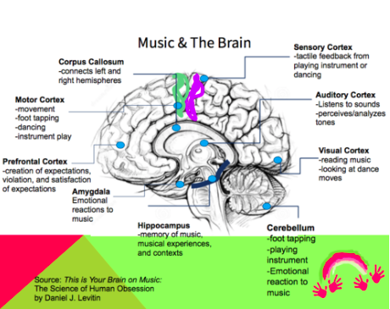

Figure 1.4. Brain reaction on listening or playing music. Source: http://www.therabeat.com/news-and-events/2017/10/5/rhythm-music-and-the-brain
(Accessed: 19 March 2018)
As it can be seen, the human brain consists of left and right hemispheres that are both activated while listening to music (Bennet and Bennet, 2008). There are nine active brain areas that react on music, such as sensory cortex, auditory cortex, visual cortex, cerebellum, hippocampus, amygdala, prefrontal cortex, motor cortex and corpus callosum. All these areas are responsible for particular function. When we listen to music there is an activation of two primary processes, such as perception of music and the way how we respond to it (Bowling, 2009). First of all, when listening to music it is mainly about auditory cortex, visual cortex, amygdala, hippocampus, prefrontal cortex and cerebellum. Auditory cortex is involved in listening and perceiving the sound, and afterwards analyzing it. The information that is processed by auditory cortex is later transmitted to visual cortex by inducing specific memories and visual situations (Bennet and Bennet, 2008). Amygdala and cerebellum are responsible for our emotional reactions to different sounds. Hippocampus activates while memorizing specific musical tones, rhythms or harmonies. Prefrontal cortex creates specific expectations before listening to a song, and analyzes satisfaction or violation while actual hearing and at the end of playback. Second of all, playing on musical instruments activates other brain parts, including motor cortex, visual cortex, sensory cortex and cerebellum. Motor cortex and cerebellum are responsible for movements while playing the instrument, for example, foot tapping. Visual cortex activates reading abilities, such as reading notes or chords. Sensory cortex generates tactile feedback from playing a specific instrument. “For example, as sound enters the ears it goes to the auditory cortex in the temporal lobes. The temporal lobe in the non-dominant hemisphere (generally the right hemisphere) hears pitch, melody harmony and beat, and (recognizing long-term patterns) puts this together as a whole piece. The temporal lobe in the dominant hemisphere (generally the left hemisphere) is better at analyzing the incoming sound and hearing the short-term signatures of music, that is, lyrics and changes in rhythm (pacing), frequency, intensity, and harmonies” (Bennet and Bennet, 2008, p. 283). Finally, the frontal lobe works for finding associations for a listened song and selects corresponding emotions alongside with old experiences (Bennet and Bennet, 2008). Hence, it is understandable how our brain processes music, and which parts are involved the most in this process. Listening to preferred music can be very pleasing as it activates expectations of satisfaction and emotional reactions. “Listening to music has been shown to modulate activity in a network of structures associated with reward and pleasure in the brain. Using functional magnetic resonance imaging (fMRI) and functional and effective connectivity analyses in human participants, Menon and Levitin (2005) demonstrated activation of the nucleus accumbens and ventral tegmental area with subsequent connections to the hypothalamus, insula, and orbitofrontal cortex” (Altenmuller, 2015). Furthermore, it is proven that musical training in the long period can change the cognitive mechanisms and neuroplasticity of the human brain. “These changes can occur in both the developing and the adult brain, and affect both white and gray matter, as well as cortical and subcortical structures. Active musical activities lead to a strong coupling of perception and action mediated by sensory, motor, and multimodal brain regions and affect important sound relay stations in the brainstem and thalamus” (Schlaug., 2015).

1.4.1 The Mozart effeсt
The famous “Mozart effect” was discovered in 1993 during the research with 36 students. The very study was the first to combine listening to music with brain performance. The study aimed to analyze if particular melodies improved cognitive abilities. Students were separated into three main groups where each group was designated to deal with tests on intelligence to observe spatial alongside with temporal reasoning. While working on these tests, two groups were listening to musical compositions: one included relaxation techniques, and another was Sonata for Two Pianos in D by Mozart. The third group was working in silence. The results of this study indicated that the group, which was exposed to Mozart’s sonata performed with the highest score. However, this effect lasted from 10 to 15 minutes (Bennet and Bennet, 2008). It is said that Mozart’s sonata included more complex melodies that varied significantly, which has led to better frontal cortex stimulation in comparison to other tested melodies. “When the theory was tested it was discovered that the Mozart sonata activated the auditory as well as the frontal cortex in all of the subjects, thus suggesting a neurological basis for the Mozart effect” (Bennet and Benner, 2008, p.281). The Mozart effect is the proof that human brain can be more neuroplastic and certain musical combinations can significantly improve cognitive skills while being set on productive thinking. Moreover, it is vital to mention that specifically selected music can stimulate needed thoughts or even behavior of people.

1.4.2 Musical components and emotions
Alongside with positive changes of human brain, music significantly raises human emotions and improves the perception of how we define essential musical components, such as rhythm, tempo, mode, harmony, tone, pitch and volume (Bowling, 2009). All of these components play a substantial role in musical compositions by influencing human brain in desired way. Speaking about tempo, arousal increases due to the improvement of a performance when there is a preferred tempo between 70 to 110 beats per minute (Bruner, 1990). However, it mainly depends on personal tastes and preferences of listeners. In terms of rhythm choice, there is a study by Hevner that explains firms to use more serious, substantial and spiritual beats. At the same time, flowing and soft rhythms are considered to be more cheerful and dreamlike. Music that consists from volatile and unstable rhythm drives the feeling of dignity and excitement (Bruner, 1990). In the next chapter, there are several researches on the role of a rhythm in music, and its influence on consumer behavior. In addition, songs with high pitch is perceived to drive more excitement and happiness in comparison to music with low pitch that generates sadness (Bruner, 1990). When it comes to harmony, there are two main classifications, such as consonant and dissonant. Consonant chords are balanced and in agreement with harmony. Dissonant chords are lacking harmony, and are irregular. “In general, consonant harmonies can be described as playful, happy, or serene. Dissonant harmonies seem to be perceived as more agitating, ominous or sad” (Bruner, 1990, p.97). The tone of music is of a high importance as well. The research has shown that tones with low frequency influence our mental and physical state by discharging it, and higher tones positively nourish human brain (Bennet and Bennet, 2008). From the perspective of volume, loud music is described as more exciting and joyful, while soft music is considered to be tranquil and severe (Bruner, 1990).
All of these components jointly create specific musical compositions, which derive particular reactions. Various emotional responses and feelings usually include happiness, relaxation, sadness, anger and many other (Bowling, 2009). Moreover, Bruner says that wisely written and arranged music has potent effects on nervous system and evokes necessary processes in the brain by leading to specific reactions of human emotions.
The table 1.2 depicts human emotional expressions on the most important musical elements. The information summarized in a table is a unique source of criteria that can be effectively exploited by marketers for wise selection of musical compositions to match it with company’s values or achieve particular results (Bruner, 1990).

Emotional Expression
Musical Element | Serious | Sad | Sentimental | Serene
Mode | Major | Minor | Minor | Major
Tempo | Slow | Slow | Slow | Slow
Pitch | Low | Low | Medium | Medium
Rhythm | Firm | Firm | Flowing | Flowing
Harmony | Consonant | Dissonant | Consonant | Consonant
Volume | Medium | Soft | Soft | Soft
Mode | Major | Major | Major | Major
Tempo | Fast | Fast | Fast | Medium
Pitch | High | High | Medium | Medium
Rhythm | Flowing | Flowing | Uneven | Firm
Harmony | Consonant | Consonant | Dissonant | Dissonant
Volume | Medium | Medium | Loud | Loud
The table 1.3 defines the more advanced information with the relation of human emotions to musical components. The very table uses the term “acoustic cues” for musical elements.
Table 1.2. The expression of emotions on musical components. Source: Gordon C. Bruner, 1990, Journal of Marketing, p. 100 (Accessed: 24 March 2018)

Summary of Cross-Modal Patterns of Acoustic Cues for Discrete Emotions
Emotion | Acoustic Cues  (Vocal Expression/Music Performance)
Anger | Fast speech rate/tempo, high voice intensity/sound level, much voice intensity/sound level variability, much high-frequency energy, high F0/pitch level, much F0/pitch variability, rising F0/pitch contour, fast voice onsets/tone attacks, and microstructural irregularity
Fear | Fast speech rate/tempo, low voice intensity/sound level (except in panic fear), much voice intensity/sound level variability, little high-frequency energy, high F0/pitch level, little F0/pitch variability, rising F0/pitch contour, fast voice onsets/tone attacks, and a lot of microstructural irregularity
Happiness | Fast speech rate/tempo, medium-high voice intensity/sound level, medium high-frequency energy, high F0/pitch level, much F0/pitch variability, rising F0/pitch contour, fast voice onsets/tone attacks, and very little microstructural irregularity
Sadness | Slow speech rate/tempo, low voice intensity/sound level, little voice intensity/sound level variability, little high-frequency energy, low F0/pitch level, little F0/pitch variability, falling F0/pitch contour, slow voice onsets/tone attacks, and microstructural irregularity
Tenderness | Slow speech rate/tempo, low voice intensity/sound level, little voice intensity/sound level variability, little high-frequency energy, low F0/pitch level, little F0/pitch variability, falling F0/pitch contour, slow voice onsets/tone attacks, and microstructural irregularity
Table 1.3. Human emotions and acoustic cues. Source Patel, A. (2010). Music, language, and the brain. Oxford: Oxford University Press, p. 346 (Accessed: 19 March 2018)
Based on the information from the table above, it is possible to classify different signals and vocal expressions to particular emotions. For example, fast speech rate and tempo can cause both positive and negative emotions as happiness, anger, and fear. At the same time, slow speech rate and tempo stimulate emotions like sadness or tenderness. Calm emotions or passive, such as tenderness and sadness are usually caused by the low intensity of voice, little sound variability and low pitch level. Active emotions that include happiness and anger are induced by high voice intensity, high pitch level and high sound variability. Furthermore, the emotion of fear is driven by a combination of both the low power of voice, high pitch level, and sound variability. Hence, emotions and music are tightly connected between each other. The very connection can be effectively used for business purposes, especially in the field of marketing. It is vital to understand the values of your business and the atmosphere it should create for target customers. Music can be exploited as a powerful tool, which creates a special atmosphere for driving human emotions, and satisfaction or violation of expectations. Moreover, it can be effectively used for fulfilling economic purposes, such as profit maximization. For finding a perfect match between expectations of consumers and music it is necessary to examine consumer behavior and its main components, including decision-making process.

Chapter 2: The Relation of Music to Consumer Behavior

2.1 The concept of consumer behavior

To understand the relation between music and consumer behavior it is necessary to examine what exactly consumer behavior means in today’s world, how people make choices and what influences them internally and externally. In general, the term of individual consumer refers to a person who buys goods or services for personal use or the purpose of his property and household (Schiffman and Kanuk, 1997). From the theoretical perspective, consumer behavior can be described as a combination of mental and emotional processes with physical activities that consumers are experiencing while selecting, purchasing, using and, in the end, disposing of particular products or services for the personal gratification of needs and wants. Comprehensive understanding of the needs of target consumers, their characteristics and decision-making process can open horizons of profitability and new opportunities (Bearden, Ingram and LaForge, 2001).

2.1.1 Theoretical approaches
Many various sciences, including psychology, sociology, social psychology, anthropology, and economics have been trying to examine the concept of consumer behavior since the 1960s. “Many early theories concerning consumer behavior were based on economic theory, on the notion that individuals act rationally to maximize their benefits (satisfaction) in the purchase of goods and services” (Schiffman and Kanuk, 1997, p.8). Initially, managers in the marketing field have been examining consumer behavior from the perspective of marketing science and prediction approach, which has gained the name positivism. The nature of the very method is to fully predict the behavior of target consumers and influence it through various tools. However, later on, the idea of understanding consumers from a better perspective turned out to be more valuable than applied managerial approach. This approach is called interpretivism and is mainly focused on understanding the behavior of consumers and defining the logic behind it. Furthermore, this approach can be called experientalism as it is mostly referred to consumption experience (Schiffman and Kanuk, 1997).

One of the critical parts in studying consumer behavior is market segmentation. This term is referred to the classification of desired markets, which go under target focus, into smaller divisions with similar needs and wants for ease of creating products and marketing communications (Schiffman and Kanuk, 1997). Market segmentation of consumers emphasizes highly on individual preferences, lifestyle and context under which people purchase (Brassington and Pettitt, 2013). Table 2.1 depicts different segmentation bases and their main components.
Table 2.1. Consumer segmentation bases and their main components. Source: Brassington, and Pettitt, 2013, p. 135-145 (Accessed: 14 March 2018)

Consumer Segmentation bases | Main components
Geographic segmentation | Location of customers, specific geographic markets, subdivisions, global presence: cultural differences, tastes, lifestyle and demand level, operational advantage
Demographic segmentation | Information about customers and household (customer-focused), including age, sex, income, race, occupation, family structure and socioeconomic status, body size and shape
Geodemographic segmentation | Combination of data between geographic and demographic segmentation with lifestyle and neighborhood
Psychographic segmentation | Lifestyle, including beliefs, opinions, attitudes, daily activities, interests, aspirations and demographics
Behavior segmentation | Individual relationship with the products, end-use purpose, expected benefits, usage rate, loyalty, attitude to the product or brand, buyer readiness (AIDA)
Each segmentation base has its criteria and components. For example, geographic segmentation emphasizes mostly on the location of customers in specific markets around the globe. Most of the global corporations prefer creating subdivisions in markets where they operate to effectively control worldwide presence and adapt to local culture alongside with lifestyle. Demographic segmentation is mainly customer-focused and includes information about the household. In this segmentation, the most essential information is age, sex, income of an individual, race, occupation, the structure of a family, socioeconomic status, and in some particular industries body size and shape are valuable criteria. However, the disadvantage of such segmentation is that people within the same demographic group, in most of the time, have different needs and wants. Geodemographic segmentation is a combination of both geographic and demographic data. It gathers data based on consumer type alongside with type of neighborhood, using particular criteria. The next segmentation is called psychographic, and it is mainly focused on consumer lifestyle, which is surrounded by unique attitudes, personal opinions, beliefs, daily activities, and aspirations. This particular segmentation is more effective when combined with demographic data to define the best offer to a client and gain competitive advantage. The last segmentation is concentrated on consumer’s behavior and his attitude to the brand. This segmentation has several factors that are important for comprehensive analysis. These factors include information about end-use of a product, expected benefits, usage rate, customer loyalty, attitude and feelings about the company and its products, and buyer readiness that is defined by AIDA model (Brassington and Pettitt, 2013). The very model stands for awareness, interest, desire, and action. Finally, every business venture or organization chooses suitable segmentation bases for usage according to their strategic direction and type of a business. All these bases can be used separately. However, the most efficient results can be achieved when data from all segmentation bases is implemented jointly for efficient delivery of value to customers.

2.1.2 Decision-making process
In order to understand consumer behavior, it is necessary to examine decision-making model and define what aspects influence people during this process. As it is shown in figure 2.1, the center of the model demonstrates the logical and aware manner of consumer’s decision making. Generally, this process goes from recognition of a problem, search for information to the evaluation of alternatives and final purchase.

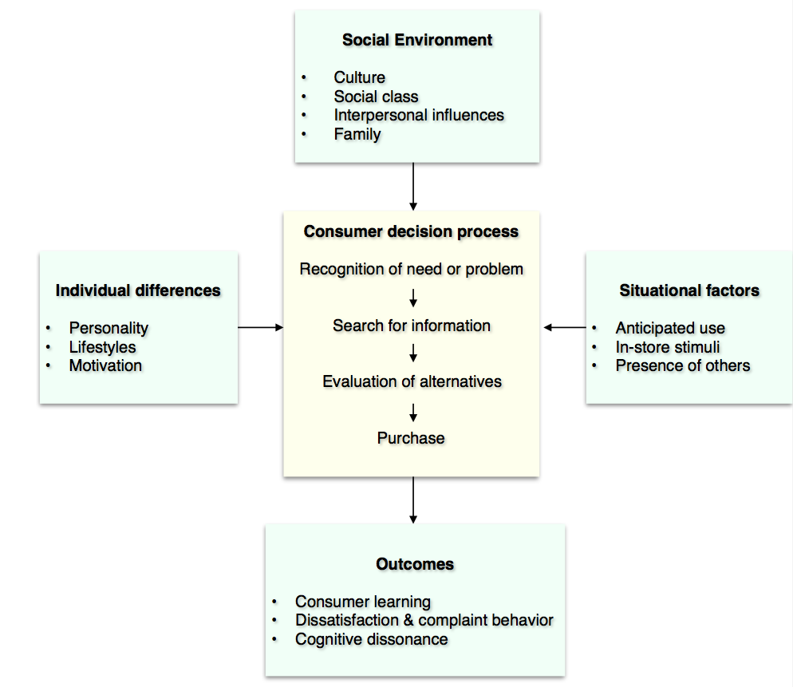
These various stages can be influenced with many factors, such as individual differences, situational forces, and social environment.
Figure 2.1. Consumer decision making model and influences. Source: Bearden, Ingram and LaForge, 2001, p. 80 (Accessed: 13 April 2018)

According to Bearden, Ingram and LaForge, consumer recognizes his need or particular problem through internal desires, lack or improper functioning of a product, and external impacts or triggers, for instance, advertising. The next step after problem recognition is searching for available information using internal or external search. Internal search is involved when consumer tries to use his own expertise and memory in order to carefully analyze the situation. External search includes various sources as advertising, word-of-mouth and online search (Bearden, Ingram and LaForge, 2001). According to Nielsen, the most valuable external searches for consumers are recommendations from other people (83%), advertising on company’s’ owned web page (70%) and online reviews from other customers (66%). After gathering enough of information, consumers start evaluating diversified alternatives. “This evaluation of alternatives is based on the individual’s beliefs about the products and their features or characteristics. These beliefs form the basis for the consumer’s attitudes, which influence both intentions to buy and purchase behavior. Following purchase, outcomes such as feelings of satisfaction or dissatisfaction and the development of brand loyalty may occur” (Bearden, Ingram and LaForge, 2001, p.81). When the best alternative is selected it comes to the final step of purchasing the product or service. Before making a final decision, consumer processes a decent portion of information from the external environment that needs to be interpreted and organized (Bearden, Ingram and LaForge, 2001). Furthermore, final decisions are divided into two types: high-involvement and low-involvement. High-involvement decisions are perceived to be of a high priority to consumer with a meaningful divergence between selected alternatives. These decisions require rational arrangement of above mentioned steps. Simultaneously, low-involvement decisions are characterized to have reduced decision process with insufficient information processing, and more often they cause repetition of purchases. For example, junk food, beverages and snacks are true outcomes of such decisions (Bearden, Ingram and LaForge, 2001).

There are numerous factors that influence consumer decision and overall behavior (see Figure 2.1). Social influences usually come from cultural background, social positioning, interpersonal impacts and home. Culture is transmitted hereditarily, and formed by specific values, ideologies, particular attitudes and various symbols that are used by group of people for effective communication, and reflects unique lifestyle inside of the society (Bearden, Ingram and LaForge, 2001). Hence, when cultural values are of a strong importance for a consumer, it definitely affects buying behavior. Another important factor is social class, which divides people into groups according to their corresponding values, behavior, shared needs and special lifestyle. In general, level of education, employment and social skill influence belongingness to a particular social class. The classification of classes is divided into lower, working, middle and upper. All of the mentioned above classes affect their members in terms of buying behavior, types of purchases and desired performance. The last influencer in social environment is family. It strongly affects socialization process of consumers and purchase intentions. From early life’s period, family empowers a person to gain values and shows rooted behavior that cannot be freely modified. Later on, gained behavior is playing a substantial role while purchasing goods or services (Bearden, Ingram and LaForge, 2001). Moreover, interpersonal relations, such as friends, colleagues and other actors, are having an impact on consumer behavior, especially in the form of word-of-mouth (Bearden, Ingram and LaForge, 2001). Individual differences reflect on purchase intentions by types of personality, promoted lifestyle and internal motivation (Bearden, Ingram and LaForge, 2001). This information can be summarized by gathering data from psychographic segmentation. When a company puts significant portion of effort to understand individual differences of its consumers, it can create unique value to users alongside with loyalty from their aspect. The next important group of influences come from situational factors, which are the most relevant to the relation of music and consumer behavior. “A common in-store situational factor is music, long considered an effective means for triggering moods” (Bearden, Ingram and LaForge, 2001, p.93). Usually, situational factors include advertising, promotions, atmosphere and physical attractiveness of a selling point, triggers, stimuli, location and overall assistance (Bearden, Ingram and LaForge, 2001). The last part of the model is defined as outcomes. In general, purchase outcomes lead to consumer learning, satisfaction or dissatisfaction, and cognitive dissonance. Referring to consumer learning, it occurs during modifications of behavior or earlier gained knowledge. While using a product, consumer experiences satisfaction or dissatisfaction that express different feelings, such as happiness, frustration or neutrality. Based on this experience, consumer decides whether it is worth to make changes to his buying behavior (Bearden, Ingram and LaForge, 2001). Finally, the last component of outcome might be cognitive dissonance. Bearden, Ingram and LaForge refer it to questionable feelings of doubt about the relevance of made purchase. Furthermore, cognitive dissonance strongly influences attitudes to the purchase, and even can variate established behavior, and force consumer for further data search.

The model of consumer decision-making and its influences thoroughly explains the behavior of buyers and helps in defining proper business and marketing strategies. The following chapter examines in details the relationship between consumer behavior and music, and how it can be implemented for business purposes.

2.2 Music and consumer behavior

After defining music to be such a strong influencer on human brains and behavior, marketers selected it to be one of the components in marketing strategies to affect consumer behavior. In the past, people have already defined music to be useful in marketing. However, at that time they lacked enough of literature to prove it. “Though it has been long accepted that music affects human beings in various ways, only recently have researchers attempted to explore the presumed relationships empirically in marketing contexts. At this time the relevant body of literature is still meager. Because the desire to understand human moods and their role in consumer behavior is likely to become ever more important, music, as a powerful emotional stimulus, should be studied more thoroughly” (Bruner, 1990, p.102).

Nowadays, music can play a significant role in consumer behavior, especially during marketing activities, advertising and service dimension. For example, music is present in every advertising stage, including informing, convincing, reminding, supplementing value, and supporting another organizational effort (Kubacki and Croft, 2004). When music and its components are wisely selected by marketers to match the brand name, they shape consumer’s attitude to a particular advertisement by creating a powerful effect on the target audience. Moreover, music must entitle the brand by representing its values, and get target consumers informed about the product or service, and overall perception (Kubacki and Croft, 2004). The research has shown that likeability of musical sounds in advertising from the perspective of target audience considerably influenced the overall evaluation of the company (Bruner, 1990). It is necessary to understand the difference between servicescape and musicscape when it comes to musical contribution in service dimension. The definition of servicescape describes this term as the entire tangible environment and physical components of a specific organization. Due to widespread usage of music alongside with the manipulation of its elements within the organizational environment, the new concept of musicscape has arisen. Musicscape mainly concentrates on musical elements connected to the organization and consumer behavior. “Most of these behaviour-related studies tried to manipulate only one of the musical variables (e.g. musical genre, volume, pitch, tempo): some researches, though, argue that it is impossible to control only one element of music as it works holistically” (Kubacki and Croft, 2004, p.581-582). It is vital to find strategically wise match between musical compositions and various servicescapes. Finally, a crucial role of music in servicescape strongly affects the behavior of consumers, particularly their emotional condition, a mood of the day and expectations (Kubacki and Croft, 2004).

2.2.1 Conducted researches and experiments
There are variety of researches conducted on the topic of music and consumer behavior alongside with numerous experiments. The study on the effectiveness of background music during commercials has shown its dependency on overall evaluation of the brand. If the audience prefers the background music it fundamentally improves the process of assessment for the benefit of a company (Bruner, 1990). Moreover, background music influences the behavior of consumers more effective during low-involvement decisions. At the same time, consumers who are being in the state of high-involvement experience distraction (Bruner, 1990). The fact that music improves mood was mentioned in the previous chapter. The next research confirmed this fact by examining types of music and how it can affect purchase intentions. “One finding was that happy music produced happier moods in subjects, but sad music produced the highest purchase intentions” (Bruner, 1990, p.98). The real insights explain the importance of understanding goals, which business is trying to achieve while selecting musical compositions for advertising or in-store usage. Other studies were focused on in-store usage of music, and its direct influence on consumers. The research on the relation of musical volume to purchase intentions concluded that loud music stimulated consumers to buy more. Furthermore, there were two experiments organized to examine outcome after playing music with different tempo in a restaurant and a supermarket. Analysis from a supermarket has demonstrated that slow music makes people move in a relaxed manner, which significantly lowered the traffic in comparison to fast soundtracks (Bruner, 1990). However, amounts of purchases increased with slow music more effectively. “This makes a lot of sense: Slower music leads to slower shoppers, which in turn leads to shoppers having more time to discover and interact with more products” (Devaney, 2016). The study from a restaurant proved that slow music makes people eat slowly by enjoying their food better than with fast music. At the same time, bills from the bar had much higher revenue indicators while playing slow music (Bruner, 1990). Music is one of the most widespread tactics that restaurants use to make people eat faster alongside with increasing traffic. “Studies show people drink more, eat faster and leave sooner when the bass is thumping, so restaurants are bringing the noise. Customers have been sounding off in recent years about the deafening volume level in restaurants” (LeTrent, 2010). The choice of music in restaurants depends on general concepts and how different places position themselves. The succeeding studies were also discovering the effect of popular music, instrumental compositions and absence of music on consumer behavior at one of the department stores. It has been revealed that younger consumers were making purchases much longer with instrumental compositions in comparison to older consumers that were shopping slower while listening to popular music. Henceforth, researchers concluded that unusual environment with unaccustomed musical tracks makes consumers do their shopping slower (Bruner, 1990). To continue with music in supermarkets, Adrian North made a study that has identified that consumers tend to buy wine from the same origins as the musical composition while listening to it and making a purchase. When traditional French music was playing, 77% of supermarket visitors were selecting French wine. On the following days, researchers were playing German music, and 73% of consumers were purchasing German wine (Stafford, 2006). That is a perfect example, how music can affect our decisions regarding shopping in an unconscious way. “The behavioural influence of the music was massive, but the customers didn’t notice or believe that it was affecting them” (Stafford, 2006). According to Erik Devaney, consumers are more disposed to buy when slow songs with sad motives are playing. Sad songs with slow tempo in the background can increase sales for 12% in comparison to fast songs (Erik Devaney, 2016). It can be summarized that music with all its components, including tempo, pitch, harmony, volume strongly influences consumer behavior and the level of involvement. It is vital to choose the right musical compositions to match with an image a particular business is trying to establish. Music can either help businesses to gain customers or loose due to distractive melodies. “It is important to learn about and understand many of the nuances of how music in a retail environment can affect buying behavior, but it is just as important to remember that nothing is black and white and what works in one store environment might cause different effects in another situation” (Ford, 2013). This section defined various studies and conclusions on how music influences purchase intentions of consumers.

3. Research

3.1 Research Objectives

The conducted researches for the dissertation intend to implement several objectives. The first objective is to understand unconscious consumer behavior while listening to different music genres, especially body movements, emotions, the tone of voice, duration of stay and purchase tendency. The second objective of the research is to evaluate conscious consumer’s opinion and attitude towards music playback in stores. The last goal includes gathering views of respondents concerning musical preferences while doing shopping. The following researches are performed to acknowledge the power of music as a valuable in-store situational factor, and analyze its effect on consumer behavior, especially while doing shopping in a store.

The research questions are:
- Do consumers pay attention to in-store music?
- What are consumers’ opinions towards in-store music?
- What are the main reasons for liking or disliking in-store music?
- How do different music genres influence consumer behavior?
- What are the main outcomes after listening to right and wrong in-store music?
- What musical components are essential to consumers?

Another research objective is to define a recipe for perfect in-store music based on the behavior of respondents alongside with questionnaire answers.

3.2 Research Method

There are two primary methods to be used to meet all mentioned research objectives. The first method is quantitative and exploratory in the form of an online questionnaire. “Google Forms” platform was used for publishing the questionnaire, and the link was distributed to Facebook users. Afterward, the gained data was analyzed with the help of Excel. The final results are presented in graphs. The second method is qualitative by conducting naturalistic observations in the retail shop “Fashion Plus”. Observations were performed personally in the shop for a duration of 3 days. The received information is summarized and presented in the form of a table.

3.2.1 Research Design
The online questionnaire was one of the fastest and cheapest methods to collect the needed data for analyzing the conscious state of respondents towards in-store music. Referring to the questionnaire design, it is mainly concentrated on simple questions, which respondents can answer without huge time consumption. Moreover, the questionnaire has a specific background theme with musical equipment to make respondents deeply immersed in the topic. The example of the provided questionnaire can be found in appendix A.
The questionnaire is constructed of 16 questions:
- Close-ended with multiple choice options
- Likert scale with intervals between 1 and 5
Furthermore, the questionnaire is divided into six sections due to the variety of respondents’ answers:
- Section 1: “Music and consumer behavior”
- Section 2-3: “Music in stores”
- Section 4: “Music and in-store environment”
- Section 5: “Outcomes of music playback in stores”
- Section 6: “Personal information”
The opening section includes two close-ended questions with multiple choice options. This section begins with a general question aiming to define whether people pay attention to musical compositions while doing their shopping following the second question of measuring their opinion towards in-store music. The second and third sections include two questions that are linked with the respondent’s answer for the previous section. These questions help to define main reasons why people like or dislike in-store music. The fourth section represents only one multiple-choice question and mainly emphasizes on defining a suitable in-store environment regarding music, such as tracks with lyrics or instrumental compositions, etc. The penultimate fifth section is the longest by consisting of both close-ended with multiple choice options and Likert scale questions. The following questions are primarily focused on consumer behavior while listening to in-store music, unexpected purchases under the effect of music, the connection of music to a concept of the store and brand positioning, outcomes of the wrong and the right in-store music, musical elements and their suitable combination. Finally, the last section principally collects personal information of respondents, including their age, gender, and occupation.


To understand the unconscious behavior of respondents, the natural observation was organized for a specific period in the retail shop. “Fashion Plus” is a chain of retail shops that has been established in 1990 (see Figure 3.1). There are five retail stores situated in different locations of Kiev, the capital of Ukraine, which is a huge market to operate. The very retail shops specify on woman clothes, shoes, handbags, furs and accessories. The mission statement of the company is: “to create a unique image for each customer to help women feel better, become more confident and self-sufficient by the way they look”.
Figure 3.1. The logo of Fashion Plus. Source: https://www.facebook.com/fashionplus1992/ (Accessed: 5 May 2018)

The target audience of the chain stores mainly covers women in the age between 30 - 50 years old that mostly live in Kiev. First success factor of “Fashion Plus” is high quality of goods and services that retail shops offer. Managing quality is crucial for small businesses. Moreover, the quality of goods and services help to maintain customer satisfaction, loyalty and decrease the risk at the same time. To keep the level of quality, “Fashion Plus” supply goods from countries, such as Italy, France, Poland, Turkey and China. Another advantage of the company is a wide range of the offered products. Hence, there is no need for customers to look for different shops if they want to find a complex outfit such as dress, shoes and accessories. It is a perfect service strategy for saving customer's time. A range of offered goods varies from everyday casual clothes to the evening dresses. Furthermore, “Fashion Plus” offers the wide selection of sizes from XS till 5XL. It means that women of different age and size can feel satisfied by finding the perfect outfit. The company employs 30 people in total, including sales consultants, marketing specialists, accountants, etc. The employees always try to create a unique image for each customer to help them become more self-sufficient and confident by the way they look. Galina Kru, the owner of “Fashion Plus”, states: “to find appropriate style that suits a person is like to define the right medical diagnosis”. In the future, the company plans to expand to international markets and create own clothing brand.

As a part of the in-store environment, “Fashion Plus” uses music. The very tool helps to create a unique atmosphere and make consumers more disposed for purchases. In most of the time, all stores playback lounge music with jazz elements. However, during natural observations we were testing three different music genres:
- Lounge-jazz instrumental (e.g. Kenny G, Moose Dawa)
- Pop (e.g. Beyonce, Justin Bieber, Lady Gaga)
- Classical (e.g. Mozart, Chopin, Bach)

The natural observation was held for three days. During the first day, there was playback of lounge-jazz music without lyrics, including songs by Kenny G, Moose Dawa, Pink Martini and others. The next day there was playing only pop music, such as Beyonce, Justin Bieber, and Lady Gaga hits. The final day of observations was followed by classical repertoire including music of Mozart, Chopin, and Bach. The list of all musical compositions that were playing during natural observation process can be seen in Appendix B.

3.2.2 Timescale and Resources
The quantitative research with a questionnaire was held for the period of one month from 5th of April to 5th of May. The timescale of this research can be found in the task tracker below (see Figure 3.2).


Figure 3.2. Timescale of Quantitative Research. Source: Own Research
The task tracker shows a list of all performed activities for quantitative research and their particular start and due dates. The needed resources for such data collection method are both tangible and intangible. Tangible resources include computer equipment and Internet access. At the same time, intangible resources consist of specific knowledge and time.


The qualitative research in the form of observations was conducted between 28th of March and 4th of April in one of the biggest stores of “Fashion Plus” that is located in the shopping mall “Ornament”.

Figure 3.3. Timescale of Qualitative Research. Source: Own Research

The timescale is presented using task tracker table (see Figure 3.3). The duration of qualitative research alongside with all preparations lasted for eight days in total. However, observations were conducted for three days within the stated period from 10 AM till 6 PM. The required resources for qualitative data collection method are tangible and intangible as well. Tangible resources involve the stereo system and computer equipment. Simultaneously, intangible resources require specific knowledge and devoted time for organizing the observation.

3.3 Research Sample

The non-probability convenience sampling technique was applied for quantitative data collection method in the form of a questionnaire. The main reasons for choosing such sampling technique are the online accessibility of potential respondents and interest of people in the very topic. People who participated in the questionnaire are mainly students, co-workers, relatives of mine that I had access to. The most convenient platform for distributing the survey is Facebook due to the ease of reaching sample representatives and willingness to volunteer. At the end of the research’s timeframe, the platform totaled 104 responses.
The graph 3.1 indicates that 62% of questionnaire respondents are young people between 18 and 24 years old.

Graph 3.1. Age of Respondents. Source: Own Research.

Another 38% of participants are adults in the age range of 25 to 34 years old. Besides, there are 2% of respondents in the age category between 35 and 44 years old.
Based on the age of respondents, it is possible to conclude that the questionnaire was very practical and easy to distributable among young people. The graph 3.2 focuses on gender tendency among questionnaire respondents and depicts that 71% of people who took part in the research are females. At the same time, there are 31% of male representatives.

Graph 3.2. Gender of Respondents. Source: Own Research.

In terms of gender, there is a tendency of female respondents in the quantitative research. Concerning respondents’ occupation, there are 65% of students. This result explains the domination of 18-24 age category among respondents. Furthermore, 35% of people indicate their current status as workers, and 2% includes students who work part-time. Unemployed and retired people did not take part in the questionnaire.

Graph 3.3. Occupation of Respondents. Source: Own Research.

Following the information from the graph 3.3, the most prominent part of people involved in the quantitative research are students. The information about the sample for qualitative research can be found below.
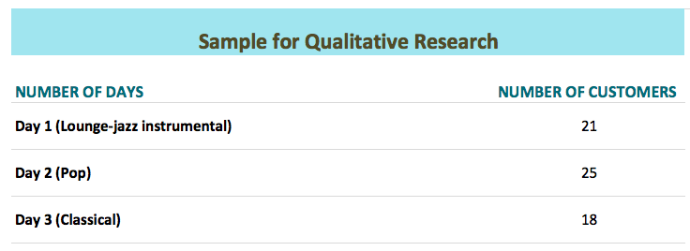
The sample for observations included target audience of retail shops “Fashion Plus”. As it was mentioned previously, the company mainly targets women in the age category of 30 to 50 years old. Furthermore, most of the clients live in Kiev. Regarding occupation, the majority of target audience representatives are employed and work in banks, hospitals, courts, universities, etc. Another descent category of “Fashion Plus” customers are housewives and women on maternity leave. The figure 3.4 below shows the number of observed customers that are included in the sample.
Figure 3.4. Sample for observations: Own Research

In general, daily flow of customers for small businesses as “Fashion Plus” is not massive. The company mainly relies on the amount of revenue rather than fast in-store traffic. During the first day of observation, the store has been visited by 21 women. The second day counted 25 customers in total. Finally, the last day of observation included 18 visitors.

3.4 Research Results

This part includes research findings and graphs with summarized data received from the comprehensive analysis. The very results will help to propose rational recommendations and conclusion on the topic of music and consumer behavior. The summarized information from questionnaire respondents is presented in the following part.

3.4.1 Attention of consumers to in-store music

The first section of the questionnaire tries to define whether people pay attention to musical compositions while doing shopping.

The graph 3.4 indicates that 98% of respondents pay attention to in-store music while shopping. This data can prove the fact that situational factors in the form of in-store stimuli are perceived well by potential customers.

Graph 3.4. Attention of consumers to music while shopping. Source: Own Research.

In addition, only 2% of respondents stated their inattention to musical compositions while shopping. The inattention can be driven by an excessive focus on other important things or internal dreaminess.

3.4.2 Disposition to in-store music

It is vital to measure consumers’ disposition to music in a store, and define why they like or dislike in-store musical compositions in general. The graph 3.5 reveals that 97% of respondents like when music is playing in a store. Positive behavior to in-store music allows marketers to experiment with it and pursue desired strategic objectives. Besides, 2% of respondents do not like music in a store, and 1% of people stated their disinterest.

Graph 3.5. Disposition to music in a store. Source: Own Research.

The factors that influence whether consumer likes or dislikes music in a store are presented in the graphs below. The graph 3.6 declares positive factors that drive favorable disposition to in-store music.
Graph 3.6. Positive factors that influence disposition to music in a store. Source: Own Research.

The responses of potential consumers are varied. However, 75% of respondents prefer having in-store music as it creates the desired atmosphere in a shop. If music is carefully selected and able to create the unique atmosphere it brings internal pleasure to visitors. Furthermore, 56% of people are disposed to music in a store due to a feeling of relaxation and refreshment. The half of respondents have a preference for in-store music as it drives particular emotions. As it was mentioned in the literature part, music can impact human brain and body in a certain way. It proves high selection of these factors among respondents. Additionally, 31% of answerers mentioned that music improves their overall state and mood, at the same time, 7% said that musical compositions in a store recall specific memories. It is possible to conclude that music on its own cannot significantly improve the overall state of a consumer while shopping time or consumers cannot consciously evaluate the effects of music on their state and mood. Finally, recalling of memories is the last selected option. Higher concentration on purchases can explain the above result. Hence, it is vital to refer that in-store music can be a perfect tool for marketers mainly in terms of creating the desired atmosphere, making consumers refreshed and relaxed and help in generating positive emotions. The graph 3.7 below specifies factors that 2% of respondents selected to justify their disliking of in-store music. This information indicates their rationale.
Graph 3.7. Negative factors that influence disposition to music in a store. Source: Own Research.

Besides, half of 2% of respondents think that music distracts their attention from making purchases and mismatches with the overall store concept. It can be assumed that such answers were driven by negative experience of respondents.
Hence, there is a useful source of information for marketers in terms of selecting perfect musical compositions for their stores.

3.4.3 In-store environment

This part analyses the presence of music in an overall in-store environment. It is vital to define whether consumers prefer music with lyrics, instrumental compositions or calm environment without musical playback. The graph 3.8 describes that 84% of respondents prefer when music with lyrics is playing in a store, at the same time, 81% of potential consumers favor instrumental music without text.

Graph 3.8. Best in-store environment in terms of music. Source: Own Research.

It gives food for thought that both instrumental music and music with lyrics are preferred by customers when rating overall in-store environment. In addition, 3% of respondents instead choose quite environment without any music, and 1% of people demonstrate disinterest to the role of music in an in-store environment.

3.4.4 Outcomes of music playback in stores

The very part examines consumer behavior while listening to music and outcomes it can bring to the business. Moreover, it is vital to define respondent’s opinion about suitable music and its correlation with store concept and overall brand positioning. The graph 3.9 shows the evaluation of the statement: “I believe music in a store influences my behavior while doing shopping”.

If a respondent pick number 5 it means he strongly agrees with a statement. However, if he decides to rate the statement with a number 1, it follows his strong disagreement. Under the results, 38% of respondents demonstrate a tendency of having a neutral position towards this statement. Simultaneously, 36% of answerers indicate disagreement with a statement that music influences their consumer behavior, and only 5% express strong disagreement. Finally, 21% of respondents agreed with a statement by evaluating it with numbers 4 and 5.

Graph 3.9. The influence of in-store music on consumer behavior. Source: Own Research.

Despite some favorable rates, the tendency still lies between neutral and negative answers. It means that majority of people consciously believe that music cannot influence their buying behavior. However, as it was mentioned in the literature review music can generate more sales and traffic to the store.

The graph 3.10 shows respondents’ assessment of the statement: “I believe music in a store can generate unexpected purchases”. The answer 1 means strong disagreement with a comment, and number 5 confirms the strong agreement. According to the graph below, 49% of respondents have the neutral position to this statement. This answer possibly can be interpreted that unexpected purchases are more dependent on the genre of music and individual preferences of consumers. Furthermore, 23% of consumers agree with the statement, and other 7% of respondents demonstrate strong agreement.

Graph 3.10. The influence of in-store music on unexpected purchases. Source: Own Research.

It is justified that these consumers had experienced unexpected purchases under the effect of in-store music. At the same time, 19% of answerers disagree with the sentence, and 2% stated total disagreement. Hence, these respondents did not experience the unexpected influence of music on their purchases. The rationale for this is driven by the idea that music itself cannot generate unexpected purchases. However, when it is combined with other factors, such as promotion or word-of-mouth, it will have more possibility to generate unexpected purchases.

The graph 3.11 explains what outcomes can the wrong music in a store derive to the business. Referring to the respondents’ answers, 82% indicated that if the music is unpleasant, they leave the store. Hence, music is a strong situational factor that can make consumers leave the place. Furthermore, 24% of respondents say that their purchasing power will decrease if the music is not appropriate. Simultaneously, 22% of answerers indicated that the wrong music recalls negative memories and emotions, and other 21% of consumers mentioned the ability to generate negative word-of-mouth if they experienced terrible in-store music. Also, only 3% of potential consumers mentioned unwillingness to come back to the store again.

Finally, 8% of results are not related to proposed choices. Consequently, if consumers do not like the music it can affect their further interactions with a business, and the most common outcome is leaving the store.

Graph 3.11. Outcomes of the wrong music played in a store. Source: Own Research.

The graph 3.12 shows various outcomes derived from listening to the right in-store music. According to the graph, 91% of respondents stay longer if they like the music in a particular store.

Graph 3.12. Outcomes of the right music played in a store. Source: Own Research.

At the same time, 67% of people indicate the willingness to visit the store again if they had a pleasant experience with the music. Moreover, 64% of potential consumers state that the right in-store music can stimulate positive recommendations to other people. Simultaneously, 29% of answerers think that appropriate music recalls positive memories and emotions, and 14% of them believe that the right music makes them purchase more. Hence, carefully selected music for in-store playback can stimulate consumers to stay longer, receive a pleasant opinion and revisit the store again, and recommend the place for others.

3.4.5 The relation of in-store music to brand and store concept

The following part examines respondents’ opinion about the correlation o in-store music with brand positioning and overall concept of the store. The graph 3.13 depicts that 55% of answerers strongly agree with the statement “In-store music should correlate with brand positioning and complement store concept”. It explains that music played in a store should represent the atmosphere that brand tries to create in a store and stimulate the corresponding mood. Other 20% of potential consumers agree with this statement by indicating number 4.

Graph 3.13. Correlation of in-store music with brand positioning and store concept. Source: Own Research.

At the same time, there are some disagreements with a sentence. For example, 12% of answerers disagree with a statement, and 8% indicate strong disagreement.

Moreover, there are 6% of people that choose neutral position towards the correlation of music with brand positioning and store concept. Based on the majority of positive answers, it is possible to justify that selected in-store music should correlate with the idea of brand positioning and overall concept of the store in order to achieve consumer’s satisfaction and other critical strategic goals.

3.4.6 Musical components

The very part examines musical components, such as genre, volume, tempo, rhythm, and pitch that are suitable for potential consumers to be played in a store. The graph 3.14 presents that 89% of respondents choose music genre to be one of the most significant musical components. At the same time, the volume of music is of a high importance by being mentioned in 87% of responses. Moreover, tempo and rhythm scored for 69%. Musical pitch is selected by 3% of answerers. The very result can be explained by a suggestion that not many people correctly understand the musical term “pitch”. This term is well-known among people who work in the music industry.

Graph 3.14. Important musical components. Source: Own Research.

Based on the information received from the graph, it is vital to mention that music genre is a crucial component people pay attention to. Following the results, volume and tempo are strongly important as well. Hence, these three components should be taken into consideration when choosing music for playback in a store.

The graph 3.15 shows the perfect level of volume for in-store music based on the opinions of respondents. The moderate level of volume, up to 60 dB, has been chosen by 86% of people.
Graph 3.15. Perfect level of volume for in-store music. Source: Own Research.

Additionally, quiet musical volume, up to 50 dB, is rated by 14% of respondents. It is vital to mention that moderate volume of in-store music is more favorable to potential consumers. The option of loud music is not selected among questionnaire respondents.

As tempo being important musical component, it is necessary to define what level of tempo is suitable for consumers. The graph 3.16 portrays that 67% of respondents prefer moderate tempo of the in-store music.

Graph 3.16. Perfect tempo for in-store music. Source: Own Research.

The perfect example of a song with moderate tempo is “Britney Spears – Oops!...I Did It Again”. Furthermore, 26% of answerers have chosen slow tempo over the other options. One of the most famous songs with slow tempo is “Whitney Houston – I Will Always Love You”. At the same time, fast tempo in music is preferential by 7% of respondents. The graph above shows that moderate tempo is the most popular in in-store music among questionnaire respondents. However, it can be suggested that tempo should instead depend on the concept, overall mood the company tries to create in a store, and preferences of target customers. The implications from qualitative research in the form of observations will be more effective in evaluating the behavior of consumers under different tempo levels in specific music genres.

3.4.6 Results of the Qualitative Study

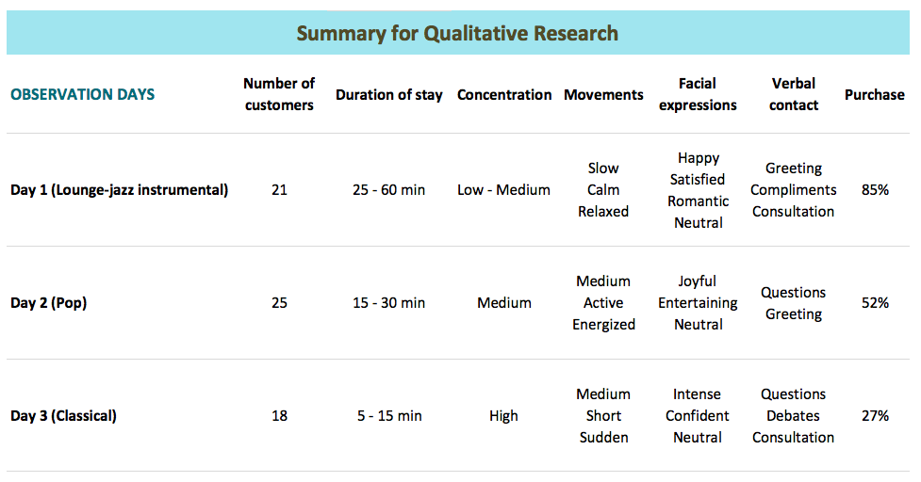
The following part discusses research findings with summarized information in a table received from observations. The very research helps to examine the unconscious behavior of consumers under the effect of different in-store music while doing shopping in the retail store “Fashion Plus”. Figure 3.5 depicts analyzed data from conducted natural observations.
Figure 3.5. Summary for Qualitative Research. Source: Own Research.

The first day of observations included playback of lounge-jazz instrumental music. The store has been visited by 21 customers. Their average duration of stay was between 25 and 60 minutes. Most of the women were having from low to medium level of concentration on clothes presented in the shop. Their movements were slow, calm and relaxed. Besides, clients were walking around the perimeter of the store and enjoying the time of their shopping. Referring to the facial expressions, observables tend to express happiness and satisfaction. Moreover, the majority of women were in a romantic mood. However, some clients had neutral facial expressions. Regarding verbal contact, the majority of customers were greeting at the beginning, giving compliments to professional work of staff, and quality of clothes. The larger part of observables was asking for the consultation and advice when choosing their outfit; customers did not experience any inconvenience with showing their fitting to the sales assistants. At the end of the first day of observations, the analysis has been demonstrated that 18 out of 21 clients purchased in the store. Furthermore, sales assistants rated lounge-jazz music very positively and mentioned that lounge instrumental music makes them feel satisfied and less distracted.

In the second day of observations, the tested musical genre was pop with songs from top charts. During that day, the store has been attended by 25 clients. The duration of stay among clients was between 15 and 30 minutes. Many women had a medium level of concentration on store items, and their movements were mainly active, energized and in a moderate speed. Majority of the clients were visiting only parts of the store by their interest. Referring to facial expressions, the observables were having joyful and entertaining emotions. Some of the women were demonstrating neutral mood. In terms of verbal contact, customers were greeting while entering the store; further selecting and fitting processes were without any help and consultations. Sometimes, clients were asking general questions about the price, size, and color. Finally, it was counted that 13 out of 25 customers made a purchase in “Fashion Plus”. At the same time, sales assistants mentioned that pop music makes them happier and energized. However, in most of the cases, such type of music significantly distracts their attention due to fast lyrics, strong beats and dance motives.

On the last day of observations, the classical music was playing in a store for the period of its working hours. The number of clients for that day was 18 in total, and their average stay was between 5 and 15 minutes. The observables were having a high concentration while looking on presented clothes in the store. Clients were paying a lot of attention to small details, such as label, buttons, material, print, etc. Moreover, they were focusing on price tags by asking various questions about discounts and bonuses. In terms of movements, customers were walking with a medium speed, and their movements were mostly short and sudden. At the same time, clients had intense facial expressions with confident and concentrated sight. Some of the observables were having neutral facial expressions. During that day, women were having a lot of verbal contact with sales assistants, and asking different questions and consultations about clothes and overall service. Furthermore, there were several clients who organized a debate for a discount bargaining. In the final day of natural observations, 5 out of 18 people made a purchase in the store. Referring to the opinion of sales assistants, the classical genre is not very suitable for the concept of “Fashion Plus” store.

Based on the results of the qualitative research, it is important to say that music genre can influence consumer behavior. Based on the findings above, lounge-jazz music helps consumers stay longer in a store, feel more relaxed and satisfied, have the lower level of concentration, exchange compliments with staff and gently ask for their consultation. Moreover, the very observation has shown that consumers are more favored to purchase clothes while listening to lounge-jazz instrumental music. At the same time, pop music makes people feel more active and energized, and visit only interested parts of the shop. Furthermore, customers were not requesting help from the staff and preferred to look on their own. Their concentration was moderate, and 52% of customers finalized a purchase while listening to pop music. The last observation day included classical repertoire, and it significantly fastened the duration of stay among clients. Women were highly concentrated on clothes, especially its small details and price. Furthermore, clients tend to ask many questions, and even make debates with sales personnel. Finally, 27% of consumers purchased while classical music playback.

Based on the analyzed results from natural observations, it is vital to mention that in-store lounge music makes female consumers act in a calm and relaxed manner by moving around the perimeter of the shop more slowly than under the effect of other tested music genres. Moreover, the average duration of stay among female consumers while lounge music playback is between 25 – 60 minutes. The time spent is 100% more than while been listened to pop music.

Under the research results received from the natural observations, it is necessary to admit that lounge music, played in a store, makes female consumers purchase more goods than under the playback of other musical genres, such as pop and classical. In general, after the first day of lounge music playback, it was counted that 85% of observables purchased clothes in “Fashion Plus” store.

3.6 Discussion

3.6.1 Research Limitations
There are some limitations in the data collection methods used for quantitative and qualitative researches. In the questionnaire method, the primary barrier is time. Due to the time limitation, it is difficult to create a decent sample. Hence, it is hard to generalize research results on the majority of consumers worldwide. The second limitation is financial resources. To conduct a research for a large scale with referral to a significant sample demands financial support. The third limitation is access to the Internet. The questionnaire data collection method requires availability to be online. There are many potential sample representatives who were not able to fulfill the survey due to the lack of Internet access. In the observation method, there are several limitations, such as time, a huge amount of details to observe, and difficulty in identifying the initial stimulus of specific behavior.

4. Conclusion
Music plays a vital role in the world by affecting society in a powerful way. Its large effect influences our lives from the very beginning to the very end. In the childhood, our mothers sing unforgettable lullabies before going to bed, then we learn music at school, and finally grow up and experience belongingness to specific music genres. We all listen to different music genres, including jazz, pop, rock or classical. Despite music genre, we all feel pleasure from listening to favorite music, and that is what makes us unified humans. However, the question of musical origins and evolution still cannot be answered with absolute certainty. There are many proposed versions on music origination, for example, many believe that music has arisen spontaneously in all existing societies. Another release states that music was inherited from nature and animals; ancient people started to imitate various sounds as bird singing or wind noise. Furthermore, Charles Darwin and Herbert Spencer proposed ideas in two different ways that musical evolution is connected with the development of human mind and mental processes. The approach of Darwin states that music is related to the survival of our species, for example, during the selection of a life partner, maternal care or unification of a tribe. At the same time, Spencer argues that music is perceived as the exceptional invention of humans with no regard to other biological influences. Besides, Eckart Altenmuller proposed an idea that music has arisen from human esthetic emotions. Consequently, there are a variety of assumptions on musical origins and evolution. Even though musical roots cannot be truly discovered, the advantages it brings to human lives are evident and beneficial. Music is widely used in medicine, education, sports and other industries. It increases memory, social cohesion, logical skills, language abilities, physical power, creativity, emotional state, etc.

Human brain activates both hemispheres while listening to and playing music (Bennet and Bennet, 2008). In total, nine brain parts are activating on music: sensory cortex, auditory cortex, cerebellum, hippocampus, amygdala, prefrontal cortex, motor cortex and corpus callosum. Hence, music demonstrates strong psychological and physiological effects on human lives by influencing human brain and subsequent well-being alongside with behavior. However, to carefully define how music changes consumer behavior, it is necessary to have a glimpse into the concept of consumer behavior and its components. The action of consumers consists of mental and emotional processes with various physical activities that come under selecting, purchasing, using and disposing of goods or services (Bearden, Ingram and LaForge, 2001). In general, the decision-making process of consumers includes several stages, such as recognition of a need or problem, search for information, evaluation of alternatives and, finally, purchase. Simultaneously, numerous factors influence the decision-making process of consumers. These factors are individual differences, social environment, and situational factors. Music performs one of the critical roles in situational factors by being implemented as in-store stimuli (Bearden, Ingram and LaForge, 2001).

“The wider relationship between music and marketing has been extensively researched by academics and professionals across a range of disciplines, including economics, music, sociology and psychology” (Kubacki and Croft, 2004, p.580). Several pieces of research have already shown that music affects consumer behavior. For example, the rhythm of a song can speed up the amount of food consumed in the restaurant, slow music in a supermarket makes customers move slowly and helps in reducing the traffic, unaccustomed musical tracks make consumers do shopping in a slow manner, and happy songs generate better mood while sad songs stimulate more purchases (Bruner, 1990). Moreover, researchers experimented in a supermarket to examine the relation between the origins of wine and music playback in a store. The research results have shown that consumers tend to buy wine from a country, which music was playing during the selection process. Based on the literature review, it is vital to say that music and its components, such as tempo, pitch, harmony and volume influence the behavior of consumers while being exposed to advertising, sitting in a restaurant or doing shopping in a supermarket. It is of a high importance to select the right in-store music for your business to match with strategic goals and company’s image.

The results from dissertation researches are focused on the conscious and unconscious behavior of consumers concerning to in-store music. The first research, in the form of a questionnaire, has shown that a significant majority of respondents pay attention to musical compositions while shopping, and prefer when music is on. The in-store music helps in creating the desired atmosphere, provides relaxation and refreshment, and stimulates particular emotions. In general, if the consumer does not like the music in a store, it can be caused by the discrepancy with his musical preferences, the mismatch between music and a store concept or simply distraction of attention. When consumers hear the right music, they are more probable to stay longer in a shop, share positive word-of-mouth, and visit again. At the same time, if they notice the wrong music in a store, the majority will leave, purchase less, and even recall negative memories or emotions. Furthermore, the consumers believe that in-store music should correlate with brand positioning and a unique concept of a store. Speaking about musical components, respondents consider that music genre, volume, and tempo are the most important. The perfect level of volume and tempo for music playback in a store is medium. Both music with lyrics and instrumental are very favorable for in-store usage.

The findings from the natural observations have covered the research gap in the very topic. The results have demonstrated that lounge music makes female consumers move slowly and stay longer in a retail store. The analyzed data from 3-day observations reflected that behavior of female consumers changes with different music genres played in a store. The lounge-jazz instrumental music demonstrated the most fruitful results, in comparison to pop and classical, by showing that consumers move slower and stay longer in a shop. Furthermore, they feel satisfied and more likely to make the final purchase.

Referring to both quantitative and qualitative researches, it is possible to create a recipe for a perfect musical composition for playback in a store. First of all, in-store music should complement store concept and correlate with brand positioning to create the desired atmosphere. Second of all, music genre should make consumers relaxed and refreshed; lounge music is useful if a business aims to make consumers satisfied and relaxed. Moreover, it can make consumers stay longer in a shop, and stimulate purchases. Whether music should be instrumental or without words, it is a matter of choice. However, it should strongly fit with the overall shop atmosphere. For the retail store “Fashion Plus”, instrumental music works better from both the client and sales assistant sides. Furthermore, sales personnel feel more distracted while listening to pop music with lyrics. Referring to musical components, volume, tempo, and rhythm are most preferred by consumers. The volume of music playback should be rather moderate than high; it prevents from consumer’s distraction and dissatisfaction. The tempo and rhythm are best in the medium level as well for playback in a store. To conclude, it is vital to say that wisely selected in-store music with a specific goal can bring many advantages to the prosperity of a business and satisfaction of consumers.

5. Bibliography
Articles and Books:
- Alpert, J. and Alpert, M. (1986). The effects of Music in Advertising on Mood and Purchase Intentions. unpublished working paper 85/86. University of Texas.
- Alpert, J. and Alpert, M. (1988). Background Music as an Influence in Consumer Mood and Advertising Responses. Advances in Consumer Research, 16, pp.485-491.
- Altenmüller, E. (2015). Music, neurology, and neuroscience. Evolution, the musical brain, medical conditions, and therapies. Amsterdam: Elsevier.
- Amen, D. (2005). Making a good brain great. New York: Harmony Books.
- Bearden, W., Ingram, T. and LaForge, R. (2001). Marketing, principles & perspectives. 3rd ed. Boston, Mass.: McGraw-Hill, pp.77-100.
- Bennet, A. and Bennet, D. (2008). The human knowledge system: music and brain coherence. VINE, 38(3), pp.277-295.
- Bowling, A. (2009). Music and the brain may be a therapeutic duet. Momentum, 2, pp.43-44.
- Brassington, F. and Pettitt, S. (2013). Essentials of marketing. 3rd ed. Harlow, England: Pearson, pp.81-159.
- Bruner, G. (1990). Music, Mood, and Marketing. Journal of Marketing, pp.94-102.
- Clynes, M. (1982). Music, Mind, and Brain. New York: Plenum Press.
- Cross, I., Hallam, S. and Thaut, M. (2016). The Oxford Handbook of Music Psychology. 2nd ed. New York: Oxford University Press, p.5.
- d’Errico, F., Henshilwood, C., Lawson, G., Vanhaeren, M., Tillier, A., Soressi, M., Bresson, F., Maureille, B., Nowell, A., Lakarra, J., Backwell, L. and Julien, M. (2003). Archaeological Evidence for the Emergence of Language, Symbolism, and Music—An Alternative Multidisciplinary Perspective. Journal of World Prehistory, 17(1), p.56.
- Forgeard, M., Lerch, J., Norton, A., Hyde, K., Winner, E., Evans, A. and Schlaug, G. (2009). The Effects of Musical Training on Structural Brain Development. Annals of the New York Academy of Sciences, 1169(1), pp.182-186.
- Gundlach, R. (1935). Factors Determining the Characterization of Musical Phrases. The American Journal of Psychology, 47(4), p.624.
- Hevner, K. (1935). The Affective Character of the Major and Minor Modes in Music. The American Journal of Psychology, 47(1), p.103.
- Hevner, K. (1937). The Affective Value of Pitch and Tempo in Music. The American Journal of Psychology, 49(4), p.621.
- Hodges, D. (2000). Implications of Music and Brain Research. Music Educators Journal, 87(2), p.21.
- Jensen, E. (2000). Brain-based learning. San Diego, CA: The Brain Store.
- Kinnear, J. (1959). The Effects of Instrumental Tone Quality Upon Mood Response to Music. Master. Florida State University.
- Kleinman, K. (2015). Darwin and Spencer on the origin of music: is music the food of love?. St. Louis: Elsevier, p.4.
- Kubacki, K. and Croft, R. (2004). Mass Marketing, Music, and Morality. Journal of Marketing Management, 20(5-6), pp.580-582.
- Levitin, D. (2006). This is Your Brain On Music. East Rutherford, USA: Penguin Group (USA) Incorporated.
- Menon, V. and Levitin, D. (2005). The rewards of music listening: Response and physiological connectivity of the mesolimbic system. NeuroImage, 28(1), pp.175-184.
- Milliman, R. (1982). Using Background Music to Affect the Behavior of Supermarket Shoppers. Journal of Marketing, 46(3), pp.86-91.
- Milliman, R. (1986). The Influence of Background Music on the Behavior of Restaurant Patrons. Journal of Consumer Research, 13(2), pp.286-289.
- Nakamura, S., Sadato, N., Oohashi, T., Nishina, E., Fuwamoto, Y. and Yonekura, Y. (1999). Analysis of music–brain interaction with simultaneous measurement of regional cerebral blood flow and electroencephalogram beta rhythm in human subjects. Neuroscience Letters, 275(3), pp.222-226.
- Park, C. and Young, S. (1986). Consumer Response to Television Commercials: The Impact of Involvement and Background Music on Brand Attitude Formation. Journal of Marketing Research, 23(1), pp.11-24.
- Patel, A. (2010). Music, language, and the brain. Oxford: Oxford University Press.
- Peretz, I. (2006). The nature of music from a biological perspective. Cognition, 100(1), pp.1-32.
- Rauscher, F., Shaw, G. and Ky, C. (1993). Music and spatial task performance. Nature, 365(6447), pp.611-611.
- Scherer, K. and Oshinsky, J. (1977). Cue utilization in emotion attribution from auditory stimuli. Motivation and Emotion, 1(4), pp.331-346.
- Schiffman, L. and Kanuk, L. (1997). Consumer behavior. 6th ed. Upper Saddle River, N.J.: Prentice Hall, pp.6-9.
- Schlaug, G. (2015). Musicians and music making as a model for the study of brain plasticity. Boston: Elsevier.
- Shimp, T. (2000). Advertising, Promotion & Supplemental Aspects of Integrated Marketing Communications. 5th ed. Dryden Press, p.261.
- Simpkins, J. and Smith, J. (1974). Effects of music on source evaluations. Journal of Broadcasting, 18(3), pp.361-367.
- Simpkins, J. and Smith, J. (1974). Effects of music on source evaluations. Journal of Broadcasting, 18(3), pp.361-367.
- Smith, P. and Curnow, R. (1966). "Arousal hypothesis" and the effects of music on purchasing behavior. Journal of Applied Psychology, 50(3), pp.255-256.
- Sousa, D. (2006). How the Brain learns. 3rd ed. Thousand Oaks: Corwin Press.
- Vinovich, G. (1975). The Communicative Significance of Musical Affect in Eliciting Differential Perception, Cognition, and Emotion in Sound-Motion Media Messages. PhD. University of Southern California.
- Watson, K. (1942). The nature and measurement of musical meanings. Psychological Monographs, 54(2), pp.1-43.
- Watson, K. (1942). The nature and measurement of musical meanings. Psychological Monographs, 54(2), pp.1-43.
- Wedin, L. (1972). A MULTIDIMENSIONAL STUDY OF PERCEPTUAL-EMOTIONAL QUALITIES IN MUSIC. Scandinavian Journal of Psychology, 13(1), pp.241-257.
- Yalch, R. (1988). Effects of Store Music on Shopping Behavior. The Channel of Communication, (4), pp.7-9.
- Zatorre, R. (1997). Hemispheric specialization of human auditory processing: perception of speech and musical sounds." Advances in Psychology, 123, p.299.
Internet sources:
- Booke, L. (2017). Rhythm, Music, and The Brain. [online] Therabeat, Inc. Available at: http://www.therabeat.com/news-and-events/2017/10/5/rhythm-music-and-the-brain [Accessed 19 Mar. 2018].
- Collingwood, J. (2016). Preferred Music Style Is Tied to Personality | Psych Central. [online] Psych Central. Available at: https://psychcentral.com/lib/preferred-music-style-is-tied-to-personality/ [Accessed 14 Mar. 2018].
- Cooper, B. (2013). 8 Amazing, Little-Known Ways Music Affects the Brain. [online] Buffer. Available at: https://blog.bufferapp.com/music-and-the-brain [Accessed 14 Mar. 2018].
- Deflin, K. (2016). 10 Positive Benefits Of Listening To Music, According to Science. [online] L4LM. Available at: https://liveforlivemusic.com/features/10-positive-benefits-of-listening-to-music-according-to-science/ [Accessed 19 Mar. 2018].
- Devaney, E. (2016). Stores Are Using Music to Make You Spend More – ThinkGrowth.org. [online] ThinkGrowth.org. Available at: https://thinkgrowth.org/stores-are-using-music-to-make-you-spend-more-d6c85974b20b [Accessed 17 Apr. 2018].
- Facebook.com. (n.d.). Fashion Plus. [online] Available at: https://www.facebook.com/fashionplus1992/ [Accessed 5 May 2018].
- Ford, M. (2013). The Psychology of Music: Why Music Plays a Big Role in What You Buy. [online] Blog.motivemetrics.com. Available at: http://blog.motivemetrics.com/The-Psychology-of-Music-Why-Music-Plays-a-Big-Role-in-What-You-Buy [Accessed 17 Apr. 2018].
- Galic, D. (2016). How to Choose the Right Music for Your Retail Store. [online] Humanity Blog. Available at: https://www.humanity.com/blog/how-to-choose-the-right-music-for-your-retail-store.html [Accessed 17 Apr. 2018].
- Greenberg, D. (2016). What Is Music…Exactly?. [online] Psychology Today. Available at: https://www.psychologytoday.com/blog/the-power-music/201608/what-is-music-exactly [Accessed 14 Mar. 2018].
- Iep.utm.edu. (n.d.). History of Evolution | Internet Encyclopedia of Philosophy. [online] Available at: https://www.iep.utm.edu/evolutio/ [Accessed 19 Mar. 2018].
- Iep.utm.edu. (n.d.). Spencer, Herbert | Internet Encyclopedia of Philosophy. [online] Available at: https://www.iep.utm.edu/spencer/ [Accessed 19 Mar. 2018].
- Laky, R. (2017). Когда и как появилась музыка?. [online] FB.ru. Available at: http://fb.ru/article/349459/kogda-i-kak-poyavilas-muzyika [Accessed 14 Mar. 2018].
- LeTrent, S. (2010). Restaurants' table turnover tricks boost business. [online] CNN. Available at: http://edition.cnn.com/2010/LIVING/04/30/noisy.restaurant.business/index.html [Accessed 17 Apr. 2018].
- McCaskill, A. (2015). Recommendations from friends remain most credible form of advertising among consumers; branded websited are the second-highest-rated form. [online] Nielsen. Available at: http://www.nielsen.com/us/en/press-room/2015/recommendations-from-friends-remain-most-credible-form-of-advertising.html [Accessed 15 Apr. 2018].
- Simplifyingtheory.com. (n.d.). What is music? | Simplifying Theory. [online] Available at: http://www.simplifyingtheory.com/what-is-music/ [Accessed 14 Mar. 2018].
- Stafford, T. (2006). music, wine and will. [online] Mind Hacks. Available at: https://mindhacks.com/2006/02/06/music-wine-and-will/ [Accessed 17 Apr. 2018].
- Weinberger, N. (1995). The Nonmusical Outcomes of Music Education. MuSICA Research Notes, [online] II(2). Available at: http://www.musica.uci.edu/mrn/V2I2F95.html [Accessed 22 Mar. 2018].

6. List of figures
Figure 1.1. Charles Darwin..................................................................................... 12
Figure 1.2. Herbert Spencer.................................................................................... 12
Figure 1.3. Active processes while playing musical instrument............................. 14
Figure 1.4. Brain reaction on listening or playing music........................................ 16
Figure 2.1. Consumer decision making model and influences................................ 26
Figure 3.1. The logo of Fashion Plus....................................................................... 34
Figure 3.2. Timescale of Quantitative Research...................................................... 36
Figure 3.3. Timescale of Qualitative Research........................................................ 36
Figure 3.4. Sample for observations........................................................................ 39
Figure 3.5. Summary for Qualitative Research....................................................... 50

7. List of tables
Table 1.1. Music genres and personal qualities.............................................. 9
Table 1.2. The expression of emotions on musical components.................... 19
Table 1.3. Human emotions and acoustic cues............................................... 20
Table 2.1. Consumer segmentation bases and their main components........... 24

8. List of graphs
Graph 3.1. Age of Respondents................................................................................ 37
Graph 3.2. Gender of Respondents........................................................................... 38
Graph 3.3. Occupation of Respondents.................................................................... 38
Graph 3.4. Attention of consumers to music while shopping................................... 40
Graph 3.5. Disposition to music in a store................................................................ 41
Graph 3.6. Positive factors that influence disposition to music in a store ............... 41
Graph 3.7. Negative factors that influence disposition to music in a store.............. 42
Graph 3.8. Best in-store environment in terms of music.......................................... 43
Graph 3.9. The influence of in-store music on consumer behavior.......................... 44
Graph 3.10. The influence of in-store music on unexpected purchases.................... 45
Graph 3.11. Outcomes of the wrong music played in a store.................................... 46
Graph 3.12. Outcomes of the right music played in a store...................................... 46
Graph 3.13. Correlation of in-store music with brand positioning and store concept... 47
Graph 3.14. Important musical components.............................................................. 48
Graph 3.15. Perfect level of volume for in-store music............................................. 49
Graph 3.16. Perfect tempo for in-store music............................................................ 49

9. Appendixes
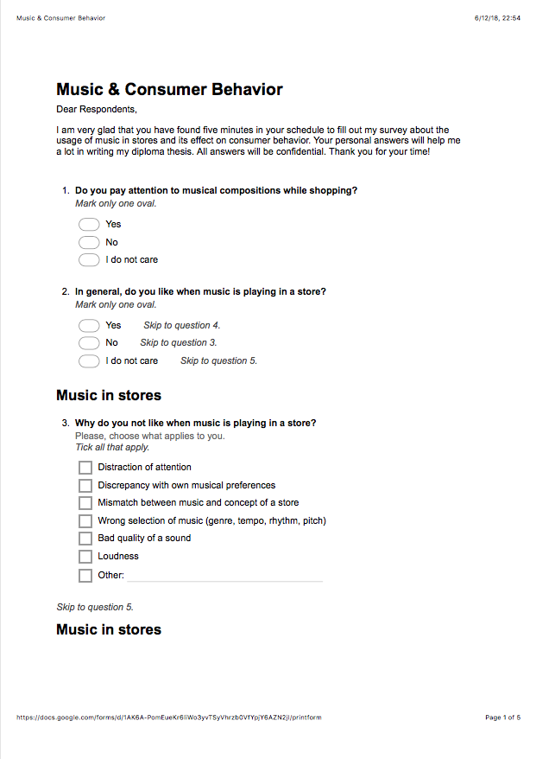
Appendix A – The questionnaire form
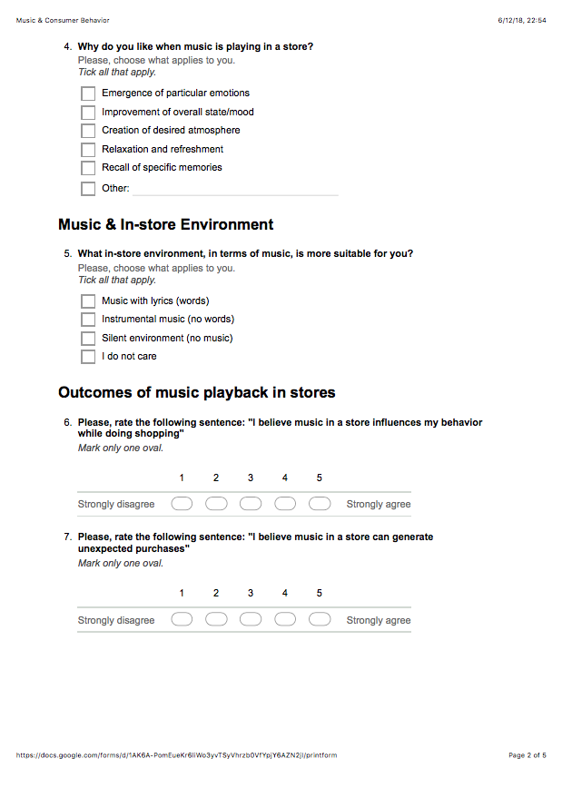

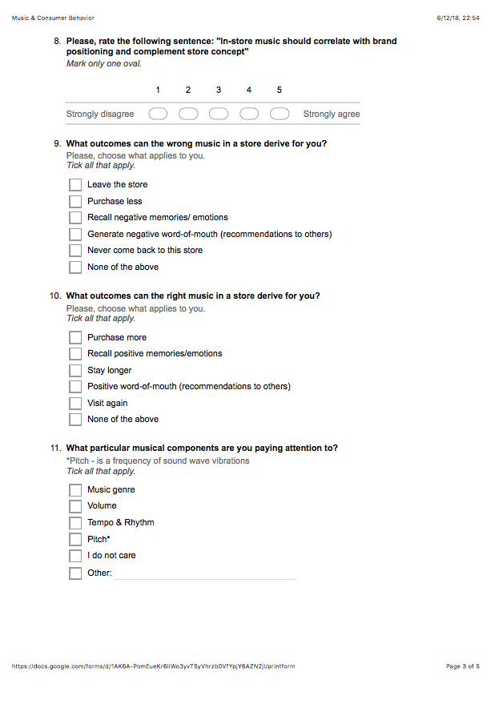

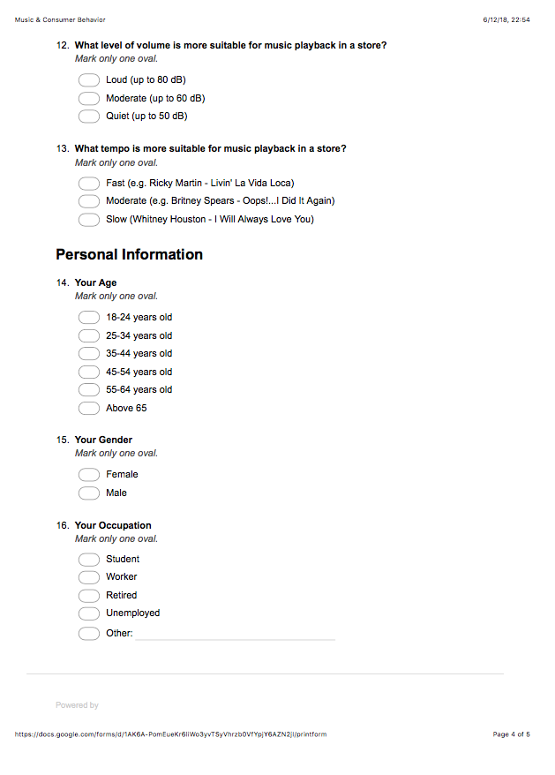

Source: Own Research.

Appendix B – Music playlist for natural observations

Musical compositions | Music genre
Kenny G – The look of love | Lounge-jazz instrumental
Kenny G – You’re beautiful | Lounge-jazz instrumental
Kenny G – Sabor A Mi | Lounge-jazz instrumental
Kenny G – Going Home | Lounge-jazz instrumental
Kenny G – April Rain | Lounge-jazz instrumental
Kenny G – End of the night | Lounge-jazz instrumental
Kenny G – Sade | Lounge-jazz instrumental
Kenny G – The Joy of Life | Lounge-jazz instrumental
Kenny G – You Raise Me Up | Lounge-jazz instrumental
Kenny G – Sentimental | Lounge-jazz instrumental
Kenny G – G-Bop | Lounge-jazz instrumental
Kenny G – As Time Goes By | Lounge-jazz instrumental
Kenny G – Jasmine Flower | Lounge-jazz instrumental
Kenny G – Loving you | Lounge-jazz instrumental
Moose Dawa - Chances | Lounge-jazz instrumental
Moose Dawa - Yesorno | Lounge-jazz instrumental
Moose Dawa - Remember | Lounge-jazz instrumental
Moose Dawa - All(ways) | Lounge-jazz instrumental
Moose Dawa - Daylight | Lounge-jazz instrumental
Moose Dawa - Menti | Lounge-jazz instrumental
Moose Dawa - Nomatter | Lounge-jazz instrumental
Moose Dawa - Backhome | Lounge-jazz instrumental
Moose Dawa - Bravo | Lounge-jazz instrumental
Pink Martini - Segundo | Lounge-jazz instrumental
Pink Martini – No Hay Problema | Lounge-jazz instrumental
Stereo Dub – Luna de Alegrias | Lounge-jazz instrumental
Sao Vicente - Ishtar | Lounge-jazz instrumental
Jazz Lounge - Bossa | Lounge-jazz instrumental
Jazz Lounge – Jazz Music love song | Lounge-jazz instrumental
Beyonce | Pop
Clean Bandit - Solo | Pop
Rita Ora - Girls | Pop
Selena Gomez – Back to You | Pop
The Chainsmokers - somebody | Pop
Charlie Puth – Done for me | Pop
Charlie Puth – Attention | Pop
Oftenbach - Katchi | Pop
Sean Paul – Mad Love | Pop
Beyonce – Single ladies | Pop
Pitbull - Fireball | Pop
Luis Fonsi - Despacito | Pop
Luis Fonsi – Echame la culpa | Pop
Enrique Iglesias – Bailando | Pop
Becky G - Mayores | Pop
Ricky Martin – Vente Pa’ Ca | Pop
Justin Bieber – 2U | Pop
Justin Bieber – Friends | Pop
Justin Bieber – Let Me Love You | Pop
Justin Bieber – What Do You Mean | Pop
Justin Bieber – Where Are U Now | Pop
Lady Gaga – The Cure | Pop
Lady Gaga – Dancin’ In Circles | Pop
Lady Gaga – Perfect Illusion | Pop
Beyonce – Deja vu | Pop
Dua Lipa – Blow Your Mind | Pop
Sean Paul – No Lie | Pop
Dua Lipa - Genesis | Pop
Dua Lipa – Be the one | Pop
Enrique Iglesias – El bano | Pop
Chopin - Nocturne | Classical
Chopin - Fantasie | Classical
Chopin – Ballade No. 3 | Classical
Chopin – Etudes No.6 | Classical
Chopin - Berceuse | Classical
Chopin – Nocturne No.2 | Classical
Mozart – Serenade No.10 | Classical
Mozart – Fantasia in D | Classical
Mozart – Symphony No.39 | Classical
Mozart – Serenade in G | Classical
Mozart – Symphony No.41 | Classical
Mozart – Sonata in A | Classical
Bach – Invention No. 8 | Classical
Bach – Adagio | Classical
Pachelbel – Forest Garden | Classical
Bach – Air on the G String | Classical
Bach – Sleepers wake | Classical
Vivaldi - Spring | Classical
Tchaikovsky – Waltz of the Flowers | Classical
Tchaikovsky – Sleeping Beauty Waltz | Classical
Beethoven – Fur Elise | Classical
Edvard Grieg – Morning mood | Classical
Paganini – Sei sonate | Classical
Grofe – Grand Canyon | Classical
Schubert - Quintet in A | Classical
Bach – Var. 13 | Classical

Source: Spotify Music

