10 Questions Startup Should Ask Before Building an App
What are the chances of startup success? Can I combine startup creation with normal work? What profit does the entrepreneur receive even if his startup burns out? This issue is normal for those who desire to begin their occupation. This article tries to tell you which else questions startups should ask before building an app.
The motivation of eminent entrepreneurs is the desire to change the world. Do all the startups have the idea of “making the world better”? Are there any instances of felicitous startups that were originally conceived as a means of enrichment? In this article, we will try to give you an overview of the main elements that you ought to concentrate on to maximize the results of your labour like building an app, and see what issues will be useful to you.

4 key elements of each startup
In the world of startups negative, for any other sphere of activity, circumstances such as, for example, app development cost and lack of funds and popularity are only beneficial to you. So, there are 4 key foundations that you require for building an app: a unique idea, a quality product, a strong team, and excellent implementation.
Sure thing! All these elements intersect. In any case, your failure is probable. The formula for the final result looks something like this: “Idea x Product x Implementation x Team x Good luck”, where luck is a random number from zero to ten thousand. Something like that. And if you have everything in 4 areas that you can control, then you can count on modest success. It's strange that in the world of startups, the conditions of the game are equal for everyone. Both: for experienced veterans and young beginners.
Question number 1. Who are my clients?
This is the momentous issue that solves the luck of the project. Many startups are closed because the founders do not know what kind of customers they have. What habits, needs, dreams, desires, and fears are they having? Make a portrait of your audience, think out all the details. Understand what kind of problem your starter solves for the user.
You compose a portrait of a typical representative of your target audience. This is, for example, the girl Alice, who learns a lot. She constantly sits until late at night, because she teaches paragraphs from the textbook or writes enormous abstracts. She is afraid to get a low rating, so she is constantly nervous about classes and exams. Besides, Alice needs an "amulet" that will protect her from bad marks to relieve stress and to believe in success.
This “amulet” may become an application in her smartphone with textbooks, diagrams, rules, etc.
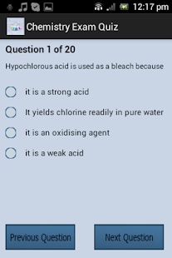 The girl will be able to cope with her tasks even on the bus, and so on. This app assists her in this.
Question number 2. What is the value of my project?
When you know what interests have your potential customers, ask yourself: “Does my startup resolve their issue? What needs does he satisfy?” Formulate in one sentence why someone should select your product, not competitors.
If you understand the “Achilles' heel” of your auditorium - the fear of getting bad grades or flying out of the university in the description you write: “With our applications, you will remain at the university and get the best grades.”
Question number 3. How do I get in touch with buyers?
List how you cooperate with and engage with users, and which channels you use to advertise. Identify where it’s more convenient for clients to get info about the product, buy it and give fiddles. Perhaps it's Facebook, a messenger, an email box, or even radio or television. After all, users of mobile gadgets not only play games or sit on social networks. Statistics show that there are sales on the mobile Internet. Developing applications will be an indisputable competitive advantage for your business.
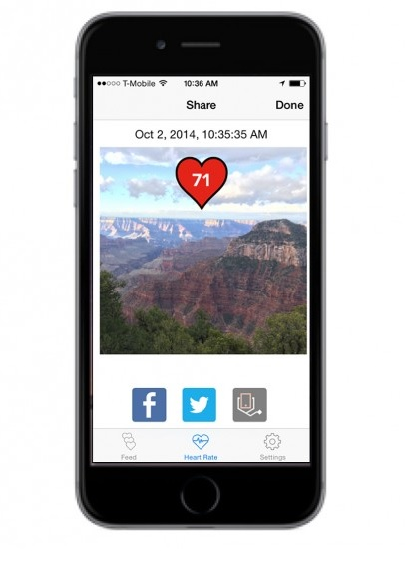To create an application, it's best to advertise on social networks where students spend more time. Your first step is business analysis, and the next - development, implementation, monitoring, and launch.
Question number 4. How will I maintain customer relationships?
Think about how you will help the client in any situation. You need to find your business approach to solving problems. This way you will have access to a multi-million mobile audience.
Question number 5. What are the sources of income?
Describe how your project will bring you money. Most young entrepreneurs say they “just sell their products”, so skip this question. However, there are many other ways to earn revenue. Think about it. Do not focus on just one way to earn.
You will create an application first. But, of course, you plan that customers will eventually be able to install apps that will be useful to them for one exam or a whole session and this will bring you revenue.
Question number 6. What will be the main resources?
You decide if you will hire people. Distribute all resources by categories: physical, intellectual, human, financial. If you work on the image of your application and site, your profit will grow.
You need to invest money in marketing and advertising your project.
Question number 7. What should I do to attract customers?
List the main steps you need to take to get customers to know about your application and install it. Compose a complete list of actions that will help to develop the project from scratch and before entering the market.
For example, you specify:
- Creating attractive video ads.
- Add good titles, descriptions and images, and more.
Question number 8. With whom I will cooperate?
Each startup needs investors and partners. Investors will invest money in your project, and partners will bring in new customers. Therefore, develop relationships with other companies and ask the useful advice. To start the inventory, list potential partners, as well as a list of resources that you’ll receive from them.
Question number 9. How much will my product cost?
Write down all the expenses that will be spent on development, advertising, the attraction of resources, basic steps, etc. And do not forget to analyze the market and look at the prices of competitors. This will help you determine the price of your application.
Question number 10. Am I ready to create a startup?
Never doubt what you are doing. Still, you have to learn a lot in the process and from your own mistakes. Moreover, now most of the info can be easily found online, and contacting the right person is possible with a few clicks.

- On average, mobile users regularly download or update 25 applications per month.
- Users of mobile gadgets not only play games or sit on social networks. 49% of mobile users search on a smartphone and 70% of them searched for a product or service.
- Statistics show that there are sales on the mobile Internet. 53% of mobile buyers make purchases monthly.
- 88% of people, who came from mobile, buy for 24 hours. About 70% buy for 1 hour.
The outcome
The growth and launch of the startup project and in particular the creation of the apps involve taking several steps, which define the market prospects of the project, financial analysis and risk analysis, and measures to promote the proposal to investors.
Many issues need to be solved before building an app. And after reading them in this article, you will be more confident in your endeavours.
So we determined:
- what the essence and features of the market are;
- Peculiarities of consumer behaviour when using applications;
- defined the main elements of each startup;
- the main groups of market factors that shape opportunities and threats to implement a startup project;
- principles of information search for market analysis;
- Convincing facts about the preferences of startup application;
- Potentially possible sources of financing for the startup project, their strong ones, and their weaknesses.
So, all that you need for success is a team of people, united by a common goal. The rules of life of the company are only applicable if they suit these people.

