Main topic. Educational institutions in the UK and Ukraine.

Main Aim:
to compare and contrast the education systems of Great Britain and Ukraine.

Subsidiary Aim:
to identify the similarities and differences between the two education systems.

Personal aims:
- to encourage students to participate actively in discussions;
- to improve students' critical thinking skills;
- to enhance students' knowledge of different education systems.
Materials:
- powerPoint presentation on the education systems of Great Britain and Ukraine;
- handouts with information on the education systems of both countries;
- whiteboard and markers for brainstorming.

Language Analysis:
The language used will be academic and formal, focusing on vocabulary related to education and comparative analysis. Students will be encouraged to use comparative and contrastive language, such as "similarly," "on the other hand," and "in contrast to." The teacher will also provide definitions and explanations of any technical vocabulary to ensure students understand the material.

Assumptions:
- students have a basic understanding of the education system in Ukraine;
- students have some knowledge of the education system in Great Britain;
- students are familiar with the concept of comparative analysis.
Board plan:
Time and Interaction | Stage name & Aim | Procedure
1.Introduction.  5 min | Teacher's greeting.  Introduce the topic and engage the students. | Our topic today is “System of education in Great Britain and Ukraine”. By the end of the lesson you should be able:  - to recognize and understand the words and word-combinations in the text;  - to understand the differences between Ukrainian and British schools;  - to make a conclusion about a system of education of Ukraine and Great Britain;  - to develop listening, speaking reading and writing skills.
1.1Warming up.  5 min | Let’s listen, read, and translate | Our Motto:  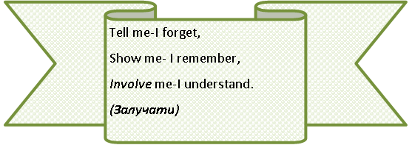
1.2 Lexical exercises.  5 min | Learn the proverbs. Match the beginning of the proverb in column A with its ending in column B.
  Match the beginning of the proverb in column A with its ending in column B.
  1. | Live and… | A. | …a dangerous thing.
  2. | Knowledge is… | B. | …to learn.
  3. | A little knowledge is… | C. | …power.
  4. | It is never too late… | D. | …to know nothing.
  5. | To know everything is… | E. | …learn.
  6. | There is no royal road… | F. | …to learning.
  The answer key: 1-E, 2-C, 3-A, 4-B, 5-D, 6-F.
2. The main part  2.1Vocabulary work.  5 min | In pairs, identify the definition and translation of the words on the board. | -courses – a set of classes leading to an exam – курс навчання  -independent – not influenced or controlled – незалежний  - opportunities – possibility to do smth – можливості  - advanced – at a higher level – високого рівня  - junior – level of school – молодший  - available - able to be used – доступний  - public – expensive private – приватний  - compulsory – smth you do because of a law – об’овязковий  - boarding – a school where students live and study – школа-інтернат  - comprehensive – completed – загальноосвітній.
2.2 Video «Education in Ukraine»  15 min | Listening to the information and doing the exercises presented in the video. | Teacher shows students a video about Ukraine.  https://youtu.be/HjSuv0mBMhA  What did you learn from the video?  What can be transferred from a British school to a Ukrainian one?
2.3 Video  «UK Education System Explained»  15 min | Listening to the information and doing the exercises presented in the video. | Teacher shows students a video about UK.  https://youtu.be/OV3tImRJVU8  What did you learn from the video?
3.Consolidation of the learnt material  3.1Answer the questions, compare the education system of Ukraine and England  10 min | Answer the question. Make a comparison of education systems. | 1. Do you like to study?  2.When did you start school?  3. What is a school?  4. What’s your favourite subject? Why?  5. Do you feel at home at your school?  6. Would you like to study abroad? Why?  7. What do you like in the system of education of Ukraine?  8. What don’t you like in our education?  Compare the education systems of Ukraine and Great Britain.  Answers  The education systems of Ukraine and Great Britain are different in several ways. Here are some key differences:  Structure and levels of education:  The education system in Ukraine is structured into three levels: primary, secondary, and higher education. Primary education consists of grades 1-4, secondary education consists of grades 5-11, and higher education includes universities and specialized post-secondary schools. In contrast, the education system in Great Britain is divided into four levels: primary, secondary, further education, and higher education. Primary education consists of Reception and Key Stages 1-2, secondary education is Key Stages 3-4, further education includes vocational education and training, and higher education consists of universities.  Curriculum:  The curriculum in Ukraine is centralized and determined by the Ministry of Education and Science. It includes subjects such as Ukrainian language and literature, math, history, geography, and foreign languages. In contrast, the curriculum in Great Britain is more decentralized, with individual schools having greater autonomy over the subjects they teach. The curriculum includes core subjects such as English, math, and science, as well as optional subjects such as foreign languages, history, and geography.  Assessment:  In Ukraine, assessment is based on exams and tests, with students receiving grades from 1 to 12. In Great Britain, assessment is based on a variety of methods including exams, coursework, and practical assessments. Students receive grades based on a scale from A* to U.  Funding:  In Ukraine, the education system is largely funded by the government, with some private schools also available. In Great Britain, the education system is also largely funded by the government, with private schools playing a larger role.  Language:  In Ukraine, Ukrainian is the primary language of instruction, although some schools may also teach in Russian or other minority languages. In Great Britain, English is the primary language of instruction, although schools may also offer language classes in other languages.  Overall, while both education systems share similarities such as a focus on core subjects, the structure, curriculum, assessment, funding, and language differ significantly between Ukraine and Great Britain.
3.2 Reading a letter.  15 min | Read the letter, translate it, and answer questions. | 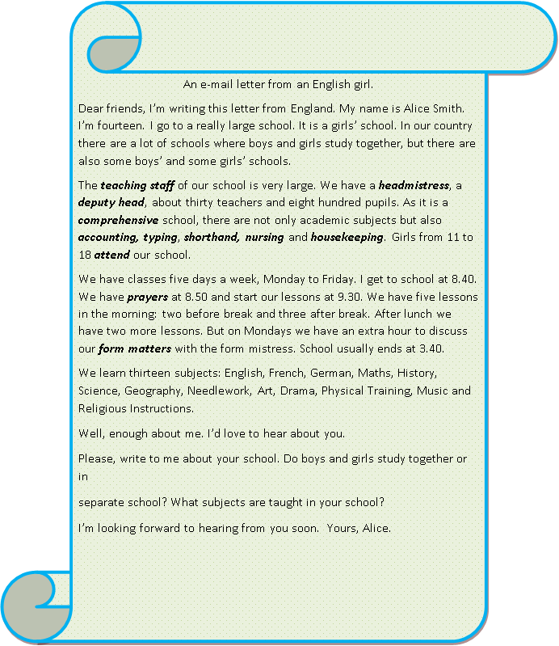  - What is the name of the school Alice goes to?  - Is it a girls' or a mixed school?  - How many teachers and pupils are there in Alice's school?  - What subjects are taught in Alice's school?  - What time does Alice start school?  - How many lessons does she have in the morning and afternoon?  - Does Alice have any extra classes on Mondays?  - What does Alice want to know about the recipient's school?  - Do boys and girls study together or separately in the recipient's school?  - What subjects are taught in the recipient's school?  Answers  - The name of Alice's school is not mentioned in the letter.  - It is a girls' school.  - There are about thirty teachers and eight hundred pupils in Alice's school.  - Thirteen subjects are taught in Alice's school: English, French, German, Maths, History, Science, Geography, Needlework, Art, Drama, Physical Training, Music, and Religious Instructions.  - Alice gets to school at 8.40.  - Alice has two lessons before break and three lessons after break in the morning, and two lessons in the afternoon.  - Yes, on Mondays Alice has an extra hour to discuss her form matters with the form mistress.  - Alice wants to know if boys and girls study together or in separate schools, and what subjects are taught in the recipient's school.  - The information about the recipient's school is not given, so we don't know if boys and girls study together or separately.  - The information about the recipient's school is not given, so we don't know what subjects are taught in their school.
4. Summing up.  5 min | Summarize the key points of the lesson.  Answer the question. | What have you done today?  How can you use your knowledge?  What is the difference between Ukrainian and British schools?  Homework.  Write a short composition “What does school education mean to you?”

