Charm Date Reviews
Charm Date is an international dating site that provides online services to single people. On the forums, you will find Charmdate reviews that will help you figure it out. Charm Date is reasonably the best choice for dating Slavic girls. We are often surrounded by scammers with fake profiles. With the Charm Date, everything is different. This service is not a scam. The team is responsible for the security of each user and nevertheless has gained a good reputation. Here you will meet like-minded people who want either sex or serious relationships. The interface is quite modern, and the crediting system is clearly described.

Charm Date international platform belongs to the Qpid organization which manages certain dating services at the same time. They are intended for singles striving to find permanent partners from numerous countries. Many couples have formed a relationship thanks to Charm Date. Any single will be lucky after starting to try online dating services. Charm Date users are offered to apply the mobile version of the following application. The app available for both Android and iOS.

First Impression
This dating platform is has a fairly stylish layout and user-friendly functionality. Each new user pays attention to exactly these necessary things. Charm Date helps bring the matter to a real date. By doing the right thing on your first date, you have an amazing experience with a woman. But if you decide to arrange an online date, this is very unusual. There is a high probability that you will see a charming lady again.
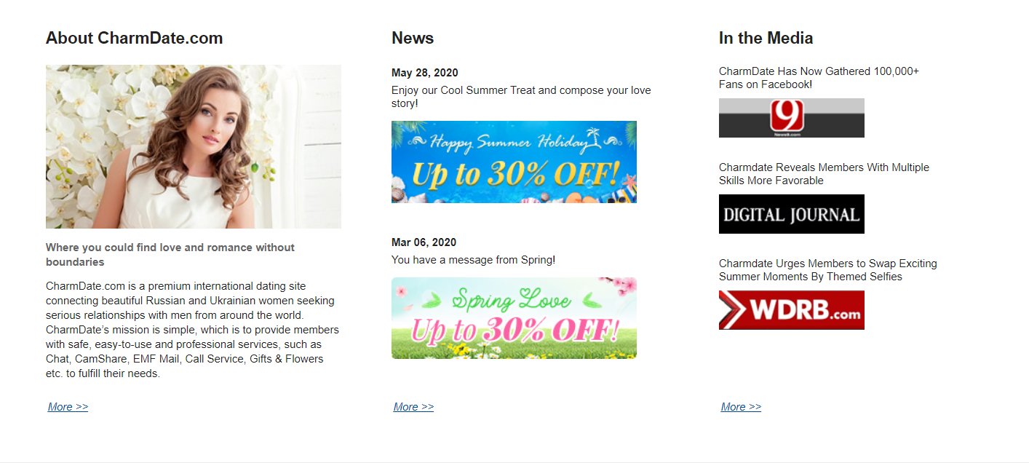

Pros
- The presence of profiles of charming girls;
- Quick verification of users;
- Excellent interface;
- No scam;
- Convenient chat;
- Quick response from customer support;
- High data protection.

Cons
- Limited number of partners (only Slavic type of girls);
- Paid communication services;
- Payment must be made immediately.

Membership Types

A large selection of users with age categories from 18 to 34 years;

• Thousands of new members are registered daily;

• Charm Date users are welcoming and helpful.

• Desktop usage;

• Charm Date is beneficial to females in general;

• Thousands of profiles to have a chat with.

The main intention of Charm Date website is to enable males-foreigners to meet a worthy Slavic girl. Please note that all women are participants of this origin.

Charm Date site is identified as a marriage site. There are participants who aspire to create strong and healthy. Most site users are from European countries, Canada, the USA, etc.

Price
Such a particular site has a credit system. Charm Date allows free credits and a paid subscription. Usually, an account which is not paid checked by support team agents. The process of confirmation demands approximately 48 hours. Any user can browse the profiles of others, study the app and chat without extra cost. Additional features require to obtain credits. It is recommended to try a Premium account on a particular dating community. You will find the very opportunity to interact with no limitations. Paid chat is an integral tool for the communication of any dating service. Getting credits encourages a newbie to choose Premium account.

Registration Process

What do you get in return?
- Quick registration without difficulties;
- An account confirmation email;
- With the Process, you will be asked to provide necessary information;
- Accomplish the registration with some questions regarding the preferences of a partner.
Login process usually takes a few minutes. Provide the personal data that you must share when creating the profile:
- Valid email address;
- Date of birth;
- Full name;
- Location.
After successfully verifying personal data, you will need to take a test in which you share your ideal partner. You must fill out the profile as completely as possible to interest someone special. Describe the appropriate age, activities, worldview, and other things, such as children or bad habits. Such valuable information will sort out the matches submitted by the site itself.

The App
- Free download;
- Download through Google Play and the App Store;
- User-friendly interface;
- Well-designed functionality;
- Thousands of downloads daily;
- Switch to any dating site owned by Qpid Network.

Qpid Networks is a dedicated worldwide dating app. It is attached to Charm Date. The interface of the application is similar to the website. After logging in, you will find a list of suggested candidates. If you are searching for more information detailed, then click on the pics to view the profile.

Please note that the Application requires payment for the functions to use. If you plan to try a video chat, it is convenient thanks to the mobile version.

A user gets the barcode to configure the application on the device. This feature is restricted to specific regions.

Website Safety
Charm Dates does not allow fake profiles. The community team verifies each user, regardless of whether it’s male or female. This is an essential method of connecting a community of true individuals. The service provides a filter for fraudulent accounts. Verification is an appropriate method to ensure users with only authentic characters.
Note: do not send money to suspicious females and do not transfer your credit card details. Immediately report any suspicious activity to the support center.

Additional Features

A review of Charm Date has revealed many useful features. It is designed for a long-term chat with many Slavic girls.

Mail from Fans

This is the message you can get from your secret fans. Such a message is free to read, but you’re buying credits to give the answer to a fan.

Call function

To make a call is a feature which is paid. The function provides you to make a call personally who you are talking to.

Camshare

This function is accessible to members with activated service applying for credits. You can use a camera while communicating.

Real-time chat

Try a chat with a participant in real time. Be ready to pay for this feature. It takes about 0.5 credits to have five minutes of communication. Additionally, it is offered to share photos and videos via chatting.

Customer Support
If you have any questions regarding the use or questions of a technical character, the support service is always in touch. On the page, you will find frequently asked questions. If you are interested in a Customer protection policy, you will find information at the bottom of each page.

FAQs

Who owns CharmDate?

The site is managed by the cooperation called Qpid Network. This organisation manages large-scale dating sites particularly the online platform Charm Date. This dating platform has directed millions of lonely hearts to the right way.

Can I use service anonymously?

It is recognized as an exceptional site without anonymous mode. Consider that correspondence remains your personal thing.

How can I sure profiles are real?

Member safety is the advantage of a certain platform. Strict standards are applied to stop fraud. All the accounts are rigorously selected. This suggests that they should present a copy of their identity certificate with a real photo.

How many members does CharmDate have?

The activity of online participants is growing every day. The site already has 400,000 weekly members 560,000 of which come are from the United States.

Is it safe?
Charm Date uses advanced technology to ensure data security. Take note that the processing of data is secured by GoDaddy and McAfee.

