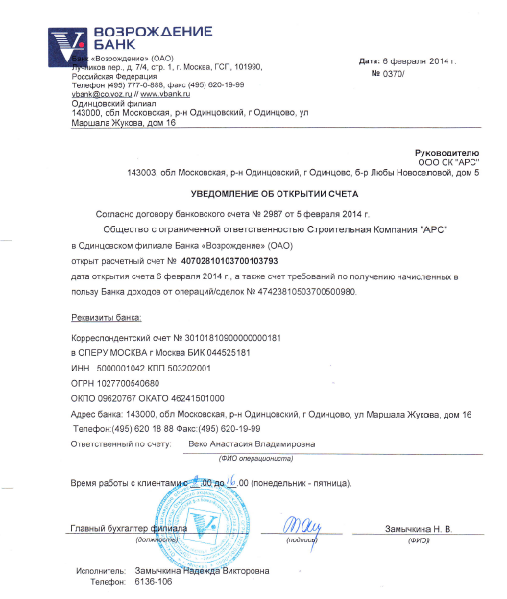
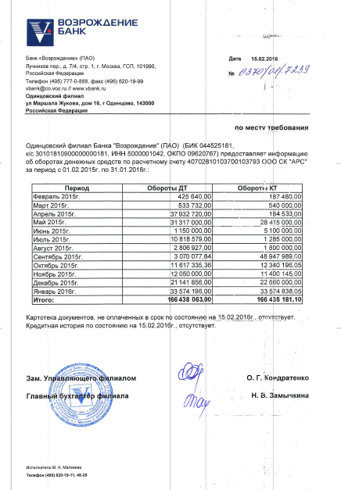
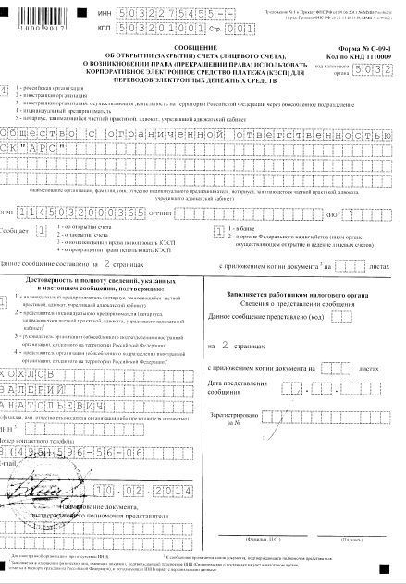

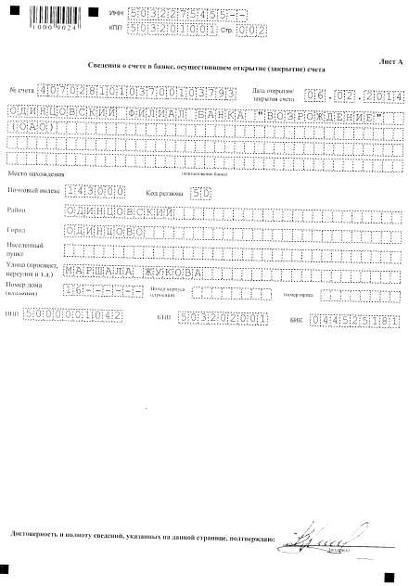

Bank «VOZROZHDENIE» (open joint-stock company) Date: 6 Feb. 2014
№ 0370/
7/4 Luchnikov Per., Building 1, Moscow, 101990, the Russian Federation
Tel.: (495)777-0-888, fax: (495) 620-19-99
vbank@co.voz.ru // www.vbank.ru
Odyntsovo branch
16 Marshala Zhukova Str., Odyntsovo, 143000, Russia

To the manager
Construction Company «АRS» LLC
House 5, Odyntsovo, Odyntsovo destrict, Moscow reg., 143000, Russia Lyubu Novoselovoy

NOTIFICATION OF OPENING OF THE ACCOUNT
According to the contract of the bank account № 2987 from 5 Feb. 2014
Construction Company «АRS» LLC
in Odyntsovo branch of the Bank «VOZROZHDENIE» (open joint-stock company)
opened settlement account № 40702810103700103793
date of opening of the account is 6 February 2014, and also requirement account of receiving favor of the bank income from operations/deals № 47423810503700500980.

Bank Essential Elements

Correspondent account № 30101810900000000181
To the OPERA MoscowBIK
INN5000001042 KPP 503202001
ОGRN1027700540680
ОКPО 09620767 ОКАТО 46241501000
Bank address: 16 Marshala Zhukova Str., Odyntsovo, 143000, Russia
Tel.: (495) 620 18 88 fax.: (495) 620 19 99
Responsible for account: Veko Anastasia Vladimirovna
(Teller Full Name)

Time work with clients from 9 to 16 (M-F)

Chief accountant of the branch: Zamuchkina N.V.
(Position) (Signature) (Full Name)

Exacutor: Zamuchkina Nadezhda Viktorovna
Tel.: 6136-106

Bank «VOZROZHDENIE» (open joint-stock company) Date: 15.02.2016
7/4 Luchnikov Per., Building 1, Moscow, 101990, the Russian Federation
Tel.: (495)777-0-888, fax: (495) 620-19-99 № 0370/01/7239
vbank@co.voz.ru // www.vbank.ru
Odyntsovo branch
16 Marshala Zhukova Str., Odyntsovo, 143000, Russia

to whom it may concern

Odyntsovo branch of the Bank «VOZROZHDENIE» (PAO) (BIК 044525181)
К/c 30101810900000000181, INN 5000001042, ОКPО 09620767 provides information about turn money of settlement account 40702810103700103793 OOO SК АRS for a period from 01.02.2015 to 31.01.2016

Periods | Turn DT | Turn КТ
February, 2015 | 425 640.00 | 187 480.00
March, 2015 | 533 732.00 | 540 000.00
April, 2015 | 37 932 720.00 | 184 533.00
May, 2015 | 31 317 000.00 | 28 415 000.00
June, 2015 | 1 150 000.00 | 5 100 000,00
July, 2015 | 10 818 579.00 | 1 285 000,00
August, 2015 | 2 806 927.00 | 1 800 000,00
September, 2015 | 3 070 077.64 | 48 947 989,00
October, 2015 | 11 617 335.36 | 12 340 196,05
November, 2015 | 12 050 000.00 | 11 400 145,00
December, 2015 | 21 141 856.00 | 22 660 000,00
January, 2016 | 33 574 196.00 | 33 574 838,05
In total | 166 438 063.00 | 166 435 181,10

Card file, not paid at maturity as of 15.02.2016 is absent. Credit history as of 15.02.2016 is absent.

Alt. branch Governor O. G. Kondratenko

Chief accountant of the branch: N.V. Zamuchkina.
Executor M.A.Matvejeva
Tel.: (495) 620 19 11,48-25
INN 5032275455— Annex №1 to the Order FNS RF of 09.06.2011 № MMV-7—6/362@
( in Oder edition FNS RF of 21.11.2011 № MMV-7-6/790@)
KPP 503201001 p.001
Report
Of the opening (closing) account (personal account) of rise of the right (lapse of the right) to use corporate standard of deferred payments (CSDP) for transfer of e-cash

Form № С-09-1
KND Сode 1110009

rating authority code 5032
- Russian organization
- Foreign organization
- Foreign organization realized activity on the territory of the Russian Federation over detached subdivision
- Private notary, lawyer, established private office

Construction Company «АRS» LLC
Name Organization, Full Name of private businessman, private notary, lawyer, established private office
ОGRI 1145032000365 ОGRNIP КIO

Informs 1
- About opening account
- About Closing account
- About rise of the right to use CSDP
- About lapse of the right to use CSDP

1
- In the bank
- In the Federal Treasury body (other body performing opening and management of personal accounts)

this message is composed on 2 pages with a copy of the document on the sheets

Confirm authenticity and completeness of information referred to in this message
- Businessman (a Private notary, a lawyer, established private office)
- Businessman representative (of a private notary, and a lawyer, established private office)
- Manager of the organization (of a separate subdivision of the foreign organization, created on the territory of the Russian Federation)
- Representative of the organization (of a separate subdivision of the foreign organization, created on the territory of the Russian Federation)
KHOKHLOV VALERIY ANATOLIEVICH
Manager’s or representative’s Full name
INN
Tel.: 8 495 596 5606
e-mail:
The name of the document confirming the representative’s powers

for a foreign organization without INN the community accompanied by a copy
confirming the representative's powers

filled by only natural person, who has a document confirming the assignment of TIN (Certificate of tax registration, a mark in a Russian citizen passport) and using INN together with the personal information

Filled by a tax authority employee
information about submitting posts
this message is presented (code)
on 2 pages
with a copy of the document on the sheets
date of submission
registered for the number

Full Name Signature

INN 5032375455 --
KPP 503201001 p.002

Information of the bank account, carried out opening (closing) an account
Account number 40702810103700103793 Date of opening/closing of an account 06.02.2014

Odyntsovo branch of the Bank «VOZROZHDENIE»
(open joint-stock company )

Location Name of the bank
Postcode 143000 region code 50
Region Odyntsovo destrict
City Odyntsovo
Settlement
Street (avenue, per., etc.) MARSHALA ZHUKOVA
house number (acre) 16 ------ Body number (structure) Office number

INN 5000001042 KNN 503202001 BIK 044525181

The authenticity and completeness of the information indicated on this page confirm signature

