ЗАДАНИЕ НИЖЕ

Задача:
Написать описание (description) для указанных объектов недвижимости

Минимальное количество знаков: 1000 бп
Уникальность текста: >90%
Ключи: В текст должно быть название объектов, слова “купить”, “недвижимость”, “дом”, “взять в аренду” (если это дом, или “квартира” или “строение”, “апартаменты” и тд.) и названия локаций где они размещены.

Лучше писать сначала название района в ключе, потом само комюнити и обьект. Например: Взять в аренду квартиру в бруклине, обьект такой то…

Пример:
https://inew-homes.com/mill-creek-farms-complex

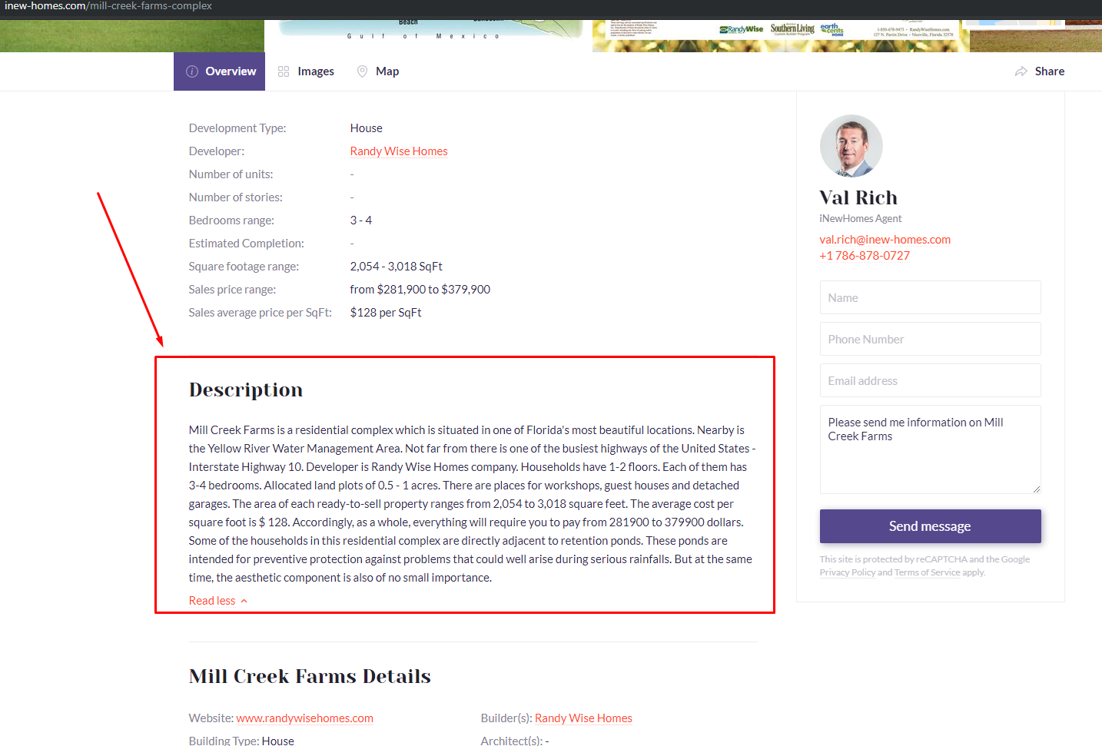

В описании необходимо ориентироваться на указанный пример:

Mill Creek Farms is a residential complex which is situated in one of Florida's most beautiful locations. Nearby is the Yellow River Water Management Area. Not far from there is one of the busiest highways of the United States - Interstate Highway 10. Developer is Randy Wise Homes company. Households have 1-2 floors. Each of them has 3-4 bedrooms. Allocated land plots of 0.5 - 1 acres. There are places for workshops, guest houses and detached garages. The area of each ready-to-sell property ranges from 2,054 to 3,018 square feet. The average cost per square foot is $ 128. Accordingly, as a whole, everything will require you to pay from 281900 to 379900 dollars. Some of the households in this residential complex are directly adjacent to retention ponds. These ponds are intended for preventive protection against problems that could well arise during serious rainfalls. But at the same time, the aesthetic component is also of no small importance.

Объекты для описания:

https://inew-homes.com/221-east-117th-street-complex
Looking to lease a residence with a vibrant character in a quiet and cozy neighborhood? Take a closer look at this fantastic property.
221 east 117th street complex is located in East Harlem, Manhattan, New York. Only a 15-minute walk from 116th Street subway station (serviced by the 6th train) makes it convenient in terms of public transport.
The area is hard to compare to any other in NYC.
This is a place where Puerto Rican culture meets the busy vibes of New York.
The number of iconic Italian, Latin American, and Caribbean restaurants around will make any spoiled foodie forget about cooking at home for long and for good.
Back to the place, the complex is designed by Robert Bianchini from ARC Architecture + Design studio, the 12,540 square feet building planned to be 6 stories high (70 feet) with 9,962 square feet of designated residential space. Each apartment has 830 square feet to create a home tailored to fit your most ambitious requirements. And that’s not all, this masonry building includes a cellar, mezzanine, and 34-foot-long back yard.
Don’t miss this unique opportunity to lease 1 of our 12 residences. Only at inew-homes you will get a special price that will leave our competitors far behind.

20$ - 1 ad
5 ads per week.
Email: irireznichenko05@gmail.com

