Genshin Impact

Product and Its Potential Audience
Genshin Impact is an open-world action RPG where the core mechanics are exploring the world, solving puzzles and quests, acquiring new heroes, and building teams with them. From a narrative perspective, the key element is advancing through the main storyline and character-specific quests.
The target audience is primarily gamers, anime and Asian culture enthusiasts, specifically fans of open-world exploration and the RPG genre. The majority of players are casual fans of the fantasy world's atmosphere, who seek to escape from the real world and immerse themselves in exploration and follow the stories and interactions of their favourite characters.
The target age group is between 14 and 30 years old. This demographic is dominant in the gacha game and anime spheres and is highly proactive in creating fan content.

Marketing analyse

TikTok video
https://www.tiktok.com/@genshinimpact_en/video/7549093889328581894
I really liked the comedic presentation of the enemies from the new region. The target audience (i.e., young people) really appreciates this kind of humor and content.
The elements of folk dance and traditional clothing characteristic of Slavic regions were also well-highlighted.
However, this creativity might confuse people unfamiliar with the game because it focuses so much on a non-playable character. A potential player could mistake him for a playable hero and join the game just for him.

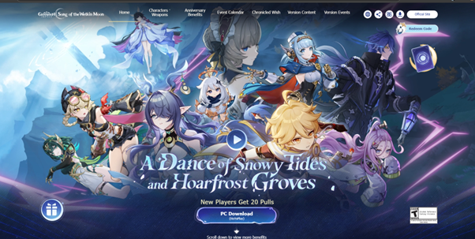
Official landing page main banner
In my opinion, the landing page is concise and well-structured, with a clear and logical scrolling principle.
The main banner looks vibrant and showcases all the new heroes and the new region, effectively highlighting the primary monetization method: the acquisition of new characters.
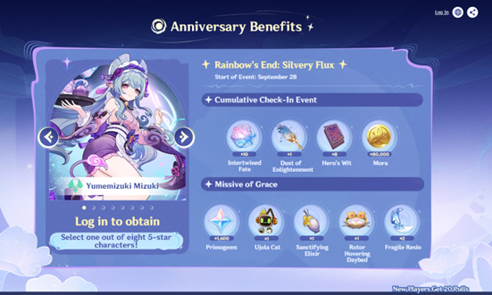
Page with rewards
The way the rewards are presented is also excellent. Offering in-game currency and a free character choice is very enticing for players in the gacha market, as it's seen as a generous gesture from the developers.
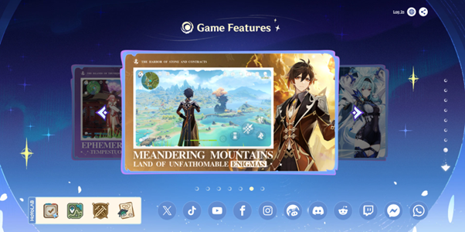
Page with in-game screenshots
However, I would point out some drawbacks. For players new to this type of project, the core aspects of world exploration and interaction are not clearly demonstrated. This is only shown in a few screenshots at the very end, and most visitors won't scroll that far down the page.
Additionally, the images themselves are not very effective. They mostly show landscapes and fail to highlight key gameplay interactions or major locations.

Marketing communication overview
In my opinion, the communication style of the community managers is skilled and concise. It's not as intrusive or loud as in the other project, "Zenless Zone Zero," and less focused on memes than "Honkai: Star Rail." Instead, it is well-balanced and aimed at retaining a stable player base. They are very successful at highlighting the characters by publishing a wide variety of content, including high-quality fan works.
However, I feel that at times there's a lack of deeper interaction with the audience. Small-scale interactive content is mostly found only on their own network, HoYoLAB. While it's very difficult to implement this across all social media platforms, especially for such a large and diverse community, the company's budget and staff are also not small.

The CTA is a traditional call to download the game, but it's also more directly aimed at acquiring new characters from the gacha.
The funnel looks like this:
- Awareness: Ads (banners on social media, video ads in apps) show the main gameplay of world exploration, how heroes are used within it, and how they are acquired through the gacha mechanic.
- Interest: The player is redirected to a page on Google Play, the App Store, or the official website to get them more interested in the game and its heroes.
- Conversion: The player wants to get a hero and explore the world, so they download the game.
- Retention: The game hooks players with free characters at the start and generously gives away in-game currency. A well-designed structure of locations and quests encourages players to return to the project for exploration. The regular release of events with time-limited rewards also helps, as users don't want to lose out on the benefits and, once attached, want to stay in the community.
- Monetization: The constant rotation of powerful characters and dding new mechanics in the world and in enemies to suit them forces players to pull for new heroes. This pushes interested players to buy in-game currency, a subscription, or a battle pass to get additional currency or weapons.
I would add more personalized communication on social media pages, similar to Honkai: Star Rail, especially for an audience unfamiliar with the gacha sphere. Currently, it looks a bit dry and overly official. A friendlier approach would encourage both new and existing players to interact more actively and create content.

A/B Test Hypothesis
If we update the main website's design to reflect the new region of Nod-Krai and replace the "Download Now" button text with the game's traditional "Start Your Journey", the number of downloads will increase.
This is because the new content's design is more visually appealing and is being actively discussed within the community, while the "Start Your Journey" call-to-action is both a traditional and symbolic phrase for the game.

