Introduction
The Kazakh lands always attracted wanderers. Amazing nature, unique culture and rich history encouraged people from all over the world to find out more about this region. Traders, missionaries, diplomats – each of them delivered various information about Kazakhstan to other countries. Despite the abundance of information, the knowledge about Kazakhstan relied heavily on the subjective experience of explorers and could not reflect the reality to the full extent.
The situation changed significantly in the 18th-19th centuries due to the complex and controversial process of Kazakhstan's integration into Russia, which lasted for 150 years: a radical turn in the centuries-old development of the nomadic people occurred and the foundations of its commonwealth with the Russian and other nations were laid. Distant from each other, both territorially and by typological characteristics of cultures, European countries and Kazakhstan promoted mutual knowledge through various forms of Russia mediation. Undoubtedly, the fact of developing new territories could not but attract the attention of European scientists, which increased the flow of researchers to Kazakhstan.
This was the reason for the intensive study of the country's lands by explorers: scientists, merchants, military officials, ambassadors. Studies were conducted by individuals, as well as by entire institutions. The study of the Kazakh lands positively affected both Kazakhstan and the countries that sent their scientists. This was expressed in new discoveries, as well as in the emergence of new names in the world scientific community.
In this article, the authors set out to consider the activities of European scientists in Kazakhstan, who made a significant contribution to the development of various fields of science. Unfortunately, the study highlights the activity of only a small part of the scientists, since the consideration of all expeditions within the limits of one research article does not seem possible.
Particular attention is paid to the activities of Gerhard Friedrich Miller, Johann Georg Gmelin, Johann Eberhart Fischer, Peter Simon Pallas, Johann Sievers, Alexander von Humboldt, Adolf Januszkiewicz, Charles-Eugene de Uifalvi and his wife Maria Bourdon in the Kazakh lands.
It should also be noted that the authors paid special attention to the time period from the 18th to the 19th centuries, since it is marked by the maximum number of scientific expeditions and discoveries in the Kazakh lands.

Literature review
In the Soviet times, M.K. Bizhanov (Bizhanov, 1967) and I.V. Erofeeva (Erofeeva, 1967) covered this topic in dissertations. However, these works cannot be called multifaceted, because they largely considered the differences between the perception of the Kazakh steppe by Russian researchers and the reality.
The historical part of development of the Kazakh territory was covered in the works of such scientists as E.S. Syzdykova (Syzdykova, 2000), M.K. Mukatayeva (Mukatayeva, 2002), V.S. Tolochko (Tolochko, 1977) and V.N. Alekseenko (Alekseenko, 1986). The issues of economic relations between the Russian Empire and Kazakhstan were examined by M.K. Rozhkova (Rozhkova, 1950: 174-176).
More recent studies include the works by E.P. Ivanov (Ivanov, 2015: 37-40), K.V. Dmitrienko (Dmitrienko, 2010: 42-45), A. Alzhanova (2011), L.Ya. Borkin, B.K. Gannibal and A.V. Golubev (2014).
Among foreign authors, who indirectly covered the topic of studying the Kazakh territory, George N. Curzon (Curzon, 1889), Richard A. Pierce (Pierce, 1960: 17-18) and Jürgen Osterhammel (2015) should be noted.
In general, today works devoted to this subject are in deficit. Most of them cover the matter superficially and in general terms. In addition, many sources are outdated.
The listed circumstances indicate that this issue needs to be studied and analyzed in detail, since knowledge about the region’s exploration is an important historical and cultural stage in the development of Kazakhstan's statehood.

Methods
The methodological basis of the study was formed by theoretical methods, namely abstraction in historical cognition, comparative-historical method, cause-and-effect analysis of connections between historical events and historical-system analysis. In addition, the authors tried to adhere maximally to the principles of objectivity, historicism, systemic and value approach.

Results and discussion
Kazakhstan has a long history of geographical knowledge. The first, though poor, information about the natural conditions of the western and southern parts of Kazakhstan is contained in sources dating back to ancient times – in Persian inscriptions, in the writings of Greek and Roman scholars and writers, Chinese and Arab explorers (Beisenova, 1984).
The growth of interest in and active study of Kazakhstan begins at the end of the 17th century – the beginning of the 18th century. This process was slow and uneven.
Most of the research fell on the share of the eastern outskirts, namely Oskemen and Zaysan uyezds, including the heights of the Southern Altai and the Tarbagatai mountains, which had long been of interest to explorers.
The most significant and noteworthy foreign travelers who explored the region were Gerhard Friedrich Miller, Johann Georg Gmelin, Johann Eberhart Fischer, Peter Simon Pallas, Johann Sievers (Lebedev, 1986), Alexander von Humboldt, Charles Eugene de Uifalvi and his wife Maria Bourdon and Adolf Januszkiewicz.
In addition to them, around the same time period these lands were also studied by other Europeans: Johann Schiltberger, Sigismund Herberstein, Daniel Gottlieb Messerschmidt, Johann Gottlieb Georgi, E.K. Meyendorf, A. Shrenk, K.F. Ledebour, A. Bunge, Carl Anton Mayer, Richard Karutz, V.G. Tiesenhausen, G. Zelinsky, B. Zalessky, K. Baer, ​​A. Bunge, F. Gebler, G. Helmersen, G. Rose and others.
All of them were distinguished by a great sense of purpose, loyalty to the service of science, a wide range of interests and an enormous capacity for work. Each of them considered various scientific aspects – geographical, botanical, cultural, historical, social, but their works as a whole helped to form a holistic picture of life in the Kazakh steppe. It is worth saying that such trips demanded courage and bravery from the researchers, as the times were troublesome, often dangerous: robbers could be met on the way, incidents of misunderstanding by local authorities occurred, and dissatisfaction of indigenous people was not uncommon. No less dangerous were diseases – even an elementary cold could ruin the life of a researcher of that time. Weather conditions in the form of snowstorms, storms, heat, fires and floods did not indulge explorers.
One of the first large-scale attempts to study the Kazakh territory in all its diversity can be considered the first academic expedition of 1733-1746, in which Gerhard Friedrich Miller and Johann Georg Gmelin (Nagler, Kariyev) took part. Later, as a third party, Johann Eberhart Fischer joined them. Their route passed through such cities as Tobolsk, Semipalatinsk, Oskemen, Barnaul and Kuznetsk. As a result of the expedition, they collected chronicles, archival documents, art objects, archaeological and ethnographic materials. Unfortunately, the materials collected by Miller were only partially published. Nevertheless, Johann Eberhart Fischer, who was commissioned to study the settlements and structures on the Irtysh River, published in 1786 the work Sibirische Geschichte von der Entdekkung Sibiriens bis auf die Eroberung dieses Lands durch die Russische Waffen. This work contained information about the Kazakh horde and an attempt to find out the origin of the word "Kazakh".
As for Johann Georg Gmelin, his route in 1740 was brought from Northern Kazakhstan to the upper reaches of Yaik (Ural River). During this period, he managed to create a number of sketches of various archaeological sites, remains of ancient structures, rock carvings and inscriptions. Data on these archeological finds were reflected in the work Reise durch Sibirien von dem Jahr 1733-1743, which was published in 1751-1752.
The year 1767 was one of the most fruitful in terms of studying Kazakhstan. By order of Catherine II, the Imperial Petersburg Academy of Sciences began training five expeditionary groups. The key task was to describe the geography of the region, its economy, history, customs and languages. They were headed by prominent scientists of that time: the German scientist-encyclopedist Peter Simon Pallas, the German explorer and natural scientist Samuel Gmelin, the Baltic German explorer and naturalist Johann Güldenstädt, the Swedish explorer and naturalist Johann Falk and the Russian scientist Ivan Lepyokhin (Borkin, Gannibal and Golubev, 2014). Conventionally, the group could be divided into 2 divisions: three of scientists belonged to the Orenburg expedition (Pallas, Falk, Lepyokhin), and the other two – to the Astrakhan (Gmelin, Güldenstädt). Consider in more detail the routes of some of them (Ibid).
As already mentioned, one of the expedition teams was headed by Peter Simon Pallas. He left St. Petersburg on a par with other expeditions in the summer of 1768. Having passed the winter in Simbirsk, in the spring of 1769 he continued his journey through Samara, Buzuluk, Orenburg, Uralsk and Ilek. The period from July 27 to August 10 was devoted to the study of Uralsk, its population, household, administrative management, fisheries, livestock, arable farming, melon-growing, diseases, etc. ("Dala ulayatynyn gazeti", 1989: 42-44). On August 11, he left Uralsk and traveled along the postal route down the Ural River. On August 15-16, he traveled from Kalmyk city to the Kamysh-Samara Lakes. On August 20, he traveled from the Gorsky village to Lake Inder and studied the surrounding mountains. On August 24, he came to Guryev and explored the local nature and population for several days. On August 31, he left Guryev and on September 6, returned to Uralsk by the same route, along the right bank of the Ural River. From 6 to 20 September, he studied the environs of Uralsk (the Krutaya River, the Tatar cemetery) and traveled in the steppe to the Inche and Derkulskaya chalky mountains ("Dala ulayatynyn gazeti", 1989: 42-44).
In 1771, Peter Simon Pallas visited the Semipalatinsk province. Despite the fact that he was a zoologist, his work Journey in Various Provinces of the Russian Empire (SPB. 1773-1778, vol. II, p. II from 117-258) has retained its value and is read with great interest.
The Pallas’s route ran from Omsk along the right bank of the Irtysh River to Semipalatinsk. On May 22, Pallas left Omsk for the village Peschanaya through the Tatar and Urlutiunsky stations, the Zhelezinskaya fortress, and the Patorizhskaya and Osmorizhskaya stations, the Karasuk Lakes and Kashyr. In describing this path, the author gave many plants for characterizing these places: "Since the ground was sandy, there were many Pontus and brown sea wormwoods, loved by saigas" (Rozhenets-Kucherovskaya, 1927: 7; Report on the composition, 1905: 20-21). Near the village of Peschanaya and the Karasuk stream, the author described the vegetation of solonchaks. Some of them were described by Pallas for the first time ever. From the village of Peschanaya (June 2) Pallas went through the Chernoretsky outpost to Korkovsky. After the Koryakovskiy outpost the route passed through the Podstepnaya village, the Yamishevskaya fortress, the Chernoozernaya village, the Lyubyazhy outpost, the Podpusknaya station, the Krivoozernaya station, the Semiyarsky, Grachevsky and Cherlakovsky outposts, the Cheremisov village, the Dolonsky outpost, the Belokamenskaya and Glukhovsky stations to the Semipalatinsk fortress (June 21) (Rozhenets-Kucherovskaya, 1927: 7; Report on the composition, 1905: 20-21).
Pallas described 220 new plant species, 62 of them were from the Astrakhan province, but he was particularly interested in saltwort. Comparing its distribution in the Caspian Sea with the points of finds of seashells and the ancient relief, the scientist made an absolutely fair conclusion that the Caspian, Aral and Black Seas were once a single sea basin (Zhuravlev, 2013).
For the further way Pallas intended to be sent to Oskemen, however, due to his illness, the route was not carried out. To explore the steppes adjacent to the Irtysh from Semipalatinsk to Oskemen, a student Nikita Sokolov was sent, whose journey Pallas mentioned in his work (Rozhenets-Kucherovskaya, 1927: 7; Report on the composition, 1905: 20-21;Tsybulsky, 1988).
Pallas did not confine himself to the description of his expeditions; he compiled and published a long series of separate articles containing descriptions of various groups of plants, animals, etc. Pallas’s principal publication Flora Rossica has a significant value. Unfortunately, it was not finished.
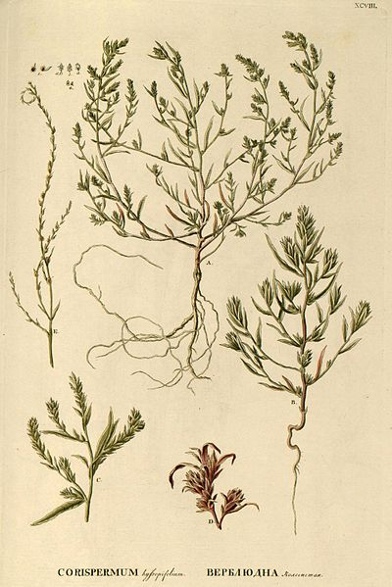
Figure 1. Illustration from Flora Rossicа (1788) with the image of corispermum (Latin: Corispermum hyssopifolium L.), from: Pallas, P.S., Flora rossica, vol. 1(2): p. 112, t. 98 (K.F. Knappe)

The comprehensive perfectly illustrated work of Pallas on zoology is also of particular importance (Zoographia rosso-asiatica) (Asian Russia, 1914: 622-623).
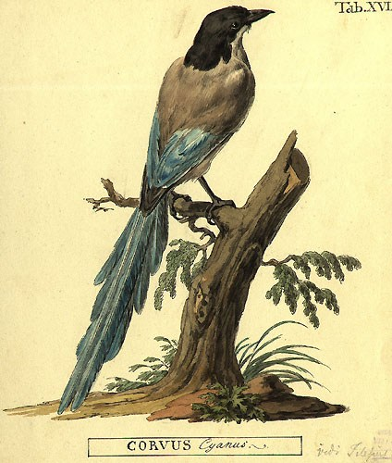
Figure 2. Illustration from Zoographia Rosso-Asiatica (1811) with the image of an azure-winged magpie (Latin: Cyanopica cyanus). Illustrated by K. G. G. Geisler.

The expedition headed by P.S. Pallas had a serious practical significance, as it gave information about the unique wealth of Eastern Siberia and the Altai, which had not been known before.
In 1792 and 1793 another German explorer Johann Sievers traveled to the Semipalatinsk region. He was seconded to an expedition to Siberia equipped by the Medical Directorate specifically to study the local type of rhubarb and organize the experiments of its culture. In addition to rhubarb, J. Sievers collected many other plants. The results of his expedition were collected into the letters – Briefe aus Sibirien (1796). These letters contained almost the entire Sievers’s diary with about 190 species of plants. Pallas also cited these plants in the XI volume of Nene Nordische Reitrage, which in return was quoted by Carl Friedrich von Ledebour in his masterwork Flora Rossica (Rozhenets-Kucherovskaya, 1927: 7; Tsybulsky, 1988).
At the end of July in 1792, J. Sievers was in Oskemen, where in early August he made an excursion to the mountains up the Irtysh River and along the Bukhtarma River to Bykov. Then he went to Semipalatinsk, where on August 14 he arrived to Barnaul of the Tomsk province.
In 1893 his route ran as follows: from Oskemen down the Ulun-Bulak River, upstream along monastic hills (Mount Ayr-tau), through the rivers Kyzyl-su, Char Churban and its tributary – Daubu (or Daubai), through the Kalbinsky Range and the Kurmenty River (the tributary of the Kokpekty River), then to the Kokpekty River itself. Crossing the other tributary of the Kokpekty River – the Karasu River, he headed past the Kush-Murun Mountains to the southern slope of the mountains from which the Kokpekty River originates. Then, through the tributary of the Ayaguz River (the Balta-kar River) to the upper reaches of the Bugala River and passing by the cliffs of Kyzyl-Tash and the mountain Bor-Oketi, he reached the Chingizka River (the tributary of the Ayaguz River), and the Ayaguz River. Further, Sievers undertook the ascent to Tarbagatai, crossed to its southern slope into the valley of Urjar and to the southernmost point – the Igen-bulak River. From here, he returned almost the same way along the Bugas River and followed the former point of Jus-Agach (on the Kokpekty River), to the Bukon River, downstream of the Irtysh River, through which he crossed the estuaries of the Bukon and Kurchum rivers. The further way of Sievers was to the east to the mountains, to Lake Ballack Chilek, where he first traveled to a salt lake lying between Mount Arkaul and Dolan Kara, and then went to the east to the mountains of Sary-tau. On August 1, 1792, he ascended to the peaks of these mountains, from where he returned to the Irtysh River and to Oskemen (Rozhenets-Kucherovskaya, 1927: 7; Tsybulsky, 1988).
The journey of J. Sievers is interesting from the point of view of the first information reported by him about the terrain, which was completely unknown in botanical terms until that time. In addition to indications of the advent of plants and their practical significance, the explorer gave brief information about the growth of forests and described the treelessness of the Tarbagatai mountain range. Several plants collected by Johann Sievers were described by P.S. Pallas in his work Plantae Novae ex Herbario et Schedis Defuncti Botanici Johannis Sievers Descriptae. In total, 10 species were described. They were all depicted in six large tables. The locations and some local folk names of the plants were also listed (Rozhenets-Kucherovskaya, 1927: 7; "Dala ulayatynyn gazeti", 1989: 42-44).
The research of Alexander von Humboldt is also noteworthy. He traveled to the Urals, Altai and the Caspian Sea, visited the cities of Omsk, Semipalatinsk, Oskemen, Orenburg and Astrakhan in 1829 (Shamshiyabanu, 2012). His visit to the province took place at the invitation of the czar; consequently, the scientist was granted a large-scale escort within Orenburg and Orsk for security purposes (Osterhammel, 2015: 365). The duration of the trip was about 6 months, which turned out to be very productive. Von Humboldt compiled a scientific description of soils, ores, climatic features of the Kazakh steppes and mountains.
Von Humboldt himself did not publish a separate work on the journey to the Urals, Altai and Kazakhstan, but he contributed a number of materials collected in the expedition in his latter comprehensive works Asie Centrale (Paris, 1843), Kosmos (Stuttgart, 1845- 1862) and Ansichten der Natur ("Pictures of Nature") (1849, 1860). All these works have been translated into many languages ​​of the world (Tsybulsky, 1988).
In Asie Centrale Humboldt came to the conclusion that in Asia, especially in the South and in the West, one can observe significant changes in the continent. Under this name, he understood the whole space, which, starting from the western shores of the Black Sea, extends through southern Russia and includes the regions of the Caspian and Aral Seas. He also noted the importance of the process of creating the mountain systems of the Caucasus, the Himalayas, the Hindu Kush, and the Tien Shan, which influenced the formation of the region’s geographic appearance: "With the rise of such huge ridges, huge hollows or depressions should have formed. The largest one is the Aral-Caspian basin" (Tsybulsky, 1988).
In the letters to E.F. Kankrin and A.K. Scheller about his impressions of the trip, Humboldt wrote the following: "We spent time in the most instructive way, here ... in your beautiful Menovy yard, on a Kyrgyz holiday with a horse race and tussle ... I cannot get enough of admiring your country; I cannot die without seeing the Caspian Sea!" And further: "During my restless life I was hardly ever able to collect such a mass of observations and ideas in a short time (6 months), although in a vast space; as bright points, as pleasant memories I shall also call horse races and a Kyrgyz musical holiday in the steppe near Orenburg.” (Shamshiyabanu, 2012).
A lot of information about the Kazakh land and its inhabitants was brought to Europe by the orientalist Charles Eugene de Uifalvi and his wife Maria Bourdon (Uifalvi-Bourdon M. Russian Asia). In 1877, they traveled within East Kazakhstan. The echoes of this journey were reflected in the works Le Kohistan, le Ferganah et Kouldja (1878); Le Syr-Daria, le Zerafchan et le pays des Sept-Rivières de la Sibérie (1879), Description ethnologique de l'Asie-Centrale, au Cachemire etc. (1900), Brokgauz, Efron (1892). There is an assumption that the world-famous writer Jules Verne could have been acquainted with the works of de Uifalvi, since in his novel Michel Strogoff about Central Asia, he constantly referred to his descriptions of these lands (Shamshiyabanu, 2012).
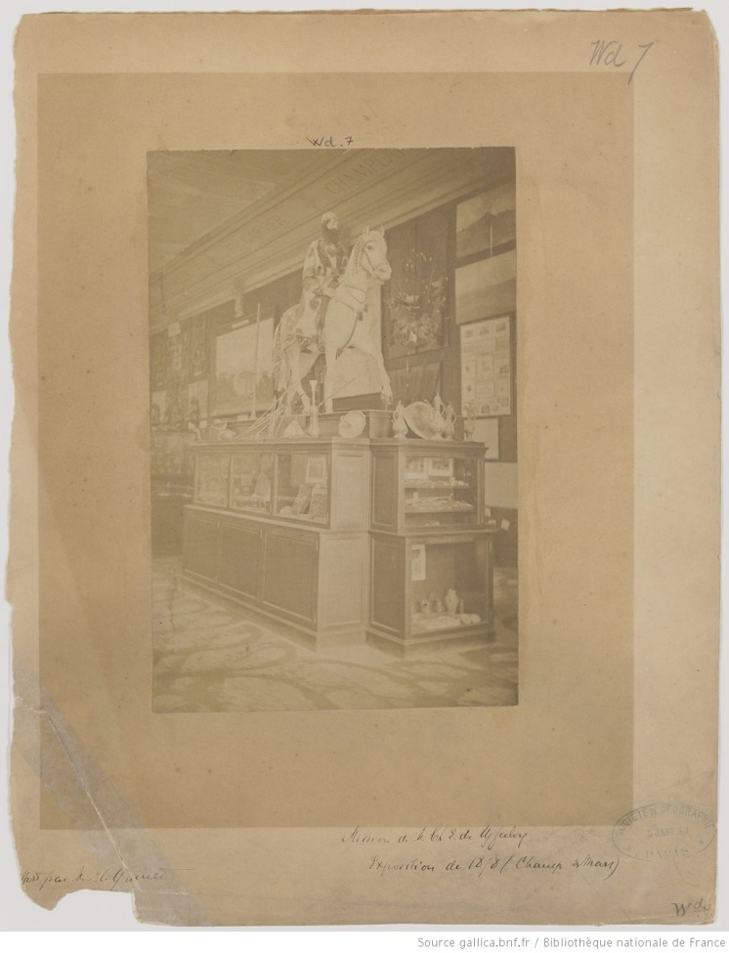
Figure 3. (Phot. de l'exposition de 1878 au Champ de Mars à Paris, vitrine consacrée à l'expédition de CE. de Ujfalvy au Turkestan russe, don A. Quinet en (1883)

The Polish revolutionary, writer Adolf Januszkiewicz also made his contribution to the study of the region. It should be noted that his research has a greater impact on the socio-cultural sphere of life of the Kazakhs.
During his work at the Border Governance of the Siberian Kyrgyzs, he had repeatedly visited the Kazakh steppes (in 1843 and 1846). Of great interest to science are the letters and notes of the researcher in which he touches upon the cultural and social aspects of life of the nation.
Januszkiewicz deeply empathized with the lives of the ordinary Kazakhs. This is clearly read in his notes: “In every yurt I hoped to find happy arcade cowherds ... alas! Rarely my gaze failed to meet sad pictures of poverty and diseases in yurts, exhausting the poor population. Almost all black yurts (because the rich live in white ones) were covered with a fever. Children suffered from smallpox, scab, abscesses. This all has to struggle with one’s own suffering, alone, since the science of Aesculapius, given here in the hands of stupid and ignorant baksy, uses methods of treatment marked mostly by the stamp of quackery and witchcraft. The heart is bursting at the sight of so many martyrs asking for help ... The poor peasant must work all summer like a Negro in the field for a rich man”. It is noteworthy that, despite the terrible conditions of life, ordinary people were able to maintain human dignity and were far from religious fanaticism. "It is noticeable that only the Kyrgyz aristocracy makes Muslim prayers ... the ordinary Kyrgyz does not pray." (Shamshiyabanu, 2012).
A certain historical and literary interest is provided by separate pages of diaries and letters from Januszkiewicz relating to the personality of the father of the great Kazakh poet and thinker Abai — Kunanbai Uskenbaev. Januszkiewicz is one of Kunanbai's few contemporaries, who left a description of his personality. Kunanbai, as an official, assisted the expedition headed by the border commander General Vishnevsky, who came to the Middle Zhuzh in 1846 with the task of making a census of the population and livestock, to examine the requests of five large tribes of the Senior Zhuzh about accepting them into Russian citizenship. Januszkiewicz had a chance to see Kunanbai closely and talk to him for several days. Of all the rulers of the Middle Zhuzh, Kunanbai made the strongest impression on him.
It is interesting that the description of the personality of Kunanbai, given by Januszkiewicz, coincides with some strokes of the artistic image masterfully created by M. Auezov in the novel The Way of Abai.
It is known that many Western European explorers and scientists noted the Kazakhs' special inclination to the art of poetic improvisation. Januszkiewicz described in detail his impressions of the public poetic performances of Kazakh akyns and improvisers. Januszkiewicz had several opportunities to listen to a poetic performance and aytys (competition) of one of the most famous akyns, Orynbai Kertagynov (1813-1890), who performed in aytys with the prominent akyns.
The explorer's notes also provide the content of a number of Kazakh legends, for example, about the origin of the Kazakhs, steppe law, sultanism, etc. (Shamshiyabanu, 2012).

Conclusions
The period of the 18th-19th centuries is marked in the history of Kazakhstan not only by the rapprochement with Russia, but also by the active study of the Kazakh lands by both Russian and European researchers from different fields of science. A lot of significant discoveries were made. These achievements stemmed from the long history of science, the accumulation of valuable and abundant materials, the development of a number of theoretical problems as well as the reliability of scientific reports and facts.
Foreign explorer scientists made an undeniable contribution to the study of Kazakhstan. Possessing encyclopedic interests, freely moving around the world, moving from one scientific center to another, they left a lot of interesting information and discoveries in the fields of botany, zoology, geology, geography, ethnography, history, archeology and linguistics.
The activities of researchers in the territory of Kazakhstan helped to raise and advance science (both local and European) to a new level of development as well as promoted the development of new territories and a change in the image of the territory of Kazakhstan as a wild, unexplored land.
References
- Afanasyev, 1971 – Afanasyev V. The secret of the "English" house. Leninskskaya Smena, 1971.
- Alekseenko, 1986 – Alekseenko V.N. Questions of the history of Central Asia and Kazakhstan in the coverage of Russian pre-revolutionary journals (the second half of the 19th and early 20th centuries)// The author’s summary of doctoral dissertation. Alma-Ata, 1986. 41 p.
- Asian Russia. Vol. II. Land and households. Edition of the Resettlement Department of the Main Directorate for Land Management and Agriculture. Saint Petersburg, 1914. p. 622.
- Beisenova, 1984 – Beisenova A.S. Issledovaniya prirody i razvitie fiziko-geograficheskikh idei v Kazakhstane (s drevneishikh vremen do nachala XX veka). Baku, 1984. 416 p.
- Bizhanov, 1967 – Bizhanov M.K. Kazakhstan in the second quarter of the 18th century in the writings and notes of Russian researchers// The author's summary of doctoral dissertation. Alma-Ata, 1967. 32 p.
- Borkin, Gannibal and Golubev, 2014 – Borkin L.Ya., Gannibal B.K. and Golubev A.V. Following the roads of Peter Simon Pallas (along the west of Kazakhstan). St.Petersburg-Uralsk: "Eurasian Union of Scientists", 2014. 312 p.
- Brokgauz, Efron, 1892 – Brokgauz A.F., Efron I.A. The Brockhaus and Efron Encyclopedic Dictionary. Saint-Peterburg, 1892. 478 p.
- Curzon, 1889 – Curzon G.N. Russia in Central Asia in 1889 and the Anglo-Russian Question. London, 1889. P. 319.
- "Dala ulayatynyn gazeti". Almaty: Gylym, 1989. P. 42-44.
- "Dala ulayatynyn gazeti". Almaty: Gylym, 1990. P. 174-175.
- Dmitrienko, 2010 – Dmitrienko K.V. Certain issues of study of Kazakhs of Asian Russia by Russian researchers in the 19th century// Omsk Scientific Bulletin. 2010. № 2 (88). P. 42-45.
- Erofeeva, 1967 – Erofeeva I.V. Kazakhstan in the second half of the 18th and early 19th centuries. In the writings and notes of Russian researchers// The author's summary of doctoral dissertation. Alma-Ata, 1967. 41 p.
- He wasn’t on the lists of the Academy // Bulletin of the Volgograd Branch of the Russian Geographical Society. 2009. №9 (71).
- History of the research of vegetation of the Ural province. Proceedings of the Society for the Study of Kazakhstan. Orenburg- Nauka. 1925. № 6. p 52.
- Ivanov, 2015 – Ivanov E.P. Study of the steppe region by Russian researchers in the 19th century// Omsk Scientific Bulletin. 2015. № 2 (136). P. 37-40
- Kazbekova, N. A. Scientific and cultural-educational activities of the departments of the Imperial Russian Geographical Society in the territory of Kazakhstan in the late 19th – early 20th centuries. Bulletin of Karaganda University. Retrieved from: https://articlekz.com/article/5246
- Lebedev, 1986 – Lebedev D.V. Essays on botanical historiography of the 19th-early 20th century. Leningrad: Nauka, 1986. 165 p.
- Mukatayeva, 2002 – Mukatayeva L.K. G.E. Katanayev on the problems of the history of Kazakhstan: the interaction of personality and culture// The author’s summary of doctoral dissertation. Almaty, 2002. 39 p.
- Nagler A., Kariyev E. The contribution of the Germans to the study of history and culture of Kazakhstan.
- Osterhammel, 2015 – Osterhammel J. The Transformation of the World: A Global History of the Nineteenth Century (America in the World)// Princeton University Press. 2015. P. 365.
- Report on the composition, activities and means of the Orenburg Division of the Imperial Russian Geographical Society for 1905. Saint Petersburg, 1905. P. 20-21.
- Richard, 1960 – Richard A. P. Russian Central Asia 1867-1917// A Studs in Colonial Rule, Univ of California Press, 1960. P. 17-18.
- Rozhenets-Kucherovskaya, 1927 – Rozhenets-Kucherovskaya S.Е. Vegetation of the Semipalatinsk province // Proceedings of the Society for the Study of Kazakhstan (Kyrgyz Region). Department of Natural Science and Geography. 1927. № 1. P. 7.
- Rozhkova, 1963 – Rozhkova M.K. Ekonomicheskie svyazi Rossii so Srednei Azii: 40-60 gody XIX veka. Moscow, 1963. P. 123-124.
- Rozhkova, 1950 – Rozhkova M.K. Ekonomicheskaya politika tsarskogo pravitel'stva na Srednem Vostoke vo vtoroi chetverti XIX veka i russkaya burzhuaziya. Moscow-Leningrad 1950. P. 174-176.
- RGS! History! Russian Geographical Society. Retrieved from: http://mob.rgo-sib.ru/rgo/55.htm
- Shamshiyabanu, 2012 – Shamshiyabanu K.S. Veyanie vremeni. IV tom. Astana: Elorda, 2012. 408p.
- Syzdykova, 2000 – Syzdykova E.S. Questions of the history of Kazakhstan in the 19th century in the works of officers of the General Staff of the Russian Empire// The author’s summary of doctoral dissertation. Astana, 2000. 43 p.
- Tolochko , 1977 – Tolochko V.S. Problems of the history of Kazakhstan in the 19th century in the military periodical press// The author’s summary of doctoral dissertation. Alma-Ata, 1977. 39 p.
- Tsybulsky, 1988 – Tsybulsky V.V. Nauchnye ekspeditsii po Kazakhstanu. Alma-Ata, 1988. P. 7.
- Uifalvi-Bourdon M. Russian Asia. (Travel impressions). [Trans. from French].-"Zvezda", 1886, № 20, pp. 480-482; № 21, pp. 504-506; 1887, № 35, pp. 761-764; № 36, pp. 777-780; № 37, pp. 806-810; № 38, pp. 831-834; № 39, с. 849-853; № 40, pp. 877-881; № 41, pp. 904-908; № 42, pp. 932-936; № 43, pp. 945-950 (under different titles). Ujfalvy-Bourdon M. de. De Paris a Samarkand, le Ferghanah, le Kouldja et la Siberie... Paris, 1880.
- Vernadsky, 1988 – Vernadsky V.I. Works on the history of science in Russia. Compiled by Bastrakova M.S., Neapolitanskaya B.S., Firsova G.A. Moscow: Nauka, 1988. P. 223-224
- Zhuravlev, 2013 – Zhuravlev A. 220 years later// National Geographic. 2013. №119

