Marauders: How to Get the Best Gear
So, you have decided to roam the Space in order to rob and get some loot. No, no, I can understand you. Work in office it’s hard, long-term and often unfair way to earn money. Do you think so too? That’s great. You’ll be able to rob every spaceship you like, defeat any enemy squad and protect your goods from intruders. You will be a legend. Of course, if you have appropriate gear.
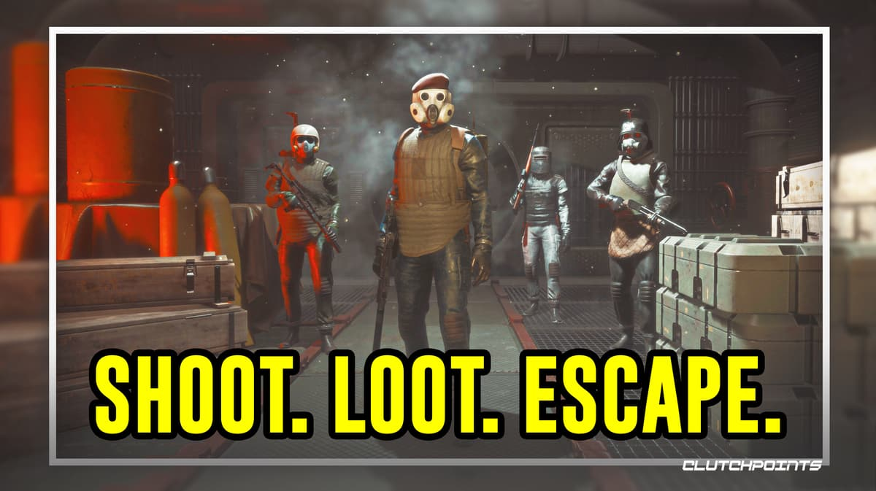

Gift
Let’s start from the easiest way to get some good ship. In order to build better ship, normally you should gather resources and increase your level. But game allows your friends to give you ship as a gift. They just have to drop their Captain Card to you, while you in the Raid, and when you leave, the ship will be in your Hangar. So if you have good friends in Marauders, just ask them. Damaged Capital Ship Next way is to visit a Damaged Capital Ship. Unlike regular Captain Ship, this one, obviously has a way less guard inside. You can notice it nearby any big Raid location. Looting this ship can be useful: even though it’s look, there still may be rare items inside. But this will be more difficult: AI holds control of security system, so be prepared for battle.
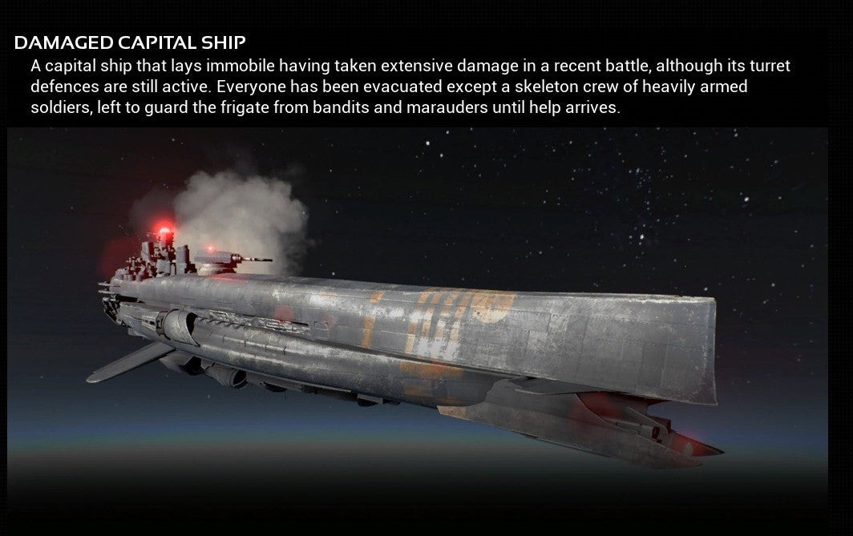
Modding weapons
If you are after best gear, why don’t you create one of them? When you get enough items, you can use some of them to modify your weapon, so it will be more useful in future firefights. You can mod weapon from the main menu by clicking on Weapons tab. If weapon can be modded, chose area and put the attachment.
Looting
Is there more obvious thing? Loot everything: your fallen enemies, hostile ships, etc. Look for upgraded weapons, documents, armor and other items and use them by yourself.
This little tips will help you to achieve your goal, but also, don’t forget about your main weapon – your brain! Sell things which have no use for you, change tactics, be adaptive, reach hights. That’s the way you should go. So try it.

