Перевод медицинской справки UA>EN

Stamp: Form Code according to ZKUD ____________

Ministry of Health Care of Ukraine Institution code according to ZKPO__________

Public Institution “Municipal Clinical Hospital of city of Sumy”

M. Vovchok Str., 40007, code 02000317

Medical documentation

Form No. 095-1/o

Approved by order of Ministry of Health Care of Ukraine on 29.12.2000 No. 369

**REFERENCE NO. 1748**

temporary incapacity for work because of injury or other health disorder

Date of issue: 29.11.2013

Name, surname, patronymic of the patient: Korobov Vitalii Volodymyrovych

Place of work – name of an institution: individual entrepreneur Korobov V. V.

Diagnosis: cerebral concussion, numerous haematomas on the whole body

Released from work from 22.11. 2013 till 30.11.2013

Release is prolonged

from till

from till

Surname of the doctor, who issued the reference */signed/*

Round seal: Andronov Mykola Ivanovych

Physician

*The adequate translation from Ukrainian into English is made by me, Olena Podhaina, a translator, on 02/10/2015.*

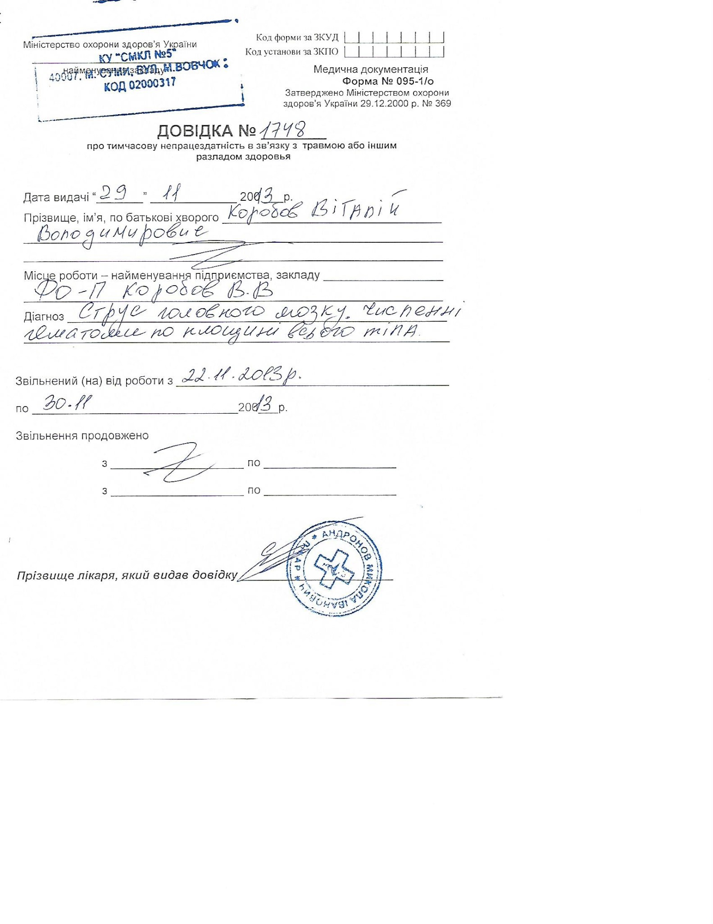

Оригинал медицинской справки UA>EN