UI testing screenshot below

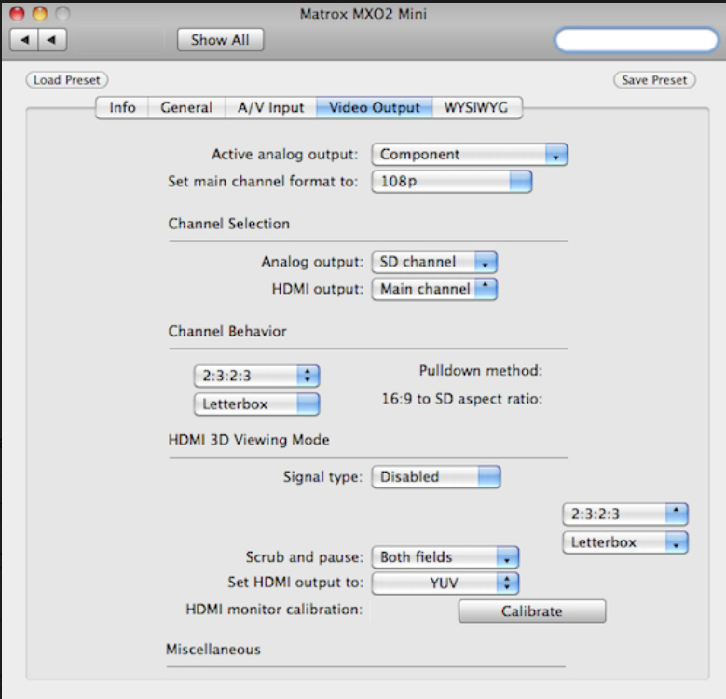

Testing Matrox MX02 Mini – Video output setup tab.
- In the upper left corner there are two same buttons that means return on a step back. There should be left active button to return on step back. And not active button to move forward (if you make some changes button become active).
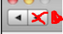

- Button “Show all” is placed not symmetrically. It would be more better to place it on right near buttons “Back”/”Forward”.

- 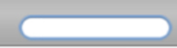 I can imagine that it is search field, but it is Negative Space. However, developer missed to place in a search mark. So in this field should be a search mark, it will be more understanding for user. It should look like: 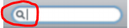
- Buttons “Load Preset” and “Save Preset” are placed very far from each other. And it is not comfortable to look for them. It would be better to place them closer to each other on left or right side.
Moving down we see setup menu in details.
- Active analog output menu. It should be like Combo box, as user should select the type of connections that user want to use.
- Set main channel format to menu. It also should be Combo box. On screen we can’t see is it Drop box or Combo box or any another type of menu. On screen is proposed invalid type of formats – 108p doesn’t exist. And users device may not support that or another format. So correctly if in this field would be something like “Follow application”, like:
- Analog output. Should be Combo box.
- HDMI output. Shown as Upper box, and should be Combo box.
- Channel Behavior menu looks incorrect, because we have variants of menu and then describing. Developer confused places them. Also on 16:9 to aspect ratio should be Combo box menu. It should look like: 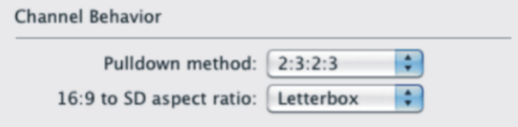
- Signal type. Should be Combo box. Proposed value is “Disabled”, and not average value. It should be proposed “Side by Side”, like: 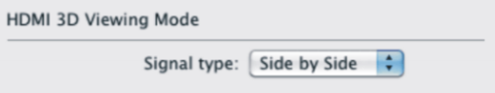
- On the right side we see non indicated lists:
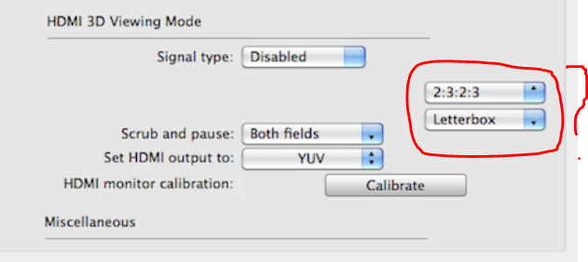

Developer should remove them.
- Miscellaneous should be upper on functions – Scrub and pause, Set HDMI output to… like:
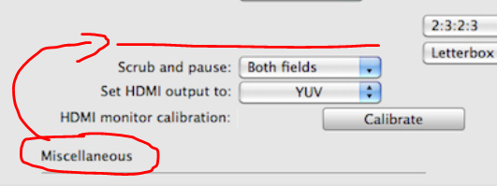

- Scrub and pause should be Combo box.
- Set HDMI output to – is correct, but value “YUV” should be placed not in the center, but in the left side.
- HDMI monitor calibration – value is too far from describing, and it looks not pro rata. It should be placed under upper values.

