Main topic. Word Formation. Suffixation.

Main Aim:
to introduce and practice the concept of word formation through suffixation.

Subsidiary Aim:
to improve students' vocabulary and ability to recognize and use suffixes in their writing and speaking.

Personal aims:
to engage students in the learning process through interactive activities and to provide clear and concise instructions for all tasks.

Materials:
- Whiteboard and markers;
- Handouts with suffix examples and practice exercises;
- Audio recordings of words with suffixes;
- Pictures and visuals to aid in understanding;
- Online suffix game (optional).

Language Analysis:
- Definition and examples of suffixes;
- Common suffixes in English and their meanings (e.g. -ness, -able, -ful);
- Rules for adding suffixes to base words (e.g. drop the final 'e' before adding -able).

Assumptions:
- Students have a basic understanding of English grammar and vocabulary;
- Students may be unfamiliar with some of the more complex suffixes and their meanings;
- Some students may struggle with applying suffixes to base words accurately.

Board plan:
Time and Interaction | Stage name & Aim | Procedure
1. Introduction of the topic and purpose  5 min | Teacher's greeting | Welcome, students! In today's lesson, we'll be focusing on suffixes.
1.1«Warming-up activity»  5 min | Development of the speech apparatus for better articulation. | Let’s begin our lesson now. So, can we begin today’s lesson ? Is everybody ready to start ? Let’s go.
1.2 ″Speed telling″  5 min | Expressive reading for the teacher, for themselves, for assessment. | How many cookies could a good cook cook  If a good cook could cook cookies  A good cook could cook as much cookies  As a good cook who could cook cookies
The main part  2. Learning a new topic  2.1Teacher's explanation Listening  15 min | Students watch the video and then review what they have heard,  the teacher's story. Suffixes are word endings we add to roots. We use suffixes to change words into nouns, verbs, adjectives and adverbs. | Teacher shows students a video  https://www.youtube.com/watch?v=Q2b5gjfcozg then they will discuss the video together and answer the question bellow using the information from the viewed video.  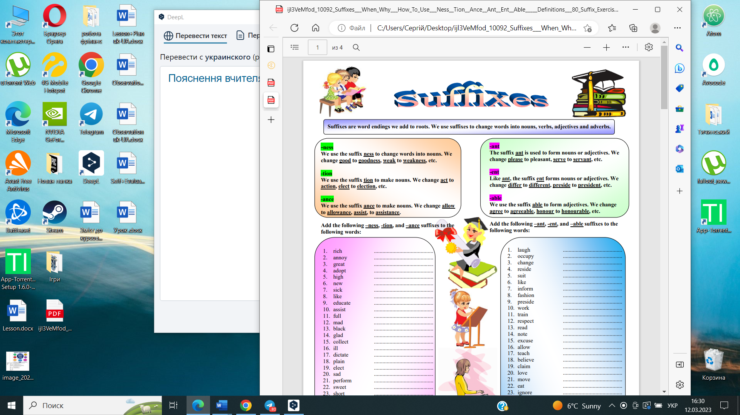
2.2Presentation.  Exercise to consolidate the material you have heard.  15 min | Students are shown words on the screen and have to correctly form the suffix.  Students will put the words in the correct form. | Add the following –ness, -tion, and –ance suffixes to the following words:  1. rich .................................  2. annoy ..............................  3. great ..........................................  4. adopt ..........................................  5. high ..........................................  6. new ..........................................  7. sick ..........................................  8. like ..........................................  9.educate..........................................  10. assist ..........................................  Answers (richness, annoyance, greatness, adoption, highness, newness, sickness, likeness, education, assistance).  Add the following –ant, -ent, and –able suffixes to the following words:  1. laugh ..........................................  2. occupy ..........................................  3. change ..........................................  4. reside ..........................................  5. suit ..........................................  6. like ..........................................  7. inform ..........................................  8. fashion ..........................................  9. preside ..........................................  10. work ..........................................  Answers (laughable, occupant, changeable, resident, suitable, likable, informable, fashionable,  president, workable).
2.3 Exercise "Form the correct form of the word"  15 min | Use the endings in the list to form adjectives from the nouns.  Checking the correct execution of the task. | https://www.english grammar.at/online_exercises/prefixes-suffixes/ps020-adjective-suffixes.htm  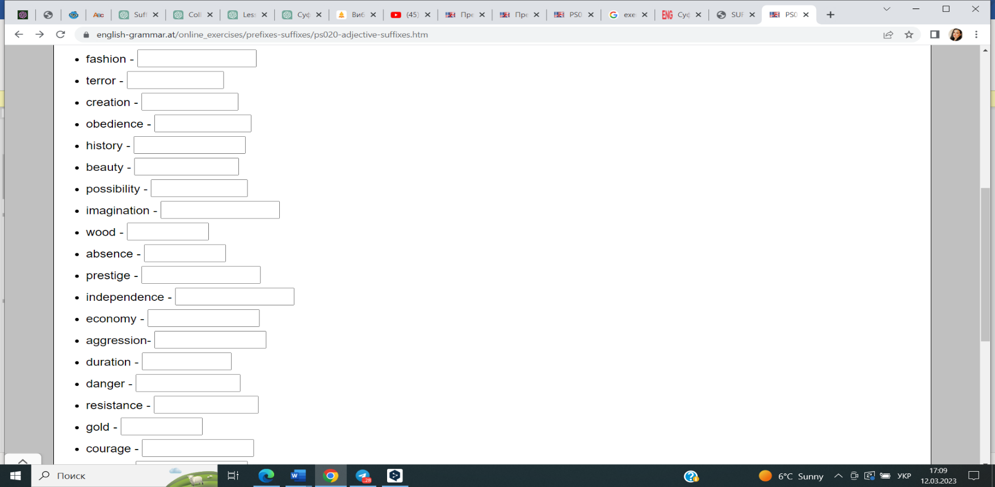  -ABLE -ICAL -ANT -ENT -IVE -EN -OUS -FUL -IBLE  Answers (fashionable, terroristic, creative,  obedient, historical, beautiful, possible, imaginative, wooden, absent, prestigious, independent, economic, aggressive, durable, dangerous, resistant, golden, courageous).
3. Fixing new material  3.1 Exercise «Circle the Suffixes!»  8 min | Read the sentences below. Find the words that contain suffixes. Circle each suffix and write its definition on the line below each sentence. Use the above chart and a dictionary as reference. | 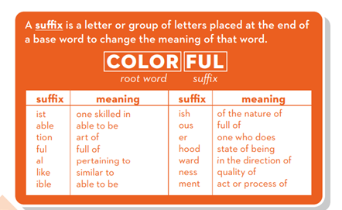  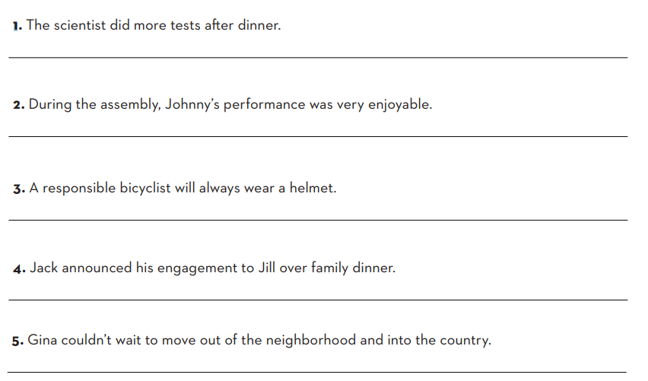  Answers  1. The suffix in "scientist" is "-ist" which means "one who practices or specializes in".  2. The suffix in "performance" is "-ance" which means "the state or quality of".  3. The suffix in "bicyclist" is "-ist" which means "one who practices or specializes in".  4. The suffix in "engagement" is "-ment" which means "the result or product of".  5. The suffix in "neighborhood" is "-hood" which means "a condition or state of being".  6. The suffix in "country" is "-try" which means "the business or work of".
3.2 Working with text  7 min | Circle the words with suxes in the paragraph below.  Students search for the words and select the suffix, explaining their choice. | You don’t have to be a botanist to grow your own food! The warmest time of year is best for planting some seeds, while others can only grow  when planted during colder times. Some plants, like tomatoes, become droopy if you don’t water them daily. You must make sure the soil has just  the right amount of wetness for each type of plant. Gardening can be dicult, but the right knowledge can make it easier.  Answers:  Botanist (suffix: -ist)  Planting (suffix: -ing)  Others (suffix: -s)  Tomatoes (suffix: -es)  Water (suffix: -er)  Wetness (suffix: -ness)  Gardening (suffix: -ing)  Knowledge (suffix: -edge)  Easier (suffix: -er)
4. Summing up.  5 min | Summarize the key points of the lesson.  Provide homework for further practice. | Homework.  TEST: add a suffix to build the correct new word.  https://www.tolearnenglish.com/exercises/exercise-english-2/exercise-english-1455.php

