P2PS: Data into the hands of owners
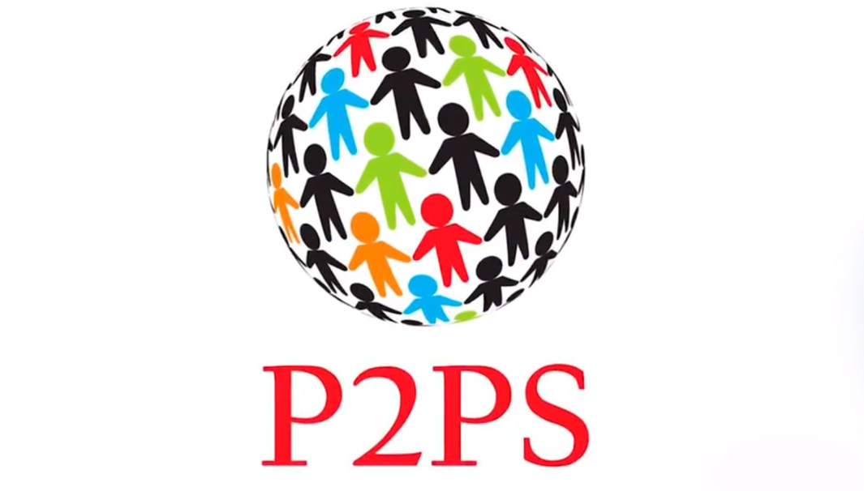
Maybe, you had something different in mind, but data is the most important asset of the 21st century. And while everyone calls bitcoin “digital gold”, we understand that in the era of information technology, data is of the highest value. That's why we decided to tell about P2PS - a contemporary solution based on the blockchain, which will become a new round of P2P-interaction development.
The recent scandal with the social network Facebook has shown the world, that protecting the personal data should be on in the first place. Neglecting this requirement lead to quite negative consequences. The leakage of user data has led to the fact that the credibility of the most popular social network has significantly deteriorated, its value dropped by as much as $ 58 billion a week, and its founder, Mark Zuckerberg, had to take a lot of measures to return everything to its places.
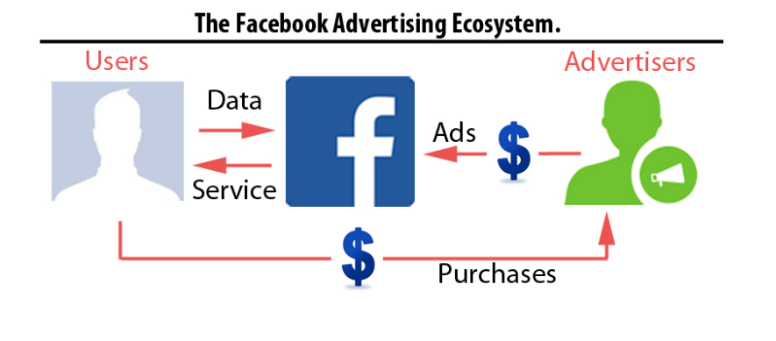
Source: 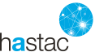
The thing is that analytical companies are interested in obtaining user data: it’s needed during the development of personalized advertising and election campaigns. They are not interested in information about the name/age of users, but something more - their preferences, opinions, thinking, and so on - everything that can be used to manipulate the masses.

Technology of safety interaction

P2PS (Peer-to-Peer Solutions) is an innovative peer-to-peer platform created on blockchain technology and it’s participants will be able to exchange digital files and assets directly, without any third-party intervention. The process of such exchange or transaction, carried out within the platform, cannot be changed, delayed or canceled by anyone. Now, the power can be concentrated in the hands of ordinary users. The main mission of P2PS is to completely secure the process of storing and transferring confidential information or valuable digital assets within a peer-to-peer platform that is subsequently transformed into an entire ecosystem.
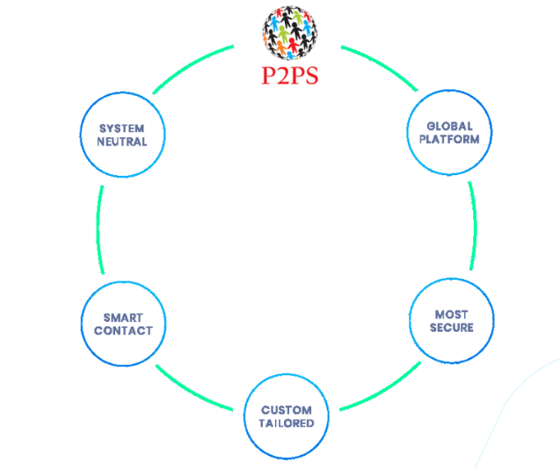
This solution will be useful not only in the field of data transfer between ordinary users. With this technology, banking systems can be built, developers can create a register of secret developments for companies and states, and even protect vital information. All commissions and services in the ecosystem can be paid using platform tokens: payments are secured. From our perspective, there are not so many analogues of the P2PS platform in the world!

Blockchain protects lifes

The most vulnerable information is the data of health insurance cards. Of course, you can answer back: "My computer stores party photos. They seriously compromise me! ". But, if the malfeasant finds out that you behave badly after drinking lots of plonk, then this will not create a serious threat for you. A completely different situation with health data.
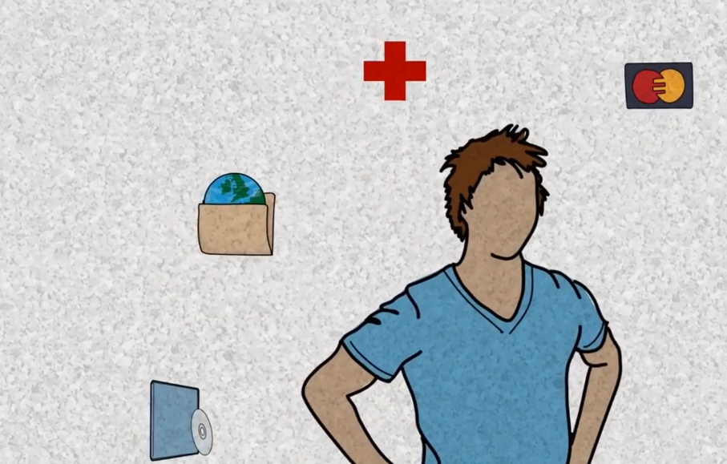
It's no secret that information about all the past medical history is stored centrally in your local hospital. By the way, if it is something like a paper notebook, then you are lucky. After all, those data that are stored in digital format, isn`t protected from abductions.
Yes, a simple person cannot view them. But it can be done during prepared hacking operation. As a rule, centralized data banks use outdated methods of protection. It’s just a piece of cake for hackers to access!
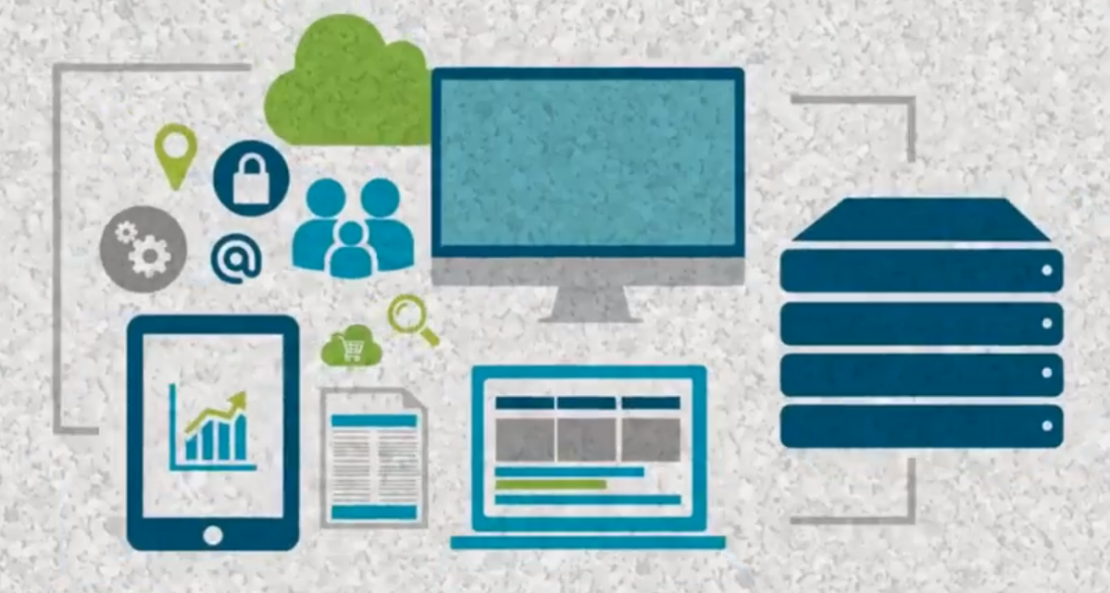
Just imagine: all your allergies and predispositions in the hands of a person who means to do you harm. But this can happen if your data is stored in a centralized way. In addition, other participants have access to data in the centralized repository – hospital staff. But we would bet money you don’t want to give the right to access your data all in a row.
It is noteworthy that P2PS technologies can solve this problem. Using the capabilities of blockchain-storage and modern methods of cryptography, the system protects your data from everyone. You can set a scope of persons who will have access to your medical record. Let's say this is only your therapist. And all the other employees will see only that part of the information that you made public. And, of course, your party photos can be stored in exactly the same way.
Meet the project closer by reading the official website, documentation and news. We have it all! Good luck to the team!

