BUSINESS PLAN


Crepes2Go

Viktoriia Krupelnytska | Kristina Durana | Jena Hirsch | Elena von Rheden | Raffaello Capraro

Entrepreneurship & Small Business

Lecturer’s name: Reg Beniac
Submission Date: 25 November 2015

University of Victoria

2015
Table of Contents

1. Introduction ----------------------------------------------------------------------------------------- 4

2. Market Analysis ------------------------------------------------------------------------------------ 5
- Market Size & Growth ----------------------------------------------------------------------- 5
- Market Value ---------------------------------------------------------------------------------- 5
- Industry Attractiveness ----------------------------------------------------------------------- 6
- Consumption Habits & Buying Patterns --------------------------------------------------- 7
- Proposed Target Market ---------------------------------------------------------------------- 8

3. Company Summary ------------------------------------------------------------------------------- 12
- Product Description --------------------------------------------------------------------------- 12
- Menu -------------------------------------------------------------------------------------------- 12
- Competitors ------------------------------------------------------------------------------------ 13
- Sourcing & Trade Channels ----------------------------------------------------------------- 15

4. Implementation ------------------------------------------------------------------------------------ 16
- Value Proposition ----------------------------------------------------------------------------- 17
- Pricing Strategy ------------------------------------------------------------------------------- 17
- Location Strategy ----------------------------------------------------------------------------- 17
- Promotions Strategy -------------------------------------------------------------------------- 17

5. Financial Plan -------------------------------------------------------------------------------------- 18
- Assumptions ----------------------------------------------------------------------------------- 18
- Sales Volume & Projections ----------------------------------------------------------------- 18
- Projected Income Statements ---------------------------------------------------------------- 20
- Break-even Analysis -------------------------------------------------------------------------- 24
- Startup Capital --------------------------------------------------------------------------------- 25

6. Licensing --------------------------------------------------------------------------------------------- 25

7. Risk & Risk Mitigation --------------------------------------------------------------------------- 26

8. Conclusion ------------------------------------------------------------------------------------------- 27

Executive Summary
Crepes2Go is a food stand that delivers sweet and savoury crepes in a convenient and time-efficient way. What differentiates the product from other food stands is the high level food quality while still being fast and affordable. Crepes2Go takes an unfilled niche in the food truck segment by offering its desired target customers fast service, and tasty crepes to go.

Crepes2Go targets two markets: students out partying on the weekends and office workers on their lunch break. These markets are sized around 16500 students and 36800 workers. The business will be located downtown, preferably on Herald St. outside the Duke Saloon or on Douglas St., in order to ensure high accessibility. This makes Crepes2Go versatile to both the daytime and late night scene. The price of the various crepes offered averages about $5 which is affordable when compared to competitors like Tacofino averaging around $8-$10 per customer.

The sources of competitive advantage for this particular business are the convenient location, the high quality of goods offered for affordable prices and the word-of-mouth reputation that the business plans to gain.

With regard to the financial plan, Crepes2Go is expecting a net loss of approximately 55500 CAD within the first four months of operation. However, the sales will start picking up in the fifth month and will be experiencing growth until its third year due to the market awareness which is also expected to increase within the period. The first year of operations will close with a profit of 24305 CAD. The forecasted profits for year 2 and 3 are 27958 CAD and 30598 CAD.
Introduction
This paper is conducted in order to introduce a business concept of a food truck that offers crepes to go in downtown of Victoria. It is a business partnership among five students from the University of Victoria who believe there is a market opportunity for a food establishment that can speed up food service and provide healthy, tasty and affordable food. There has been evidence indicating that Canadians enjoy crepes, and there is no crepe specific business currently operating downtown.

Crepes2Go’s goal is to offer specialty food items and make them easily accessible to its target market. Crepes2Go will start out as a single stand in the downtown area. If successful more stands would be opened and eventually a cafe if there was demand for it. The business plan investigates the unfilled niche for Crepes2Go in the food truck segment.

First of all, the paper analyzes the desired market in terms of the growth rate, size and industry attractiveness. Based on the buying behavior of prospective customers a target market is suggested. Secondly, a company profile and its strategy is developed with respect to previous analysis. Afterwards, financial forecasts are created to measure the economic success of the company. In the last part, the paper looks into licensing requirements and risk mitigation.

Market Analysis
- Market Size and Growth
With regard to Table 1, the market size and growth is anticipated to make room for Crepes2Go. The forecasted average growth rate of independent street stalls and kiosks is 3.3% from 2014 to 2019. However, the industry’s growth rate of 3.3 is quite small compared to other food service industry players. This means the market is already established and people have their go-to stalls already and Crepes2Go has to carve out its own niche and needs to be aggressive about it. On a positive note, in 2014, value sales of street stalls/kiosks rose by 5% in current terms to reach C$532 million. This growth was heavily influenced by independent street stalls and kiosks which had a 6% increase in value sales. This indicates that food stalls and kiosks are a good marketing venture and a popular choice for consumers.

- Market Value
Year | Market Value
2015 | 435.8
2016 | 452.5
2017 | 466.3
2018 | 478.1
Table 1. Market value of independent street stalls and kiosks for years 2015 to 2018 measured by forecasted sales

- Industry Attractiveness
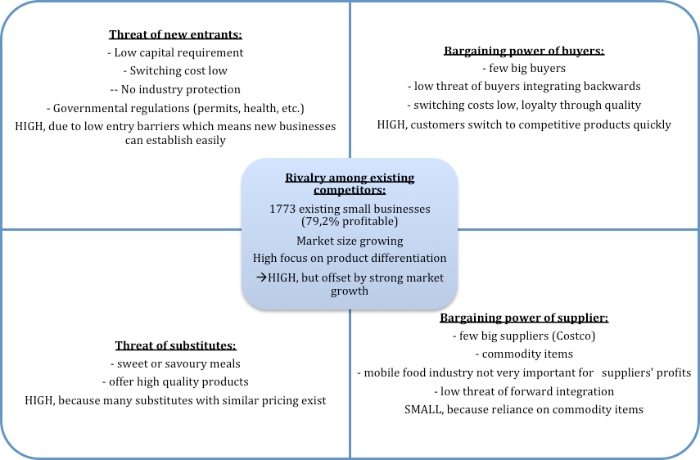
It is necessary to get an understanding about the food and beverage industry Crepes2Go will be operating in. With regard to Figure 1, one is tempted to conclude that the industry is only fairly attractive. However, there is a strong market growth and currently no crepe business existing in Victoria, so one can determine Crepes2Go could establish itself in this market. In addition, product differentiation is used to offset the threat of customers switching to competitors. Furthermore, low entry barriers assist the business in establishing itself.
Figure 1. Porter’s Five Forces Diagram

- Consumption Habits and Buying Patterns
Firstly, the research in form of an online survey (Google Forms) was conducted in order to better understand the buying behavior and preferences of prospective customers. In total, 27 responses were recorded.
Buying from Kiosks | Percentage of People
Buy | 52%
Don’t buy | 48%
Table 2. Percentage of people who buy from kiosks
Level of Willingness to Buy Crepes | Percentage of People
5 (highest) | 34%
4 | 23%
3 | 31%
2 | 12%
1 (lowest) | 0%
Table 3. Willingness to buy crepes from kiosks
When People Buy from Kiosks | Percentage of People
Morning (Breakfast) | 26%
Afternoon (Lunch) | 35%
Evening (Dinner) | 8%
After Partying | 26%
Table 4. Consumer buying behavior with regard to the time they purchase from street kiosks

Frequency of Buying | Percentage of People
Once a week | 37%
Twice a week | 41%
Everyday | 4%
Twice a month | 4%
Table 5. Consumer buying frequency

- Proposed Target Market
The customers Crepes2Go wishes to target are students and downtown office workers as they do not want to wait in long queues in restaurants or cafes. The startup focuses on providing quick, efficient service. Students do not want to wait to grab their snack, because they may be on a break between classes or hungry after a night out drinking. According to the results of the above survey, the best time for prospective customers to have a snack is during the lunch time after 12pm, or after pub rush hours – midnight.
Downtown office workers who work at banks, real estate companies etc. prefer buying food to go while on their lunch break. Having a sit down meal at a restaurant or cafe is too time consuming. Another benefit is that workers can grab several crepes for their colleagues at work.
Table 6. analyzes the target audiences’ typical segmentation profiles, in terms of factors like geographics, demographics, psychographics, product use, product benefits, and media habits.

 | BEN - UVic student | EMILY - Downtown worker
Geographics | Living place: UVic Dormitory  Shopping: Thrifty Foods McKenzie, Save-on-Foods McKenzie, Uptown, Hillside, Chapters downtown  Entertainment: Odeon Cineplex cinema, Felicitas Pub on Thursday's karaoke, Distrikt, Upstairs, Darcy's  Food: McDonalds after partying downtown, Starbucks on Yates Street  Sport: UVic Gym | Living place: Gordon Head  Shopping: Thrifty Foods MacKenzie, Fairways Market McKenzie, The Root Cellar, Bay Center and Mayfair mall. She has a dog, and they often drive to Elk Lake, Cedar Hill Golf Course or Mt. Tolmie together for a walk. She goes to the VI Fitness for Women at the Shelbourne Plaza for yoga classes every Saturday.  Entertainment: Royal Theater  Food: Il Terrazzo, Tapa Bar on weekends with family  Sport: Fitness IV studio - yoga classes.
Demographics | · 22 y.o. male student  · Studying business  · Owns a car – black Volkswagen Golf  · Has a part-time job at DTZ  · Low-middle level of income | · 45 y.o. female. Married, and has children. Owns a car – red Toyota Rav4. Works at Scotiabank downtown. High-middle level of income. Has a finance & accounting degree from the University of British Columbia.
Psychographics | · Young & outgoing person  · Loves travelling & sport activities  · Curious about discovering new places & food  · Fan of a quick food –doesn’t want to waste his time on queues  · Follows technological innovations & fan of IT  · Loves pancakes, waffles, crepes | · Loves exclusive products  · Spends lots of money on herself  · Values family so much  · Likes qualified products/services  · Loves cooking  · Fan of local products/services  · Supports local community  · Very social and has lots of friends  · Fan of sweet crepes  · Used to travel a lot, that is why she is familiar with small trucks with food to go
Product Use | · Eats breakfast and dinner at home every week day  · Prefers to eat lunch outside during weekdays and dinner outside on weekends  · He will probably grab a crepe to go during the lunch time from 12pm till 1pm on Monday, Wednesday, Friday. And after partying downtown after midnight on Saturday.  · | · Eats breakfast and dinner at home, or restaurants  · Eats lunch somewhere outside during her job break  · She will probably grab a crepe to go during her lunch break along with Starbucks coffee  · She is more likely to take several crepes for her colleagues. Emily would decide to have a crepe to go in the week starting from Monday till Friday from 12:00 to 1:00pm or 1:30pm.
Product Benefits | · Look for a quick service, tasty/fresh ingredients, friendly communication, and worker's knowledge about products  · Prefers big portions of food  · Location of Crepes2Go is ideal for him. | · Emily will be looking for a quick service, healthy choices and a feeling of a pleasant conversation with a worker.  · She would appreciate the variety of choices of crepes. The location of Crepes2Go is very convenient and fit her schedule..
Media Habits | · Has a FB account – uses during his spare time every day. Has Instagram & Skype. Loves watching Netflix, YouTube.  · Likes reading UVic newspapers: Martlett, the Ring  · Blog: Victoria Going Local  · Uses Yelp.com & TripAdvisor. | · Has a FB account – checks twice a day. Checks yelp.com before going to a new place. Prefers reading local news: Saanich news  · Douglas magazine on-campus  · Times Colonist. She likes spending a lot of time on TripAdvisor when she is planning her next trip to Europe  · Has a few apps: Yelp, Spotify, Skype.
Table 6. Proposed Target Market

Observations: As one can see from both examples of representatives of the potential target audiences, these people are very active, and value every second of their time. They are busy with responsibilities at work or university. In addition, the desired target customers are good in dealing with technology, especially social media. One of the most important things is that they love desserts, including crepes, which is the main offered product of Crepes2Go.
All in all, from all customers’ information mentioned above, it can be concluded where and which message should be designed for creating a successful marketing communications strategy to increase customer's awareness and desire to buy. Table 1. helps to understand that mostly our target customers are willing to buy a crepe to go during lunch time, or after partying downtown. Moreover, both potential representatives of the target audiences are looking for a quick service, freshness and good taste of products.

Company Summary

- Product Description
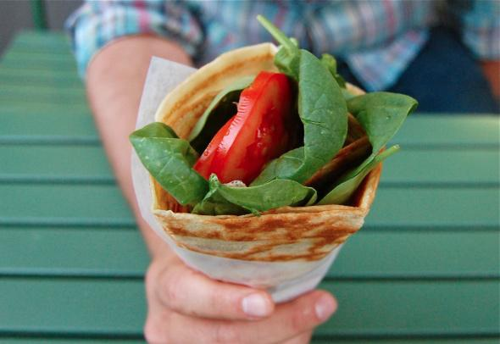
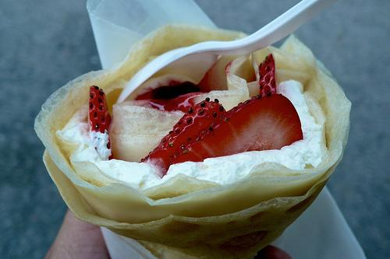
Crepes2Go plans to offer both savoury and sweet crepes. The crepes are served by rolling them in a special waxy paper that will make it easier for our customers to consume. (see picture 1. & 2.)

Picture 1. Picture 2.

- Menu
The menu (see Table 8.) consists of various options of sweet and savoury crepes that was developed based on research results and as a means to differentiate Crepes2Go from competitors. Therefore, special healthy types of crepes are offered, such as “Veggie” and “Light” that contain minimal calories.
Savoury Crepes
Veggie | Spinach, cheese, mushrooms
Hammie | Ham, cheese, mushrooms, tomato sauce
Eggie | Egg, spinach, mushrooms
English Style | Bacon, cheese, egg
Table 7. Savoury Crepes
Sweet Crepes
Choco | Nutella, whipped cream, fudge
Sweet dream | Strawberry jam, banana, fudge
Canadian choice | Banana, maple syrup, whipped cream
Light | Banana, strawberry jam, fudge
Table 8. Sweet Crepes

C. Competitors
According to the information from yelp.com there are currently no food trucks in Victoria that are mainly selling crepes. However, Crepes2Go’s potential competitors are food trucks downtown that are selling various foods like tacos, hot dogs, French fries etc. These businesses are Red Fish Blue Fish, Tacofino, Puerto Vallarta Amigos, who target our intended customer base. The following table compares the main competitors of Crepes2Go to each other (see Table 9.).

 | Competitor 1:  Red Fish Blue Fish | Competitor 2:  Tacofino | Competitor 3:  Puerto Vallarta Amigos | Crepes2Go
Revenue | n/a | n/a | n/a | $516,407.31
Sales growth | 3,8% | 3,8% | 3,8% | 3,8%
Market position | #1 | Top 5 | #2 | Planned Top 3
Location | Wharf street | Fort street | Yates street | Douglas, Herald streets
Product/tech trends | Fresh and sustainable approach to the old fish 'n' chip shop. Seafood | Quality, freshness and affordability with an environmental and nutritional conscience. Mexican food | Authentic Mexican food and vegetarian options | Fresh and tasty crepes to go for affordable prices. Various types, including healthy ones. Fast preparation time, and convenient location right on the main central street.
Price range | $11-30 | $11-30 | Under $10 | $5
Market focus/  expansion trends | Victoria | Victoria, Tofino, Nanaimo | Victoria | Victoria
Quality of financial position & investors | n/a | Sole proprietorship | Family-run business | Partnership
Overall Assessment | Trying to win on quality of food & location | Trying to win on reputation, and quantity of branches | Trying to win on high awareness, quantity of trucks around Victoria, and old family recipes | Plan to win on affordable prices, variety of crepes, and good marketing communications strategy.
Revenue | Fee for product | Fee for product | Fee for product | Fee for product
Table 9. Competitor Analysis

In order to analyze the relation of price and performance between the avobe mentioned competitors and Crepes2Go, a perceptual map is designed (seeFigure 2.).
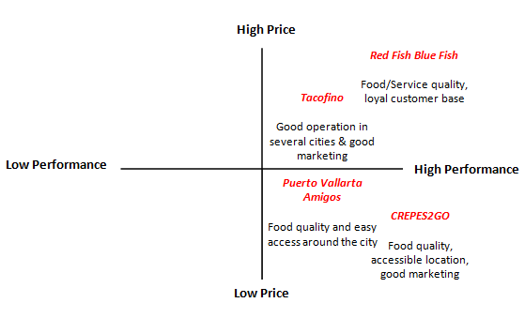

Figure 2. Perceptual Map

The perceptual map shows that Crepes2Go positions itself as a business emphasizing on a high quality for affordable prices.

- Sourcing & Trade Channels
The ingredients mentioned in the menu section will mainly be supplied by Sysco. Alibaba.com, a Chinese e-commerce company will be used, to buy a crepe car and hot plates. With regard to the trade channels, Crepes2Go will be using a direct marketing channel strategy as Figure 3. shows.

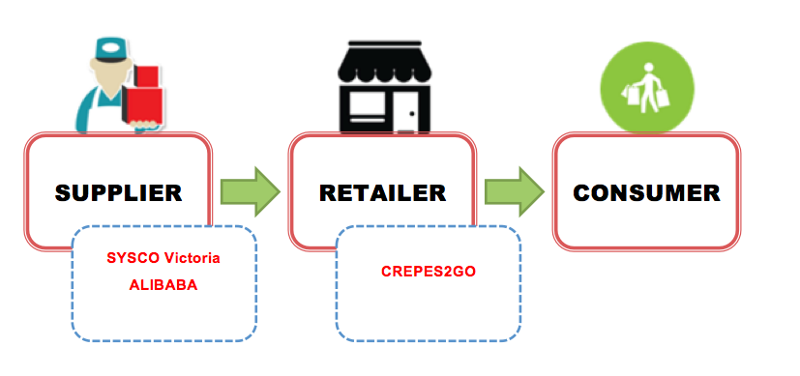
Figure 3. Trade Channels for Crepes2Go

This means after making the final product it will directly be delivered to the customer without any intermediaries. Further, the production will occur where the product is sold and food will be stored in the food truck, avoiding warehouse costs.

Implementation
- Value Proposition
Crepes2Go wants consumers to see it as accessible and tasty. In contrast to other late night food vendor it will come across as healthier and of higher quality than a lot of competitors (eg. hot dog vendors and pizza parlors). The branding is where the food is fast, accessible but better than ones typical late night offerings. In addition, when open during the day, workers will view Crepes2Go as a quick lunch that is tasty, and a better alternative to a sandwich shop or coffee shop. In other words, more specialized.

- Pricing Strategy
Pricing will be on the lower end of the spectrum. Based on the survey results, 35% of the people are more likely to pay $5.00 for a crepe and another 35% are willing to purchase for $4 (Table 3.). However, crepes will be $5 before taxes in order to be profitable especially since the cost of goods will be 40% of the selling price. The goal is to charge within that realm.

- Location Strategy
Crepes2Go is facilitated in a food truck that will look into locations in the downtown area, specifically on Douglas Street and in front of downtown bars (The Duke Saloon). This location will make it accessible to a huge part of the target market because it is one of the main streets where people pass by. This accessibility is one factor that will heavily influence the sales volume because consumers prefer a food truck that is readily available and easily spotted especially after a night out on the town.

- Promotions Strategy
Marketing occurs through flyers (see Appendix 1) and social media and potentially by making deals with bars. Flyers will be used to advertise the existence of the stand as well as make sure it is on the Victoria food trucks app so people always know the location. Instagram and Facebook are used (see Appendix 2) to update customers on any deals they can take advantage of and even conduct contests to win free food. Crepes2Go would have its own hashtag and feature Victorian’s photos which would help advertise the crepes and promote business.

Financial Plan
This section shows the financial strategy on how Crepes2Go will be profitable as a startup business. Most figures are derived by basing them on the industry of street stall/kiosk foodservice and on the assumptions below:

- Assumptions
- Cost of goods sold is equal to 40% of the total sales
- Demand for crepes will retain the same buying frequency for three consecutive years
- Population growth rate remains a constant for three consecutive years.

- Sales Volume and Projections
Tables 10, 11 and 12 shows the total sales in units per year for Crepes2Go. These numbers were based on the buying frequency of consumers from kiosks and their willingness to buy crepes.
Buying Frequency Year 1
Times per Week | Number of People | Total Buys in a Month | Total Buys in a Year
0.5 | 0.05 | 0.1 | 1.2
1 | 0.45 | 1.9 | 22.6
2 | 0.45 | 4.2 | 50.1
7 | 0.05 | 1.5 | 18.3
Total Sales in Units (in thousands) | 92.2

Table 10. Total sales in units based on consumer buying frequency

Buying Frequency Year 2
Times per Week | Number of People | Total Buys in a Month | Total Buys in a Year
0.5 | 0.05 | 0.1 | 1.2
1 | 0.45 | 2 | 22.8
2 | 0.45 | 4.2 | 50.5
7 | 0.05 | 1.5 | 18.5
Total Sales in Units (in thousands) | 93
Table 11. Total sales in units based on consumer buying frequency

Buying Frequency Year 3
Times per Week | Number of People | Total Buys in a Month | Total Buys in a Year
0.5 | 0.05 | 0.1 | 1.2
1 | 0.45 | 1.9 | 23
2 | 0.45 | 4.2 | 51
7 | 0.05 | 1.6 | 19
Total Sales in Units (in thousands) | 94.2
Table 12. Total sales in units based on consumer buying frequency

The number of people who will purchase the product is derived through the percentage of the people willing to buy crepes from food stalls based on the results of the survey conducted. The result shows that 57% of the total respondents have a willingness degree of 5 and 4 with the former being the highest rating. This percentage was used as a multiplier for the total population of Downtown Victoria and the nearby area of Hillside and Quadra in order to derive the target market size. Furthermore, the target ages for customers are 15 to 30 years old and this represents 23.6% of the population of Victoria. This percentage was also taken into consideration in the calculation of the number of people who will purchase crepes. The total sales in units was derived by getting the sum of the total number of purchases for each frequency suggested by the survey respondents. The percentage of the respondents who suggested the listed frequencies was multiplied to the total population who were willing to purchase the product.

- Income Statements
Year 1
 | January | February | March
Revenue | $5,200 | $5,200 | $20,800
Cost of Goods Sold | $2,080 | $2,080 | $8,320
Gross Profit | $3,120 | $3,120 | $12,480
Operating expenses
Salaries Expense | $10,000 | $10,000 | $10,000
Supplies expense | $100
Regulatory Fees | $830
Rent Expense | $10,000 | $10,000 | $10,000
Utilities | $1,000 | $1,000 | $1,000
Gas | $500 | $500 | $500
Advertising Expense | $2,000 | $2,000 | $1,000
Total Operating Expenses | $24,430 | $23,500 | $22,500
Taxable Income |  | -$20,380 | -$10,020
12% Tax
Net Income | -$21,310 | -$20,380 | -$10,020

 | April | May | June
Revenue | $31,200 | $46,800 | $46,800
Cost of Goods Sold | $12,480 | $18,720 | $18,720
Gross Profit | $18,720 | $28,080 | $28,080
Operating expenses
Salaries Expense | $10,000 | $10,000 | $10,000
Supplies expense |  | $100
Regulatory Fees
Rent Expense | $10,000 | $10,000 | $10,000
Utilities | $1,000 | $1,000 | $1,000
Gas | $500 | $500 | $500
Advertising Expense | $1,000 | $1,000 | $1,000
Total Operating Expenses | $22,500 | $22,600 | $22,500
Taxable Income | -$3,780 | $5,480 | $5,580
12% Tax |  | $657.60 | $669.60
Net Income | -$3,780 | $4,822.40 | $4,910.40

 | July | August | September
Revenue | $46,800 | $52,000 | $52,000
Cost of Goods Sold | $18,720 | $20,800 | $20,800
Gross Profit | $28,080 | $31,200 | $31,200
Operating expenses
Salaries Expense | $10,000 | $10,000 | $10,000
Supplies expense |  | $100
Regulatory Fees
Rent Expense | $10,000 | $10,000 | $10,000
Utilities | $1,000 | $1,000 | $1,000
Gas | $500 | $500 | $500
Advertising Expense | $1,000 | $1,000 | $500
Total Operating Expenses | $22,500 | $22,600 | $22,000
Taxable Income | $5,580 | $8,600 | $9,200
12% Tax | $669.60 | $1,032.00 | $1,104.00
Net Income | $4,910.40 | $7,568.00 | $8,096.00

 | October | November | December
Revenue | $62,400 | $72,800 | $78,000
Cost of Goods Sold | $24,960 | $29,120 | $31,200
Gross Profit | $37,440 | $43,680 | $46,800
Operating expenses
Salaries Expense | $10,000 | $10,000 | $10,000
Supplies expense | $100
Regulatory Fees
Rent Expense | $10,000 | $10,000 | $10,000
Utilities | $1,000 | $1,000 | $1,000
Gas | $500 | $500 | $500
Advertising Expense | $500 | $500 | $500
Total Operating Expenses | $22,100 | $22,000 | $22,000
Taxable Income | $15,340 | $21,680 | $24,800
12% Tax | $1,840.80 | $2,601.60 | $2,976.00
Net Income | $13,499.20 | $19,078.40 | $21,824.00

Year 2 and Year 3

Income Statements
 | Year 2 | Year 3
Revenue | $530,000 | $530,000
Cost of Goods Sold | $220,000 | $220,000
Gross Profit | $310,000 | $310,000
Operating expenses
Salaries Expense | $130,000 | $130,000
Supplies expense | $400 | $400
Regulatory Fees | $830 | $830
Rent Expense | $120,000 | $120,000
Utilities | $12,000 | $12,000
Gas | $6,000 | $6,000
Advertising Expense | $9,000 | $6,000
Total Operating Expenses | $278,230 | $275,230
Taxable Income | $31,770 | $34,770
12% Tax | $3,812 | $4,172
Net Income | $27,958 | $30,598

The monthly and yearly revenues were calculated by multiplying the total sales in units, shown in the previous section, to the selling price per unit of crepe which is CAD 5.60. The estimated cost of goods for each crepe is 40% of the revenue per unit. Net losses will be incurred for the first 4 months of operation. However, because of the increasing market awareness and growth in consumer buying frequency, Crepes2Go is projected to be profitable beginning its fifth month.

- Break-even Analysis
This section will show how many crepes must be sold in order to keep up with the costs of our business. For the first year, the breakeven point in units will be expressed per month. The succeeding 2 years will show the breakeven point per annum.
Year 1 (per Month)
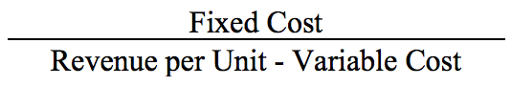

= 6 696 units
For the first year, Crepes2Go must sell 6696 units each month in order to breakeven.
Year 2 (per Annum)
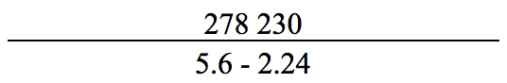
= 82 807 units
For the second year, Crepes2Go must sell 82 807 crepes in order to breakeven.
Year 3 (per Annum)
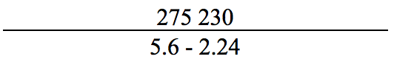
= 81 914 units
For the third year, Crepes2Go must sell 81 914 crepes in order to breakeven.
Based on projections, Crepes2Go will be selling 10 000 more units of crepe above the breakeven point. This entails that the business will be profitable especially in its second and third years of operation.

E. Startup Capital
The required startup capital amounts to CAD$ 20 000. This will be spent on the food truck, stoves, and supplies we will need in order to start our operations.

Licensing

There are certain licenses and permits required in order to open a food truck business in Victoria. (see table 13.).
Type of licensing | Time to get | $ to pay
Business license | 10 Days | $100
Electrical Permit | Varies | $100
Inter-Municipal Business License | Varies | $100
Sidewalk Cafe Permit | 1-3 Weeks | Varies
Sign Permit | Varies | $30
Street Vendor Business License | 10 days | $100
Electrical Installation Permit | 1 day | $300-$800
Operate a Food Service Establishment Permit | 1 day | No information found
Agreement to Implement Employment Equity | 0 days | 0 days
Federal Business Registration | 0 days | 0 days
Table 13. Licensing

Consequently, ten permits and licenses are required in total. Waiting time for these documents varies from one day to three weeks.
Risk Analysis & Risk Mitigation
This section discusses the risks and methods of tackling these risks that Crepes2Go will face. The first risk is that the supplier may fail to deliver goods on time. In order to combat this risk a very reliable food supplier, which is trusted by 20 different food establishments in Victoria was chosen for Crepes2Go. Secondly, there is a risk that employees may call in sick on occasion which would impact daily business. Especially in a small food stand. In order to avoid having the stand unmanned there will be 2 people operating the food truck for every 8 hour shift. Another 2 will take over once that shift is complete. Work can be exchanged and covered at the employee’s discretion. Thirdly, another risk is that equipment such as the stove or refrigerator may become damaged. In order to combat this risk all the equipment will be insured and appropriate employees who know how to operate equipment effectively will be hired. This ensures there will be less of a chance of damage to equipment due to improper use.

Conclusion
The plan is to open a food truck downtown to sell savoury and sweet crepes for people who are seeking affordable prices, tasty and healthy ingredients, fast service and easy access. According to the competitors analysis, there are no food trucks selling crepes in Victoria. The main competitors are specializing mainly in tacos, fries and fish & chips. The desired target audiences are students and downtown workers. According to the conducted analysis 57% of asked people from the desired target audiences are willing to buy crepes to go. Crepes2Go will use a direct marketing distribution strategy without any intermediaries. To establish a business it is needed to acquire around ten licenses and permits that are essential to operate a food truck business in Victoria. All in all, the business will be struggling for the first four months before becoming profitable in the fifth month, when the market finally has awareness about this startup business.

Appendix 1
Flyer Sample


Appendix 2
Facebook Page Sample
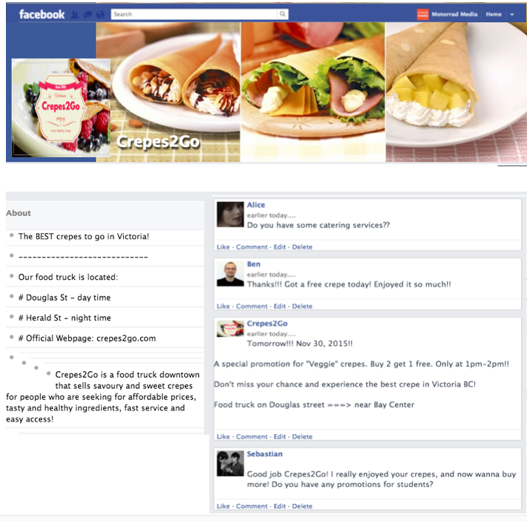

- Facebook Page sample

Information was analyzed from yelp.com, and conducted research
Porter, Michael E. "The Five Competitive Forces That Shape Strategy." Special Issue on HBS Centennial. Harvard Business Review 86, no. 1 (January 2008): 78–93.
first year revenue
first year sales growth based on the street stalls/kiosk based food service industry
http://www.yelp.com/biz/red-fish-blue-fish-victoria
http://www.yelp.com/biz/tacofino-victoria
http://www.yelp.com/biz/puerto-vallarta-amigos-victoria
from survey analysis
http://www.canadabusiness.ca/eng/

