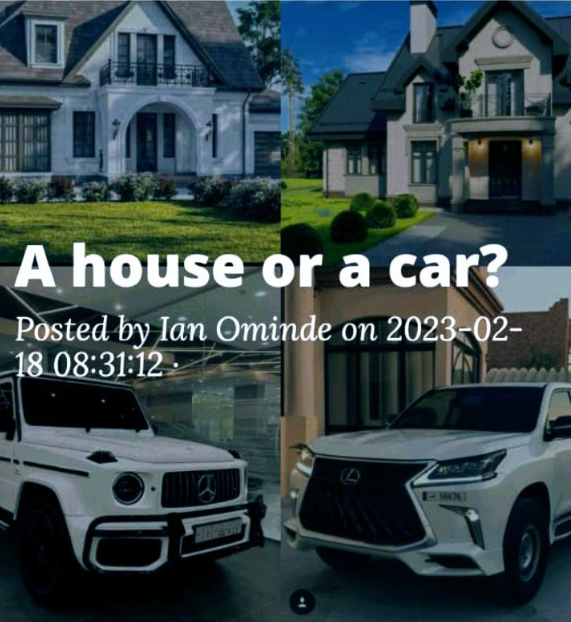
A house and a car are the biggest personal assents that many people can have in their lifetime. Both are major financial commitments and of course, exciting milestones. But the dilemma of choosing between the two is baffling, literary no one can tell you what to choose between the two in a blink. But there are some intrinsic factors you can put into consideration to help you in making the best decision. If you are tossing between getting a new pair of wheels or getting the keys to your house we are here to help you with some of the factors to give consideration.
- Your financial situation
The question of whether to buy a car or a house will be orthogonal if you can’t afford the high cost of home ownership.
You should consider if you have enough money to buy or construct a home plus the maintenance and furniture costs and after doing so you determine if your current financial status is fit for home ownership. If not, a car would be your possible choice at the meantime.
- Your purchase timeline
You should consider how soon do you need to make the purchase, are you sure of where you will be in the next several years? If not buying a car can happen more quickly than buying a house, because unlike the house you can go with your car anywhere you go.
Potential home buyers should consider long time scenarios like a change in their employment status or income and the property resale and rental potential.
- The state of the housing and car markets
Interest rates are climbing right now, both auto loans and mortgages are affected by this rates. In addition, both homes and vehicles inventories are low therefore this is not an affordable time to buy either of them. If the interest creeps down or inventory goes up in either of the two markets it would be a perfect time to strike at that particular category.
- Budget for the extra expenses
Both a car and a house have extra expenses, you should evaluate this expenses to determine the ones you are able to keep up with. The following are some of the expenses associated with both cars and houses.
Hidden costs associated with car ownership includes;
- Parking
Parking costs varies widely across different cities and nations and before making any commitments its worth doing your research do avoid disappointments.

- Servicing and maintenance
Depending on the car model, car maintenance can be a bog expense or not an issue. Many new cars comes with not only warranty but also free servicing for the first few years of ownership. In contrast, if you buy second hand car it’s worth factoring servicing and maintenance into your budget.
- Depreciation
Depreciation would vary according to the make model and age of the car you purchase. New cars tend to lose around 20% of their value at the first year of ownership while second hand models depreciates more slowly in their value.
- Car insurance
Car insurance can be a huge expense, especially to the new and young drivers with minimal experience. It’s common for drivers under the age of 24 to pay annual average premiums of up to $1000.many motorists buying new cars choose to add GAP insurance, which offers peace of mind to them but increases the cost significantly.
- Fuel cost
Due to the rising fuel prices once you want to buy a car fuel should be on top of your budget. Fuel cost depends on how often you use the car and the type or model of the car hence you need to buy a car which you can withstand its fuel consumption.
- Vehicle tax
Road tax is another big expense and can cost to average of $140 yearly though this can vary between vehicles.
There are also hidden costs associated with housing and property ownership and they include the following;
- Insurance
Most homeowners take insurance policies costing up to $150 per quarter this cost must be accounted for before making any commitments
- Property taxes
This property taxes can push up the cost of homeownership. It is calculated based on the value of the property
- Interest rates on the mortgage
Interests post a significant increase to your mortgage and naturally it is important to look for the best deals
- Maintenance and upkeep
As a homeowner, it will be your responsibility to carry out general maintenance and upkeep to your property. This maintenance costs varies between houses but they are worth to consider before committing yourself to home ownership.
- Bills
Home ownership comes with a couple of bills that one must consider, this bills may include electricity, water and entertainment etc. this bills should be put into consideration while budgeting
- your immediate needs
This needs vary between different individuals depending on the location of their workplace and the number of their family members. People with huge families are advised to own their own home while those with small families can rent comfortably and prefer car ownership.
People living far from their workplaces are advised to have their own cars while those living near their workplaces can use public transport at ease and hence their obvious choice is homeownership
- State of public transport
People living in cities with high costs of public transport are advised to buy their own vehicles while those in cities with well-developed public transport with subways and good taxi network are not advised to buy their own vehicles hence one should weigh his options before making any decisions

What should I buy first?
The answer to this question depends on your specific financial situation: since both houses and cars costs a significant sum of money you will need to weigh your options carefully and determine what each will require from you. Think about the trade-offs that comes with each one. Consider what each one adds into your life, and how it fits with the future you are actively designing and the life you are creating. From the above factors you can estimate the cost of ownership of the two assets and compare to your situation and make the best choice for yourself.

