The Saturation Principle (H). Implementation

Methods and Their Hierarchical Structure.
Vyacheslav V. Kolbin, Saint-Petersburg State University (Russia)

Abstract
This article constructed a system of axioms to define the principle of saturation of binary relations. A structure was developed to provide the ways for implementing the principle of saturation in the process of ordering of binary relations. This article is a sequel of studies [1-7].
Key words: principle of saturation, binary relations, hierarchical structure.

The Saturation Principle (H). Implementation Methods and Their Hierarchical Structure
Let 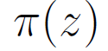 — be some continuous pseudoweighting function, that is, for 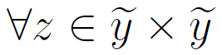and 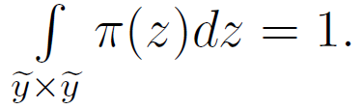
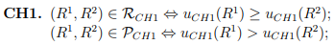
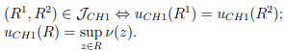
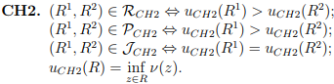
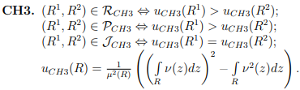
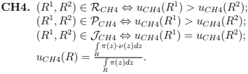
We may offer as one implementation method for the saturation principle a special case of relation , that is to compare the ’’means” of function on binary relations 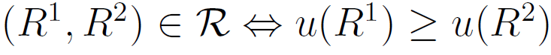, where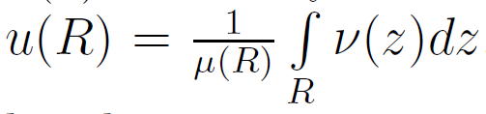. But the transition to the ordering of binary relations by the saturation principle shall be made only where the orderings in the sense of the extension principle fail to produce positive results, that is, for the relations R¹, R² and for the chosen function 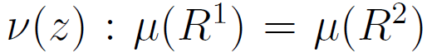and 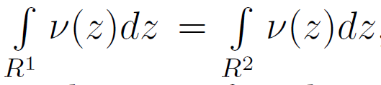, but this means that 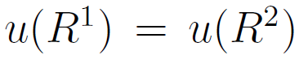, and hence introduction of such method for ordering binary relations has no practical significance.
Theorem 1. For binary relations the validity or invalidity of the axioms defining the saturation principle (H) for ordering binary relations is given in the table below:
Proof. The proofs of validity of axioms (AO1.1), (AO2.1) are obvious, because they can be represented as the real-valued functions of sets.
Consider the binary relation
(AH1.1) Let 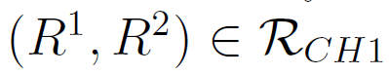 and 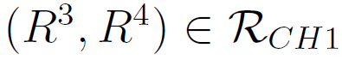, then . If 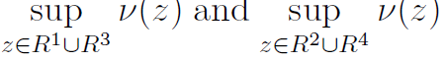 and are attained on the elements 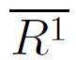 and 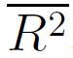, respectively, or on the elements 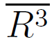
 | AO1.1 | AO2.1 | AH1.1 | AH1.2 | AH2.1 | AH2.2 | AH3.1 | AH3.2
 | + | + | + | - | - | + | - | -
 | + | + | - | - | - | + | - | -
 | + | + | - | - | - | - | - | -
 | + | + | - | - | - | - | - | -
and 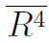 respectively, then the proof is obvious. Now let 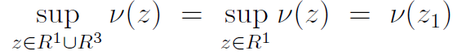 and 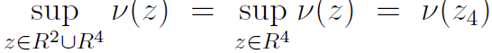. The first relationship means that 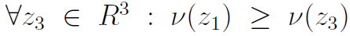 and hence The case, where and , is proved in much the same way, therefore 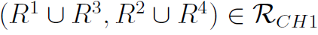.
(AH1.2) This axiom fails to hold true, because if 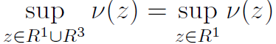, 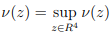 and 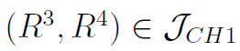 then we may have 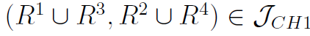.
(AH2.1) This axiom fails to hold true. Indeed, if, e.g., 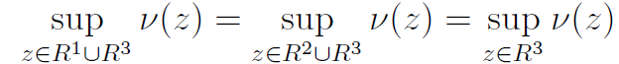, then we may have both .
(AH2.2) Let then If and are attained on the elements and respectively, then the proof is obvious. Show that and may not hold at the same time. Indeed, if this is the case, then and or which contradicts the assumption. Now let and then that is,
(AH3.1) This axiom fails to hold true. Indeed, if the elements on which and are attained fail to belong to and respectively, then we may have both 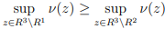 and
(AH3.2) The proof of invalidity is similar to (AH3.1).
Consider the binary relation
(AH1.1) This axiom fails to hold true. Indeed, let and then and But , therefore, to prove the validity of the axiom, it suffices to show that but this relationship is not always true.
(AH1.2) The proof of invalidity is similar to (AH1.1).
(AH2.1), (AH3.1), (AH3.2) Invalidity is proved in much the same way as for the binary relation .
(AH2.2) Validity is proved in much the same way as for the binary relation
Consider the binary relation .
(AH1.1), (AH1.2), (AH2.1), (AH2.2), (AH3.1), (AH3.2) When the intersections of comparable binary relations are not required to be zero, invalidity of these axioms can be shown by analogy with the above relations represented by using integral expressions.
Consider the binary relation and find out that the axioms defining the saturation principle hold for this relation.
(AH1.1), (AH1.2), (AH2.1), (AH2.2), (AH3.1), (AH3.2) These axioms fail to hold true. Indeed, if and , then is identical to the function u_{CP4} for which these axioms fail to hold.
This completes the proof of the theorem.
We shall construct the systems of weakened axioms that define the saturation principle.
then
then
then
then
then
then
then
then
then
then
then
then
then
then
then
then
then
then
then
then
Theorem 2 (implementation of the saturation principle). The binary relations are the implementation methods for the saturation principle (H) of ordering binary relations under the systems of axioms, respectively:
Proof. It can be readily seen that each axiom is the weakening of the relevant axiom in the collection defining the saturation principle. Thus, in order to prove the theorem, it suffices to show that the weakened counterparts of the axioms defining the saturation principle we have discussed above hold binary relations
(AH1.2⁽¹⁾) In order to prove validity, it suffices to repeat the proof this item of Theorem 1.
and then that is,
and then
If and then the proof is obvious. If and are attained on the binary relation then it is necessarily so on one element, and the proof is also obvious. Now, if then is, impossible, because otherwise. Thus, there is still the case where and But then in all cases.
(AH3.2⁽¹⁾) The proof of validity is similar to (AH3.1⁽¹⁾).
(AH1.1⁽²⁾), (AH1.2⁽²⁾) In order to prove validity, it suffices to repeat under new preconditions the proofs of the relevant items of Theorem 1.
(AH2.1⁽²⁾), (AH3.1⁽²⁾), (AH3.2⁽²⁾) The proof of validity is similar to (AH2.1⁽¹⁾), (AH3.1⁽¹⁾), (AH3.2⁽¹⁾), respectively.
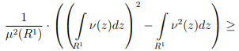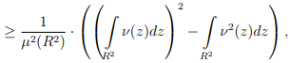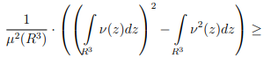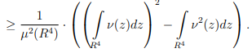
But since we have
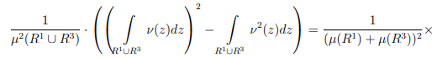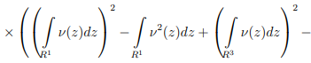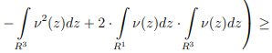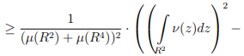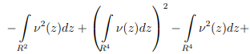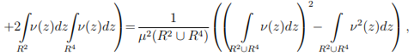
that is
then
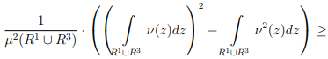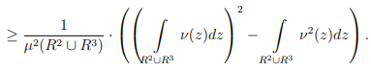
But since then
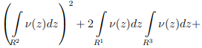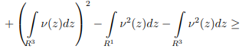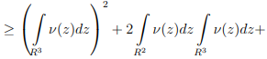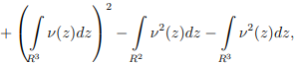
therefore 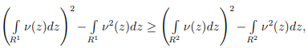 and hence
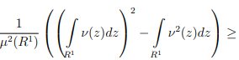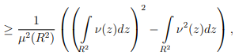
that is,
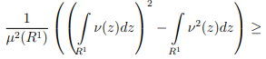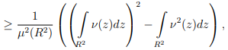
But since we have
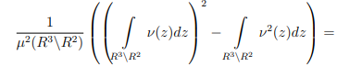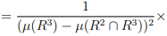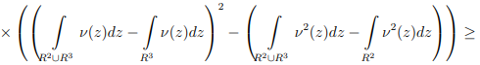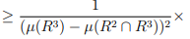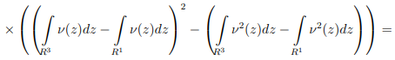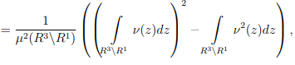
That is,
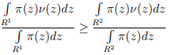
and
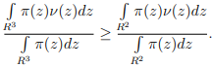
But since , we have
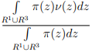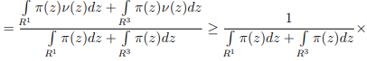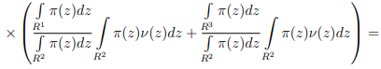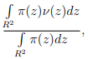
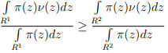
and
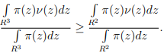
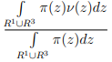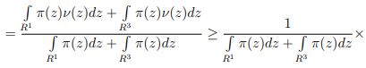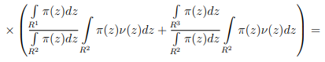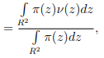
that is
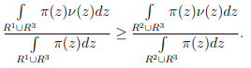
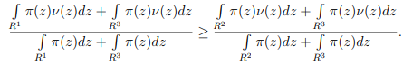
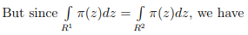
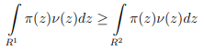
or
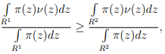
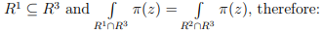
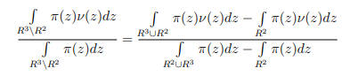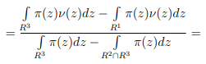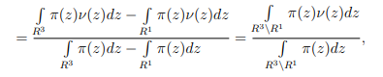
that is,
(AH3.2⁽ ³⁾) The proof of validity is similar to (AH3.1⁽³⁾).
This completes the proof of the theorem.
We shall construct the hierarchical structure for the implementation methods of the saturation principle we have discussed above. The method (CH1), is the strongest method because The next level in the hierarchy is the method (CH2): . For the construction of further levels of the hierarchical structure, it can be readily seen that the system of axioms {AH⁽⁴⁾} is weakening of {AH⁽³⁾}, therefore the method (CH3) is stronger than the method (CH4) in sense of Definition 2.3.5.
Thus, the hierarchical structure for the implementation methods of the saturation principle can be represented as follows:

References
- Kolbin V.V. Conceptual Setting. Applied Mathematical Science. Vol.8. 70, 2014. 3461-3468.
- Kolbin V.V. Generalized Mathamatical Programming as a DecisionModel. Applied Mathematical Science. Vol. 8. 70, 2014. 3469-3476.
- Kolbin V.V. Binary Relation in the Set of Feasible Alternatives. Applied Mathematical Science. Vol. 8. 109, 2014. 5399-5405.
- Kolbin V.V. Binary Relation in the Space of Binary Relation. II. Applied Mathematical Science. Vol. 8. 109, 2014. 5415-5425.
- Kolbin V.V. Binary Relation in the Space of Binary Relation. I. Applied Mathematical Science. Vol. 8. 109, 2014. 5407-5414.
- Kolbin V.V. Stochastic Programming, D.Reidel Publ. C. ( Holland-USA), 1977, 196 pp.
- Kolbin V.V. Macromodels of the National Economy of the USSR. Methodological Aspects. D.Reidel Publ. C. ( Holland-USA), 1985, 465 pp.

