3 Impressive & Interesting Restaurant Trends 2018 Is Bringing In
Meta: Restaurants are changing every day, find out how this year they are making some bigger changes than normal.
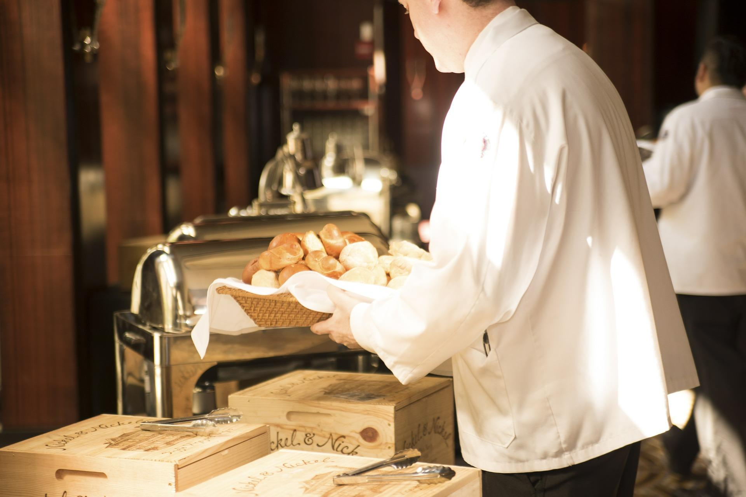

https://pixabay.com/en/waiter-bread-deliver-serve-food-492872/

Every year, it's important to pay attention to how culture is changing. What and where we eat are two of the most essential points to consider, as food culture is one of the main cultural centers for most cities and countries. For some towns, it's all they have to offer. For many cities, it's a symbol of extravagance, richness, and diversity, a central totem that brings people together.

It's no secret that the Restaurant trends 2018 has to offer will be unique as technology and accessibility provide a closer look at how restaurants operate and connect with customers.

Three that we are interested in discussing are:

- Ultra-Customer Service
- Data Shaping Menus
- Fusion & Outlier Inspired Cuisine
Each thus far has had an interesting effect, and we expect it will continue to as more restaurants use or adopt aspects of each. Without any further ado, let's get into it.

Ultra Customer Service
Customer service isn’t anything like it used to be. Depending on where you are located, it can mean having your waters constantly filled without asking, or your food out within a short amount of time. Customer service means different things to different people.

One of the reasons that this is important is because, beyond the food itself, the customer's experience comes down to the staff's ability to predict and assage any problems a customer may have. So, one of the emerging trends is two-fold:

- Ultra Hospitality
- Customer Tracking

Ultra hospitality means having a human touch in every aspect of the process. Whether via booking a reservation, ordering, or even finding the bathroom. There is someone always present, with a warm smile that helps you get what you need as fast as possible. While that sounds like what'd you'd expect at any top of the line restaurant; it is becoming more commonplace in even lower-end establishments.

Greater comfort, and greater ease of service that is only possible by coercing the wait staff into covering each other’s customers for any gap. It's highly efficient and thus far thoroughly successful.

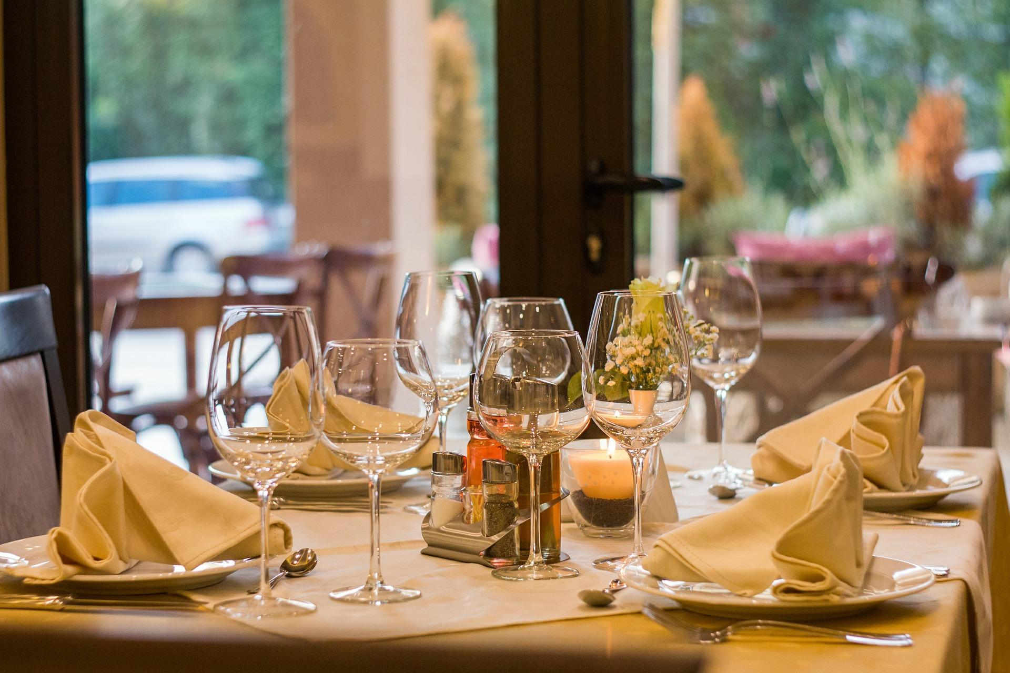

https://pixabay.com/en/restaurant-wine-glasses-served-449952/

Data Shaping Menus
Menus are transforming as well. No longer does one restaurant have the same menu for the entire year. Seasonal menus based on customer data collected by the restaurant team or third-party researchers are influencing what we are served. Its done so that there is never a lull in sales and to avoid customers becoming bored with cuisine.

This can mean foods that would otherwise not be thought of could be brought on potentially (based on owner, market price, and the chef's input), that would typically never before have been possible.
Restaurants and market researchers are capturing, comparing, and sorting data for every customer profile they create, and working to what they think of as the “perfect” menu for the season. Tech’s massive impact on the culinary arts is one of the biggest restaurant trends 2018 has seen thus far.

Fusion & Outlier Inspired Cuisine
Continuing from what was mentioned above, fringe foods and style of cuisine are making an impact. Things like soul food, Asian fusion, and African inspired dishes are making waves in newer markets.

To freshen up what restaurants are trying, more and more chefs and owners are taking risks.

