
DISEASE PREDICTION SYSTEM USING DECISION TREE AND RANDOM FOREST ALGORITHM
By
MUIA MUTUKU

REG NO:IN13/00021/19
&
MUTUA BONAVENTURE MATATA

REG NO:IN13/00093/19

DEPARTMENT OF COMPUTING SCIENCES

SCHOOL OF INFORMATION SCIENCE AND TECHNOLOGY

A Project Submitted to the School of Information Science and Technology
for the Study Leading to a Project in Partial Fulfillment of the
Requirements for the Award of the Degree of Bachelor of Computer Science.

DECLARATION
We certify that this proposal report does not incorporate, without acknowledgement, any material previously submitted for a degree or diploma in any university and to the best of my knowledge and belief, it does not contain any material previously published or written by another person or myself except where due reference is made in the text.

Name: MUIA MUTUKU Registration Number: IN13/00021/19

Signature………………………….. Date………………………….

Name: MUTUA BONAVENTURE MATATA Registration Number: IN13/00093/19

Signature………………………….. Date………………………….

SUPERVISOR
This project proposal has been submitted for examination with my approval as University Supervisor.

Signature………………………… Date………………………………
NAME: Dr.James Gitongori
Department of Computing Sciences
School of Information Science and Technology
Kisii University

DEDICATION
We dedicate this piece of work to our lecturers and supervisor: James Gitongori and our loving parents and our friends towards their continued support while we were working on this project.

ACKNOWLEDGEMENT
First of all, we give thanks to God Almighty for bringing us this far. We will acknowledge all the grace He gave us until we came to the end of our four-year course. We would like to express our gratitude towards James Gitongori, who gave me the technical guidance and continuous supervision of the project.
We thank the Computer Science degree coordinators at the University of Kisii, the project examination board, and the project coordinators of the Bachelor of Science in Computer Science degree program for giving us the technical knowledge and guidance throughout the degree program.
We would also like to thank our parents and friends, who have helped us from the beginning to make this project a success. Finally, we want to thank everyone who took an active part in making this project a success.

TABLE OF CONTENT

Table of Contents
CHAPTER 1.0 INTRODUCTION 7
1.1 Background information 9
1.2 Problem statement 10
1.3 Objectives 10
1.4 Scope 11
1.5 Justification 11

CHAPTER TWO LITERATURE REVIEW 12
CHAPTER 3.0 METHODOLOGY 18
3.1 System development methodology 19
3.2 Analysis and design tools 20
3.3 System implementation tools 20
3.4 System testing and validation 21
CHAPTER 4.0 SYSTEM ANALYSIS DESIGN 22
CHAPTER 5.0 SYSTEM IMPLEMENTATION TESTING AND VALIDATION 30
CHAPTER 6.0 SUMMARY ,CONCLUSION AND RECOMMENDATIONS 35
REFERENCES 37

ABSTRACT

Disease Prediction helps patients to identify the risk of disease or health problems/disorder. In certain circumstances, people feel unsafe to visit hospitals or individual doctors. Further, sometime people just want to know the type of disease, they have been suffering with. Therefore, a need for a generic disease prediction system arises using which people can predict the disease on the basis of symptoms that they are facing. This would also create an awareness of diseases and available medical advice thus avoiding further health complications.
The proposed project aims at developing a web-based system that can predict diseases based on the symptoms reported by the user
In today’s world almost everyone has an access to smartphones, it is going to play a crucial role in improving future of public health care system. This will further help patients in getting fast and appropriate medical opinion, improve patient care, decrease in resource consumption and further reduce health care costs.

CHAPTER ONE

1.0 INTRODUCTION
People need expert advice to take care of their health. It doesn't always happen that people go to hospitals to get their tests done and get the reports to know what is their health condition. We need something smarter technology to fill this gap between human and their health. Sometimes people will not be able to access the use of healthcare facilities because of several factors.
The Smart Health Care Prediction System is a project which is the solution for an end-user to all his problems. This project tries to help the user with all his health-related problems and provide services. This platform revolutionizes the manner in which people can monitor and upkeep their health and also enables the patients to reach their nearest health services at the touch of a button. The users get expert guidance from licensed medical practitioners.
Over the course of the last several years, there has been a discernible quickening in the rate of change that is occurring in the healthcare business. As a direct consequence of the evolution of technology, data science and machine learning have arisen as strong tools that may aid medical practitioners in detecting illnesses and generating predictions about sickness. These techniques can also help prevent diseases. The goal of this project is to use machine learning to develop a model that is capable of reliably predicting illnesses given a list of symptoms. This model will be used in this project. The model will be trained using a dataset that includes symptoms and illnesses, and when it has been trained, the final model will be implemented as a web application. The dataset that will be used to train the model can be found here.
This online consultation program will have a huge database containing information on myriads of symptoms and possible disease diagnosis for all symptoms. The users had to enter their medical problems and symptoms to get the results. This project uses the method known as
'Data Mining' to find accurate results based on the information received. Today's era is the one of informatization. With the advancement of technology and scientific theory, traditional medicine with biotechnology as its core, has gradually begun to digitize and to Informa ionize. And smart HealthCare incorporating a new generation of information technology has emerged. Smart healthcare is not just a simple technological advancement, but also an all-round, multi-level change. This change is embodied in the following: medical model changes (from disease-centered to patient centered care), informatization construction changes (from clinical informatization to regional medical informatization), changes in medical management (from general management to personalized management), and changes in the concept of prevention and treatment (from focusing on disease treatment to focusing on preventive healthcare).
These changes focus on meeting the individual needs of people while improving the efficiency of medical care, which greatly enhances the medical and health service experience, and represent the future development direction of modern medicine. This review will start from the concept of smart healthcare, then briefly introduce the key technologies supporting smart healthcare and explain the achievements and challenges of it by reviewing the application status of these technologies in important medical fields, before finally putting forward the future prospects of smart healthcare.
Data mining can be described as a process of searching patterns or correlations from a large data set to valuable information that can solve problems and predict outcomes. It involves analyzing certain amount of information to locate certain patterns of occurrence to predict future tendencies, using several processes of effective data collection, warehousing and computer processing. With this functionality therefore, it serves a great purpose when it comes to predicting people’s health diseases especially on finding correlation between the health information that has been given by both the medical staff and the patient. These finding may provide a beneficial advantage in the healthcare industry as it may be used to manage patients on their current health issues and for doctor to alleviate them from their jobs.
There are currently a lot of health institutions that has been developed such as hospitals and medical centers which are crucial to maintain and improve the health of the community around us. It is a prime establishment of giving proper healthcare especially for every one of us who have ever lived. For every illness and diseases that people may face today and sometime in the future, it is because of these medical institutions and all the doctors who worked at these places that have made our lives physically better and healthy.
Although hospitals now are well-equipped with their staffs working, there are still known issues that still persists that cause the staffs to make poor clinical decision that affects a patient’s health such as the lack of qualified doctors, unorganized health information and poor communications between doctors and patients With all of these issues mentioned, solutions are needed to be made and that is where a health prediction system should be implemented which could potentially eliminate these concerning issues. Hence, the current research proposes to apply data mining for smart health prediction.

  - BACKGROUND INFORMATION
It might have happened so many times that you or someone yours need doctors help immediately, but they are not available due to some reason. The Health Prediction system is an end user support and online consultation project. Here we propose a system that allows users to get instant guidance on their health issues through an intelligent health care system online.
The system is fed with various symptoms and the disease/illness associated with those systems. The system allows user to share their symptoms and issues. It then processes user’s symptoms to check for various illnesses that could be associated with it. Here we use some intelligent data mining techniques to guess the most accurate illness that could be associated with patient’s symptoms.
In doctor module when doctor login to the system doctor can view his patient details and the report of that patient. Doctor can view details about the patient search what patient searched for according to their prediction. Doctor can view his personal details. Admin can add new disease details by specifying the type and symptoms of the disease into the database. Based on the name of the disease and symptom the data-mining algorithm works. Admin can view various disease and symptoms stored in database.
This system will provide proper guidance when the user specifies the symptoms of his illness.
Data mining is the process of sorting through large data sets to identify patterns and relationships that can help solve business problems through data analysis. Data mining techniques and tools enable enterprises to predict future trends and make more-informed decisions.
Data mining is a key part of data analytics overall and one of the core disciplines in data science, which uses advanced analytics techniques to find useful information in data sets. At a more granular level, data mining is a step in the knowledge discovery in databases (KDD) process, a data science methodology for gathering, processing and analyzing data. Data mining and KDD are sometimes referred to interchangeably, but they're more commonly
seen as distinct things.

  - 1.2 PROBLEM STATEMENT

The core idea behind the project is
- To propose a system that allows users to get instant guidance on their health issues. This system is fed with various symptoms and the disease/illness associated with those systems. This system allows user to share their symptoms and issues It then processes user’s symptoms to check for various illnesses that could be associated with it If the system is not able to provide suitable results, it informs the user about the type of disease or disorder it feels user’s symptoms are associated with and also suggest the doctor to whom he or she can contact.

1.3 MAIN OBJECTIVES
Main aim is to develop a disease prediction system which will allows users to get instant guidance on their health issues. The system contains data of various symptoms and the disease/illness associated with those symptoms. The system can discover and extract hidden knowledge associated with diseases from a historical data set.

1.3.1 OBJECTIVES
- To conduct a thorough literature review
- To develop a system to predict diseases
- Improving the accuracy of existing prediction models
- Test the system to evaluate its accuracy ,reliability and effectiveness

1.5 SCOPE
Disease prediction helps in the diagnosis multiple diseases by analyzing various symptoms using machine learning algorithm techniques. Machine learning technology offers a strong application forum in the medical industry for health disease prediction concerns based on user/patient experience.
The system contains data of various symptoms and the disease/illness associated with those symptoms.
  - JUSTIFICATION
- The smart medical prediction system is of great importance to the enterprise strategy and business development, and it is also of great value to provide medical advices for patients and assist patient guidance.
- This system allows users to get instant guidance on their health issues through an intelligent health care system online.
- Predict various fatal disease at comfort of your place

CHAPTER TWO

2.0 LITERACTURE REVIEW
The prediction of diseases has been challenging task for the system. The goal of this paper is to develop machine learning algorithms for prediction of diseases. We carry out a medical observation for some time for prediction purpose. The machine learning consists of analysis of large amount of data available in healthcare field and obtains the useful information. The information can be converted to knowledge using different algorithms.
Divya Tomar and Sonali Agarwal have presented a concise presentation of machine learning techniques in healthcare area. This contains additional features, applications, difficulties and future scope of machine learning techniques. Priyanka Pawar, Megha Walunj and Pallavi chitte presented a procedure to anticipate elements in view of client input side effects. They have assembled a model to exhibit the effectiveness of these techniques which will guide clients about their problems which they are experiencing.
It predicts possible illness by data collections and and gives proposed specialists and medical arrangements. Divya Jain presents a review of the implementation of machine learning algorithm on datasets. It states the details of the idea on two-step frequent data items using machine learning rules. In this paper, we set out to identify efficient algorithm for results. We can create different types of applications for healthcare industry so as to fulfill by using all these predictive analysis and machine learning algorithms.
In this review we have a tendency to converse the assorted methodologies for sickness detection. Studies show that hoping on pure naked-eye observation of specialists to notice and classify diseases is time overwhelming and high-ticket, particularly in rural areas and developing countries. Thus, we have a tendency to gift quick, automatic, low price and correct image procedure primarily based resolution. resolution consists of 4 main parts; within the 1st phase we have a tendency to produce a color change structure for the RGB leaf image then, we have a tendency to apply color house transformation for the color transformation structure. Next, within the second part, the pictures are divided exploitation the K-means bunch technique. within the third part, we have a predisposition to calculate the feel choices for the divided infected objects. Finally, within the fourth part the mined options are versed a pre-skilled neural network.

This presents Associate in Nursing approach for cautious detection of diseases and identification .
There are numerous work that has been done related to disease prediction system using different Machine
Learning algorithms and achieved different results for different methods in medical field.

The paper 1“Disease Prediction System” used Decision tree, Random forest and Naïve Bayes algorithms to predict a disease on the basis of systems and to enable synchronized and well versed medical systems ensuring maximum patient satisfaction

The paper 2” Heart Disease Prediction with Machine Learning Approaches" made use of LR,NB,KNN,SVM,DT and RF algorithms for prediction of heart disease with proper data processing and implementation of ML algorithm with different parameters and among all Machine Learning algorithms, the highest accuracy is achieved by KNN with 87%.

The paper 3”Heart Attack Prediction By Using Machine Learning Techniques" has compared various Machine Learning models with the help of performance metrics and to detect heart related problems with highest accuracy of 89.34% by SVM.

The paper 4 ”Disease Prediction Using Machine Learning over Big Data” has proposed a CNN-MDRP algorithm which combines structured and unstructured data and proved that CNN-MDRP is more accurate than previous prediction algorithm.

The paper 5” A Review of Heart Disease Prediction Using Machine Learning and Data Analytics Approach” used different types of DM and ML methods to predict the happening of heart disease and apply the proposed system for the area it needed.

The paper 6“Application of Machine Learning Predictive Models in the Chronic Disease " focused on SVM and LR algorithms and evaluate the study models associated with diagnosis of chronic disease. These models are highly applicable in classification and diagnosis of CD.

The paper 7 “COVID -19 Outbreak Prediction with Machine Learning" made use of MLP and ANBEIS and presented a comparative analysis of ML and soft models to predict Covid-19 outbreak and provides initial benchmarking to demonstrate the potential of ML for future. The paper 8"Heart Disease Prediction System Using Machine Learning" has built a heart disease prediction system using NB algorithm that provides 88.163% accuracy among others. The paper 9"Heart Disease Prediction Using Machine Learning" suggested a robust model to predict a heart disease and found that Logistic Regression algorithm has the most efficient with an accuracy of 82.89% followed by DT and NB with 80.40% each and SVM was having 81.75%. The paper 10 " Implementation of Machine Learning Model to Predict Heart Failure Disease” has explored, recommended and applied a Machine Learning model in which Rapid Miner tool is used that calculated the high degree of correctness than Matlab and Weka tool. The paper 11 “Multiple Disease Prediction Using Different Machine Learning Algorithms Comparatively” has proposed a multiple disease prediction system which provides medicine and drug consultation of disease predicted. The paper 12 “Heart Disease Prediction Using Data Mining Techniques” used KNN, Naïve Bayes and SVM algorithms and collated with respect to the accuracy using heart disease dataset and achieved the highest accuracy of 86.6% using Naïve Bayes. The paper 13 “Heart Disease Prediction Using Machine Learning Techniques” has proposed a method for heart disease prediction using Machin Learning and the results showed a great accuracy standards for producing a better estimated results. The paper 14“Disease Prediction using Machine Learning” used KNN, Naïve Bayes, Logistic Regression and Decision Tree algorithms to make a disease prediction system which can predict the disease on the basis of symptoms and implemented using grails framework. The paper 15 “Disease Prediction using Machine Learning” used Naïve Bayes, Decision Tree and Random Forest algorithms to create a disease prediction system with better accuracy and it also provides motivational thoughts and images..

Several researchers have mentioned and implemented various detection techniques of disease using different datasets and machine learning approaches. Most of the researchers used some parameters like blood pressure, cholesterol, obesity, sex, unhealthy diet, lack of exercise, being overweight, high systolic Blood Pressure, high body mass index, high cholesterol level, tobacco smoking, high fasting plasma glucose level, and conclude that a heart disease patient can be attacked for those reasons. Budholiya et al. proposed a system where his team uses XgBoost algorithm along with Random Forest (RF), Extra Tree (ET) with Bayesian optimization, One-Hot (OH) encoding techniques that show the higher accuracy from the XgBoost algorithm, which reached about 91.8% (Budholiya et al., 2020). Yadav et al. used 1025 instances with 14 attributes from the UCI repository by using four tree-based classification algorithms: M5P, random Tree, and Reduced Error Pruning with the Random Forest ensemble method. They reached 99% accuracy on Random Forest (RF). They have also used three features-based algorithms: Pearson Correlation, Recursive Features Elimination, and Lasso Regularization (Yadav et al., 2020). Furthermore, Bergamini et al. proposed a Mapping risk of ischemic heart disease (IHD) using machine learning in a Brazilian state. Their main goal was to create and validate a Heart Health Care Index (HHCI) to predict the risk of IHD based on location and risk factors. They’ve used Secondary data, geographical information systems (GIS), and ML to validate the Heart Health Care Index (HHCI) and found an RMSE of 0.789 and error proportion close to one (0.867) in Support Vector Machine (SVM) (Bergamini et al., 2020). Samhitha et al. raised a system that used outfit characterization techniques to improve the exactness of frail calculations by consolidating different classifiers. They’ve also executed the calculation with a restorative dataset (Samhitha et al., 2020). Singh et al. planed a system where his team used algorithms like k-nearest neighbor (KNN), decision tree (DT), linear regression, and support vector machine (SVM) by using UCI Heart disease dataset and found 87% accuracy on KNN (Singh et al., 2020). Balakrishnan et al. proposed a model that his team constructed using Deep Neural Network and χ2-statistical model. They solve the problem of underfitting and overfitting issues and used DNN and ANN to analyze the efficiency of the model, which accurately predicts the presence or absence of heart disease (Balakrishnan et al.,
2021). Regression and Classification techniques are used to mine the data of the Cleveland heart dataset by Kavitha et al (2021). Decision Tree, Random Forest, and Hybrid model fused with DT and RF are applied as a classification method. The Hybrid model showed the highest accuracy pointed at 88.7% in this proposed prediction system. Moreover, Terada et al. used three machine learning classifiers in their medical diagnosis support system (MDSS) for atherosclerosis (Terrada et al., 2020). In their proposed system, UCI and Sani Z-Alizadeh, clinical datasets are used in the training and testing phase. The performance was measured by accuracy, precision, recall, F1-score, and Mathew’s correlation coefficient and showed that the 10-folds cross-validation method gained 94% accuracy. Fuad Ali Mohammed Al-Yarimi et al. endeavored an effective feature selection and analyzing technique to get actual accuracy to predict heart disease (Al-Yarimi et al.,2021). The variable size n-gram patterns technique examines the feature selection process of the dermatological dataset. The Naïve Bayes classifier is performed on particular optimal features to get the highest accuracy and maximum sensitivity. On the other hand, Mehmood proposed a method named CardioHelp to predict the presence of heart disease at an early stage (Mehmood et al., 2021). This research paper prepared a dataset and compared it with the state-of-art method to improve accuracy. Using 13 parameters, they have shown the accuracy is best in CNN that is 97%. Rani worked with the neural network method for feasible dataset classification. This research has used 13 parameters in its analysis phase and tried to increase the classification process’s efficiency (Rani et al., 2011). In 2013, the research conducted by Taneja et al. (2013) said that diagnosing heart disease patients in a timely is the most challenging task for the medical fraternity for high treatment cost and not affordable for all patients. So, the researcher proposed a system to predict heart disease using different supervised machine learning algorithms. The system shows 95.56% accuracy using the J48 technique, 92.42% accuracy in the SMO technique, and 94.85% accuracy in the multilayer perception approach.
. Using various classifications in his diagnosis test, he has shown the highest accuracy of 92.02% (Acharya et al., 2015). After that, Aman et al. (2021) established a heart disease prediction system using the WEKA tool and 10-Fold cross-validation. The author worked with SMO, J48, KStar, and Bayes Net classification to predict accuracy (Aman et al., 2021). Based on his research performance, the accuracy of SMO is 89%, 87% accuracy in Bayes Net, and accuracy of Multilayer perceptron, J48, and KStar are 86%, 86%, and 75%, respectively. The accuracy achieved from those algorithms is not satisfactory considered to others. Mohan et al. suggested a unique strategy for identifying key characteristics using classification techniques, which enhance the accuracy of cardiovascular disease forecasting. The proposed method for heart disease using the hybrid random forest with a linear model delivers an improved effectiveness with an overall accuracy of 88.7%, according to research (HRFLM) (Mohan et al.,
2019). Furthermore, Riyaz et al. proposed a model that predicts heart disease using SVM, Naïve Bayes, Association rule, KNN, ANN, and Decision Tree classification techniques (Riyaz et al., 2022). Mamun Al et al. suggested a research based on three-classification based on k-nearest neighbor (KNN), decision tree (DT), and random forests (RF) algorithms utilizing a heart disease dataset gathered from Kaggle. With 100 percent accuracy, sensitivity, and specificity, the RF technique was successful (Ali et al., 2021a). Ali and Bukhari provided a model with a 93.33 percent accuracy rate, and that is greater than the accuracy of twenty-eight recently established HF risk prediction models, which ranged from 57.85 percent to 92.31 percent. If this method is used in a clinical setting, this will be beneficial to physician (Ali et al., 2021b).

CHAPTER THREE

3.0 METHODOLOGY
Our project is stand on multiple disease prediction in accordance with symptoms entered by patient. The first task is to determine the problem statement. Then making the dataset ready to work on. After that we conceptualize our data using scatter plot, distribution graph, etc. by doing so we can find out anomalies, missing values, etc. on our data and make our dataset perfect for prediction. And finally, the main feature will be Machine Learning in which we will be using algorithms like Decision Tree, Random Forest, Naive Bayes and KNN which will predict accurate disease for early prediction and better patient care. For this model, we have used python as a platform to execute our Machine Learning algorithms. We have also developed an elegant GUI to provide interaction with system
Decision Tree
It is a type of supervised Machine Learning algorithm that mainly deal with classification problem. The main objective of using decision tree is to make a training model that can be used to predict the class or values of the desired value by learning elementary decision procedure surmise from existing data (training data) [9]. In Decision Tree algorithm, we start from root of the tree to predict the class. We collate the values of the root trait with data's trait. On the basis of differentiation we go ground with the branch parallel to that value and move to next node [9]. In this system Decision Tree splits the symptoms as per its classification and lowers down the dataset complexity. It is most effective Machine Learning algorithm to describe Decision tree in graphical manner [2]. It deals with huge and complicated datasets without involvement of multiple parametric structure. With the help of training datasets, decision tree model is decided and a validation dataset decides appropriate tree size to achieve the optimal final model.

In our proposed method, disease can be detected more efficiently and less costly within a short time. This paper worked with preprocessed data to train and test using machine learning algorithms. In the first stage, preprocessed data are divided into two parts. Most of those are used in the training phase (80%), and the rest (20%) are used in the testing phase. In the training and testing phase, the proposed system has trained our dataset using machine learning algorithms like Decision tree, XgBoost, KNN, Support vector machine, Naïve Bayes, Logistic Regression, AdaBoost, and Random Forest. Using the Jupyter platform, we have trained and finally predicted the result of a patient. As shown in Fig. 1, our trained system will indicate the presence of cardiovascular disease in a patient. The primary intention of this raised system is to detect heart disease more efficiently and accurately.

  - 3.1 Preprocessing
Firstly, we have preprocessed the collected dataset to reduce complexity and enhance user accessibility. There are many datasets in Kaggle, UCI, Cleveland, etc. In those entire data centers, more than 76 attributes are presented. We have selected the Kaggle dataset, where 13 parameters are assigned, and those factors are more responsible for heart disease. The selected Kaggle dataset contains almost equally condition and non-disease patient data, whereas the UCI dataset is not similarly divided for disease and non-disease patients. That diminishes the number of inputs to the network and helps it learn more accurately and efficiently. The most appropriate top 13 attributes are age, sex, chest pain, blood pressure, serum cholesterol, fasting blood sugar, resting ECG, thalassemia, max heart rate achieved, ST depression induced by exercise relative to rest, significant vessels and using those factors the system predicts the heart condition.
In order to get started on the process of developing the machine learning model, it is important to carry out the process of preprocessing the dataset. This is required in order to get started. This is the beginning of the process's first step. This includes getting rid of any symptoms that are the same as one another, getting rid of any unique characters or numerals, and turning everything to lowercase form. During the preprocessing step, which will be undertaken on the sicknesses dataset, any diseases that do not have associated symptoms will be eliminated, and any unusual characters or numbers will be cleaned up. This will be done in preparation for the subsequent stages of processing. In addition, this process will be carried out on the dataset of diseases. In addition to this, we are going to eradicate any diseases that are not accompanied by any symptoms.

3.2 Splitting
The accurate classification result of the dataset depends on the training and testing phase. To get a better result, we divided our whole dataset into two parts: the majority percent of the dataset (80%) for training, and the rest of those are for testing (20%).
Our main goal is to train the best performing model possible, using the pre-processed data.
We used classification algorithms.
- Decision Trees
- Random Forest

3.3 Classification models
The training data uses eight machine-learning algorithms, i.e., DT, LR, Naïve Bayes, AdaBoost, SVM, RF, XgBoost, and KNN. Each algorithm is explained in detail below.
3.3.1 Decision Tree
A decision tree is one kind of supervised learning algorithm. A decision tree is constructed based on high entropy inputs (Charbuty et al., 2021). It uses tree representation starting from root to edge leaf node, and all leaf node corresponds to a class label, and attributes are depicted on the internal node of the tree. In an entropy system, the decision tree removed irrelevant samples from the dataset, and gained information is known as root. In machine learning, KNN is used to classify as a non-parametric method. That means KNN does not make presumptions about the data distribution used in the analysis. This algorithm predicts the class of a new instance based on the most votes by its closest neighbors. It uses Euclidean distance to measure the length of an attribute from its neighbor. The result can vary for the K value and give the best predictions for the optimal

  - 3.4SYSTEM TESTING AND VALIDATION
TRAINING AND TESTING OF THE MODEL ON DATA
For training a model we initially split the model into 2 sections which are ‘Training data’ and ‘Testing data’.
We trained the classifier using ‘training data set’, and then test the performance of your classifier on unseen ‘test data set’. An important point to note is that during training the classifier only the training set is available. The test data set must not be used during training the classifier. The test set will only be available during testing the classifier.
Training set: The training set is the material through which the computer learns how to process information. Machine learning uses algorithms to perform the training part. A set of data used for learning , that is to fit the parameters of the classifier.
Test set: A set of unseen data used only to assess the performance of a fully-specified classifier
Once the model is trained we can use the same trained model to predict using the testing data i.e. the unseen data. Once this is done we can develop a confusion matrix, this tells us how well our model is trained. A confusion matrix has 4 parameters, which are ‘True positives’, ‘True Negatives’, ‘False Positives’ and ‘False Negative’. We prefer that we get more values in the True negatives and true positives to get a more accurate model. The size of the Confusion matrix completely depends upon the number of classes

Python Libraries that would be need to achieve the task:
1. Numpy
2. Pandas
3.Sci-kit Learn
4. Tkinter

CHAPTER FOUR

4.0 SYSEM ANALYSIS AND DESIGN
4.1 SYSTEM ANALYSIS
Machine learning uses programmed algorithms that receive and analyze input data to predict output values within an acceptable range. As new data is fed to these algorithms, they learn and optimize their operations to improve performance, developing ‘intelligence’ over time.
Main goal of this was to provide development opportunities that enhance knowledge, develop skills. Machine learning, one of the top emerging sciences, has an extremely broad range of applications in fields such as Business Analytics where big companies use their extreme amount of raw data to figure out it into a meaningful data using Graphs and plots to make decision about prices and future investments
This was very important so that I can know more about our emerging fields. Any firm needs to work on common raw data so that it is understandable and meaningful to the people who wants to make decision using graphs and predictable methods.
During this period, I found myself to be efficient at work. My major strengths were that I was punctual, flexible, knowledgeable and compassionate.

4.3 SYSTEM DESIGN
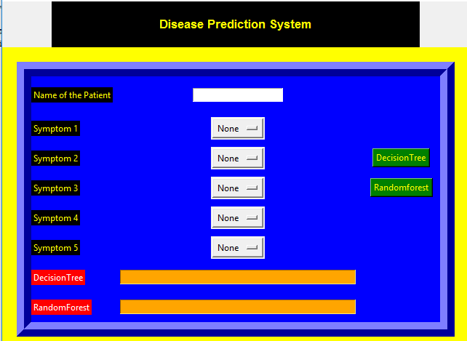
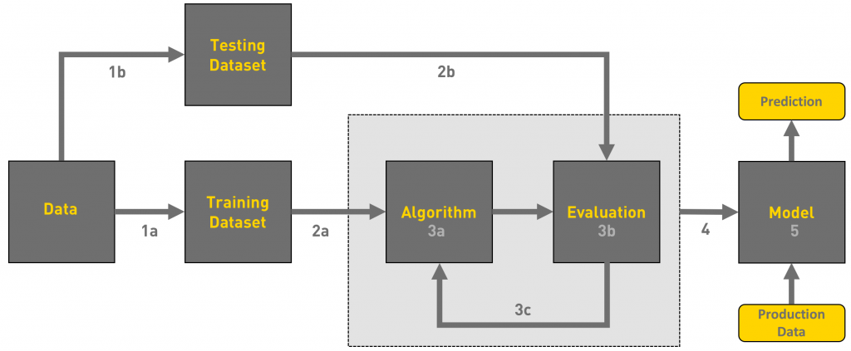

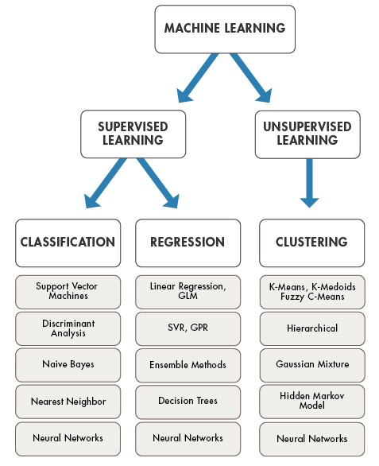
As we want to predict the disease of the patient so classification algorithm is the best suited for this type
Classification Algorithm has many algorithms providing various levels of accuracy
The two best models namely Random forest and Decision tree will be used here

DATASET:
The dataset that will be used for this study will be split into two sections, namely, symptoms and illnesses. Each of these sections will be analyzed separately. Separate consideration will be given to each of these divisions. The dataset that is titled "symptoms" will contain a list of symptoms along with descriptions of each symptom. The dataset that is titled "diseases" will contain a list of illnesses along with the symptoms that are associated with each illness. Both of these datasets will be connected to one another. Both datasets will be linked to one another. The dataset is going to be preprocessed to verify that the symptoms and illnesses are appropriately represented. Also, any data that is missing or incorrect is going to be deleted at this stage in the process. In addition, the preprocessing will ensure that the dataset has all of the relevant data by providing a guarantee of this fact.

TRAINING AND TESTING OF THE MODEL ON DATA
For training a model we initially split the model into 2 sections which are ‘Training data’ and ‘Testing data’.
We trained the classifier using ‘training data set’, and then test the performance of your classifier on unseen ‘test data set’. An important point to note is that during training the classifier only the training set is available. The test data set must not be used during training the classifier. The test set will only be available during testing the classifier.
Training set: The training set is the material through which the computer learns how to process information. Machine learning uses algorithms to perform the training part. A set of data used for learning , that is to fit the parameters of the classifier.
Test set: A set of unseen data used only to assess the performance of a fully-specified classifier
Once the model is trained we can use the same trained model to predict using the testing data i.e. the unseen data. Once this is done we can develop a confusion matrix, this tells us how well our model is trained. A confusion matrix has 4 parameters, which are ‘True positives’, ‘True Negatives’, ‘False Positives’ and ‘False Negative’. We prefer that we get more values in the True negatives and true positives to get a more accurate model. The size of the Confusion matrix completely depends upon the number of classes

FEATURE EXTRACTION:
When the dataset has been preprocessed, the symptoms dataset will be used to extract features for the machine learning model. Symptoms are signs that something is wrong. This will take place when the preparation of the dataset has been completed. In order to facilitate the process of feature extraction, the symptom dataset is transformed into a numerical format. After that, the model for machine learning might make use of this representation. In order to do this, you will need to use methods like bag-of-words analysis and TF-IDF. In TF-IDF, the frequency of each word in a symptom is calculated, and then that number is multiplied by the inverse document frequency of that word in order to give that word a greater weight in the feature representation. Bag-of-words, on the other hand, entails encoding each symptom as a vector of occurrences of each word in a preset lexicon. This may be done by using a prepared dictionary. An alternate strategy to TF-IDF is called bag-of-words.
MODEL SELECTION:
We will put a range of machine learning algorithms through a series of tests in order to see how effectively these algorithms can diagnose diseases based on the symptoms shown by patients. Our goal is to determine the accuracy with which these algorithms can do so. These programs will make use of a wide range of statistical approaches. Some of these approaches include decision trees, random forests, logistic regression, and support vector machines. In order to determine how accurate the model is, it will first be trained using one section of the dataset, and then it will be tested using another section of the dataset. The model will be brought to its highest level of precision by following these steps. The degree of precision that can be achieved by each algorithm will be evaluated, and the one that is capable of achieving the greatest level of precision will be chosen as the one to serve as the basis for the ultimate model.
MODEL EVALUATION:
A wide variety of measurements, such as accuracy, recall, and F1 score, amongst others, will be used in the analysis in order to determine whether or not the findings that were generated by the machine learning model were accurate. This will allow for the determination of whether or not the findings were accurate. The term "precision" refers to the degree to which the number of real positive findings is related to the total number of positive results obtained by the test. The "recall" is the proportion of true positives to the total number of genuine positives that are detected in a sample, and it is expressed as a percentage. This proportion is the proportion of true positives to the total number of real positives that are identified. Finding the harmonic mean of the numbers obtained for memory and accuracy is what determines an individual's F1 score. Throughout the evaluation process, these metrics will be employed so that a conclusion can be made about how correctly the model is able to diagnose diseases based on the manifestation of symptoms.
Once the model is trained we can use the same trained model to predict using the testing data i.e. the unseen data. Once this is done we can develop a confusion matrix, this tells us how well our model is trained. A confusion matrix has 4 parameters, which are ‘True positives’, ‘True Negatives’, ‘False Positives’ and ‘False Negative’. We prefer that we get more values in the True negatives and true positives to get a more accurate model. The size of the Confusion matrix completely depends upon the number of classes.
- True positives: These are cases in which we predicted TRUE and our predicted output is correct.
- True negatives: We predicted FALSE and our predicted output is correct.
- False positives: We predicted TRUE, but the actual predicted output is FALSE.

- False negatives: We predicted FALSE, but the actual predicted output is TRUE.
We can also find out the accuracy of the model using the confusion matrix.
- Accuracy (all correct / all) = TP + TN / TP + TN + FP + FN
- Misclassification (all incorrect / all) = FP + FN / TP + TN + FP + FN
- Precision (true positives / predicted positives) = TP / TP + FP
I.e., for example:
Accuracy = (100 + 50) / 165 = 0.9090 (90.9% accuracy)
Confusion matrices have two types of errors:
Type I and Type II. False Positive contains one negative word (False) so it’s a Type I error. False Negative has two negative words (False + Negative) so it’s a Type II error.
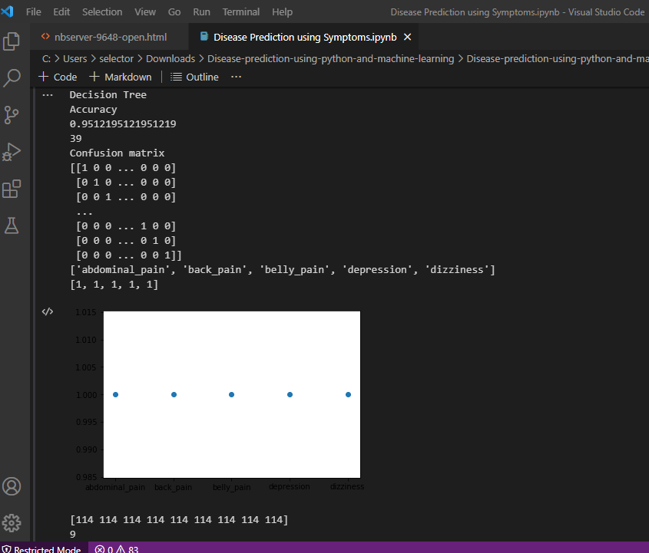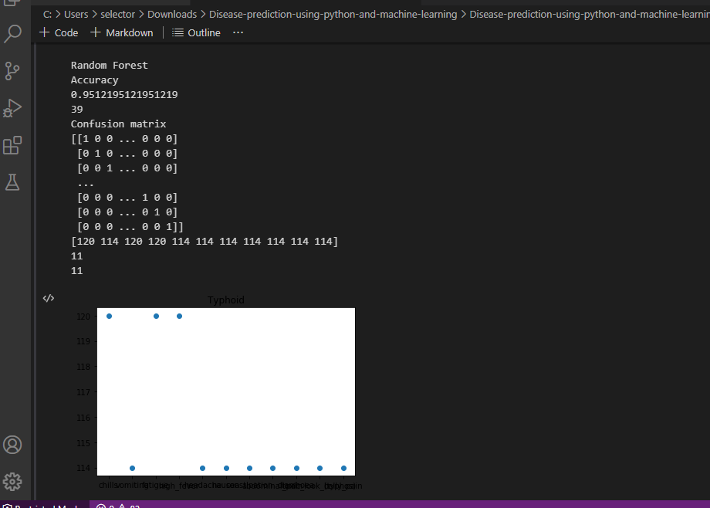

CHAPTER FIVE
5.0 SYSTEM IMPLEMENTATION TESTING AND VALIDATION
The completed machine learning model will be deployed as a web application, and users will be able to input their symptoms into the model. After that, users will get a prognosis on the ailment that is most likely to be the root cause of their symptoms. For the whole of the program's development phase, a web application framework will be used. Some examples of such frameworks are Flask and Django. The user will be able to enter their symptoms into the program through a straightforward user interface, and the program will then provide a diagnosis of the condition that is most likely to be the cause of the symptoms after the user has entered their symptoms. The application will also provide additional details on the disease, such as its signs and symptoms, the factors that contribute to its development, and treatment options for people who are afflicted by it.
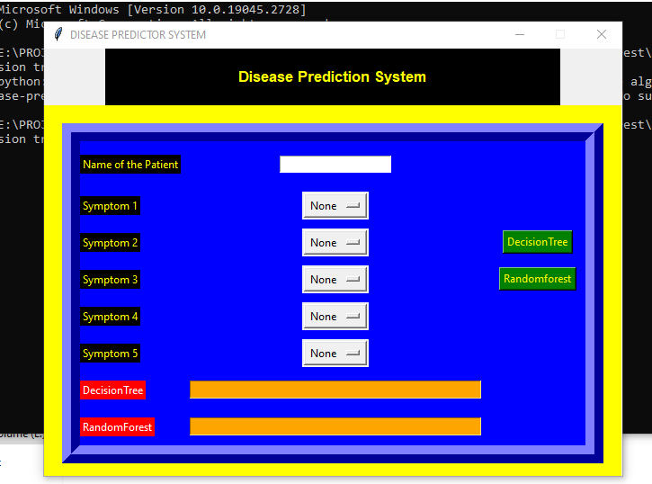
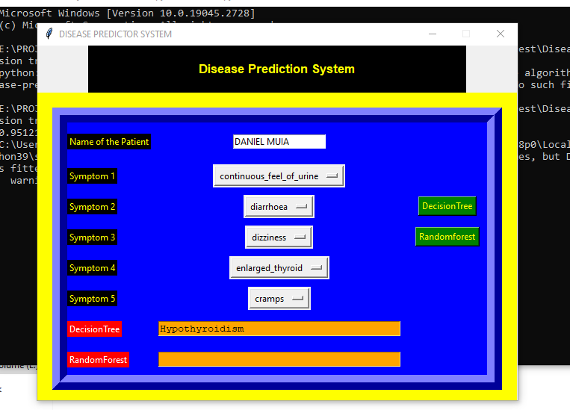
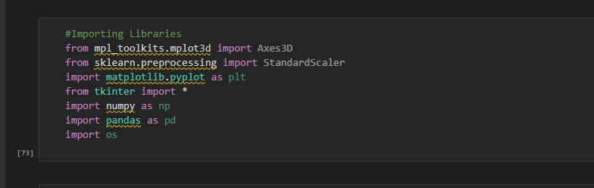
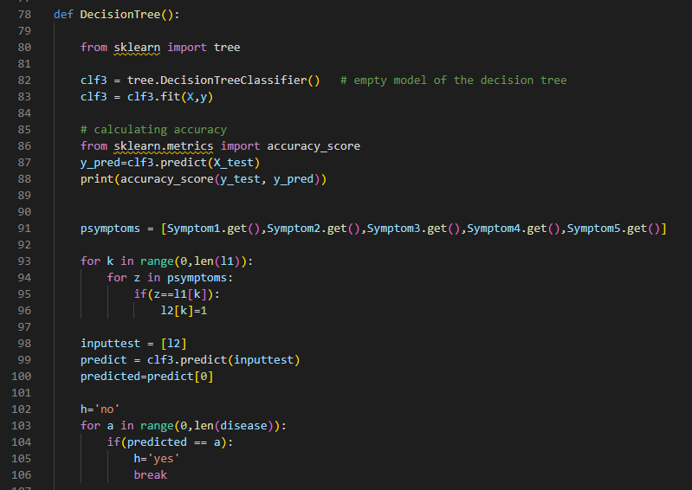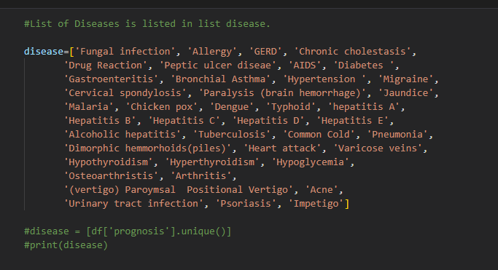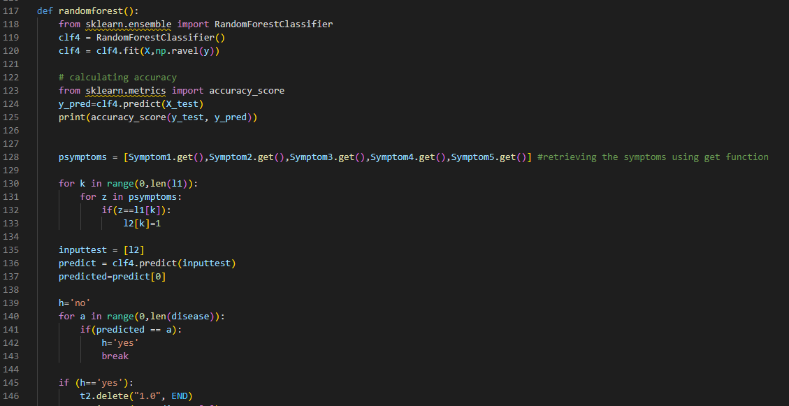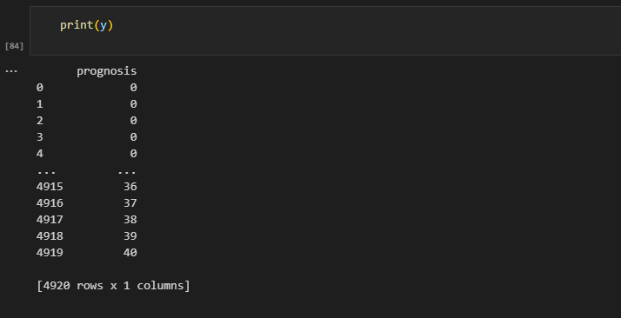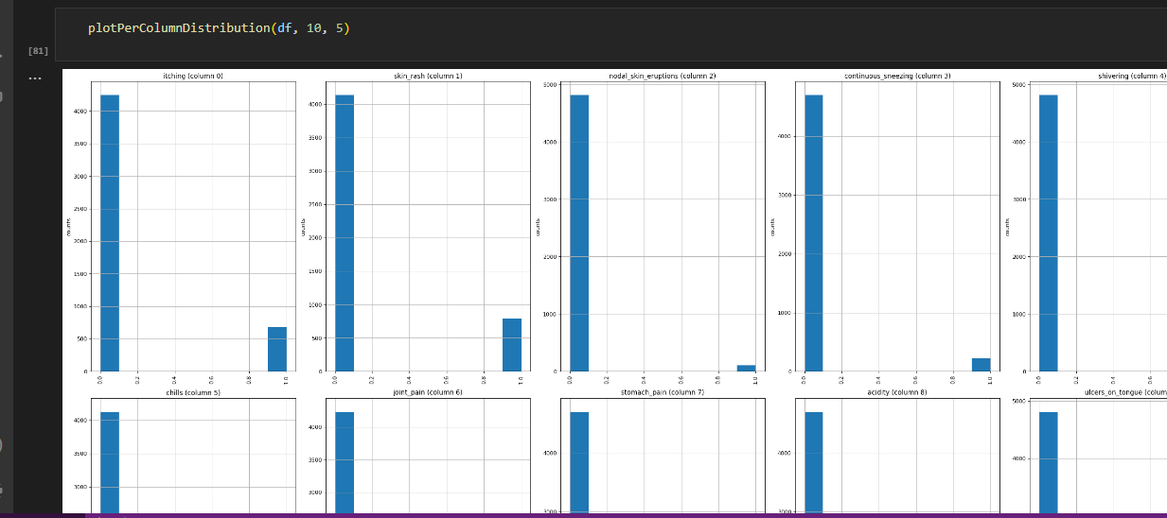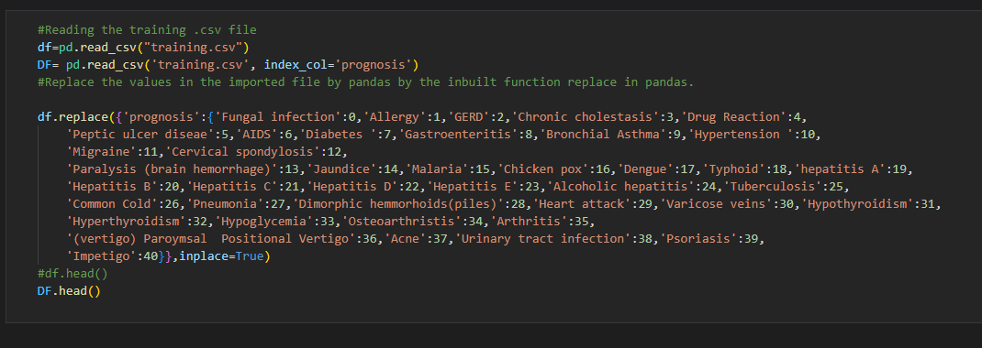

CHAPTER SIX

6.0 SUMMARY ,CONCLUSIONS AND RECOMMENDATION
  - 6.1 SUMMARY
The goal of this project is to use machine learning to develop a model that is capable of reliably predicting illnesses given a list of symptoms. This model will be used in this project. The model will be trained using a dataset that includes symptoms and illnesses, and when it has been trained, the final model will be implemented as a web application. The dataset that will be used to train the model can be found here. Throughout the study, some of the measures that will be utilized to assess how accurate the model is include the accuracy, the recall, and the F1 score. Users of the program will be provided with a user-friendly interface when the application is fully developed. This interface will allow users to input their symptoms and get a diagnosis of the disease that is most likely to be the source of those symptoms.
  - 6.2 CONCLUSIONS
A disease prediction system using decision tree and random forest is a powerful tool in the healthcare industry that can aid in early detection, prevention, and treatment of various diseases. These algorithms utilize a large dataset of patient information to identify patterns and make predictions based on those patterns.
The use of decision trees can help in identifying the most relevant features or risk factors associated with a disease. Random forest, on the other hand, can provide more accurate predictions by combining the outputs of multiple decision trees. Both decision tree and random forest algorithms can handle missing data and outliers.
The system's accuracy is dependent on the quality and quantity of data used to train the model. The accuracy can be improved by using a larger dataset and ensuring that the data is representative of the population being studied. Additionally, feature selection and engineering techniques can be used to further improve the accuracy of the model.
The system can be used to predict a wide range of diseases, including cancer, cardiovascular diseases, diabetes, and infectious diseases. It can also be customized for specific populations, such as gender, age, or ethnicity.
In conclusion, a disease prediction system using decision tree and random forest can be a valuable tool in healthcare for early detection, prevention, and treatment of diseases. However, its accuracy depends on the quality and quantity of data used to train the model, and further research and refinement may be necessary to improve its performance.

6.3 RECOMMENDATION
Collect high-quality data: The accuracy of the disease prediction model depends on the quality of the data you use to train the model. Ensure that the data you collect is representative, diverse, and well-annotated.
Use appropriate algorithms: There are many machine learning algorithms that can be used for disease prediction. Choose the algorithm that is best suited for your specific use case. For example, decision trees, logistic regression, random forests, and neural networks are all commonly used algorithms for this purpose.
Consider interpretability: Interpretability is important in medical applications. Ensure that the model you build can be easily understood and interpreted by clinicians and medical practitioners. This will help them to make better decisions and provide more accurate diagnoses.
Validate the model: It is important to validate the model on new and unseen data to ensure that it is accurate and generalizes well. Use appropriate metrics such as precision, recall, F1-score, and AUC to evaluate the performance of the model.
Consider ethical and legal implications: Disease prediction models raise ethical and legal concerns, such as the privacy of patient data and the potential for bias. Consider these implications and ensure that the model is developed in a way that is transparent and respects the privacy and rights of patients.
Involve domain experts: Involve domain experts such as medical professionals and researchers in the development and validation of the model. This will help ensure that the model is clinically relevant and accurate.
Make the model accessible: Make the disease prediction model accessible to clinicians and medical practitioners through user-friendly interfaces and dashboards. This will help them to integrate the model into their daily workflows and improve patient care.
REFERENCES
Khurana, Sarthak., Jain, Atishay., Kataria, Shikhar., Bhasin, Kunal., Arora, Sunny., & Gupta, Dr.Akhilesh . Das. (2019). Disease Prediction System.International Research Journal Of Engineering and Technology, 6(5), 5178-5184.
Kamboj, Mgha. (2020). Heart Disease Prediction with Machine Learning Approaches.International Journal Of Science and Research, 9(7), 1454-1458.
Ware,Miss. Sangya . , Rakesh,Mrs.Shanu. K., &Choudhary,Mr.Bharat . (2020). Heart Attack Prediction By Using Machine Learning Techniques. International Journal Of Recent Technology and Engineering, 8(5), 1577-1580.
Shirsath, Shraddha.Subhash., & Patil, Prof. Shubhangi. (2018). Disease Prediction Using Machine Learning over Big Data .International Journal Of Innovative Research in Science and Technology , 7(6), 6752-6757
Marimuthu, M., Abinaya, M., Hariesh,K.S., Madhan,K.,& Pavithra, Kumar. V. (2018). A Review of Heart Disease Prediction Using Machine Learning and Data Analytics Approach .International Journal of Computer Application , 181(18), 20-25.
Battineni, Gopi., Sagaro,Getu.Gamo. ,Chinatalapudi, Nalini. , &Amenta,Francesco. (2020). Application Of Machine Learning Predictive Models in the Chronic Disease.International of PersonalisedMedicine , 10(21), 1-
Ardabili, Sina. F., Mosavi, Amir., Khamosi, Pedram., Ferdinand, Filip. ,Varkonyi-Koczy. Annamaria.R. Reuter, Uwe., Rabczuk, Timon., & Atkinson,Peter M. (2020). COVID -19 Outbreak Prediction with Machine Learning.Journal of Algorithms,13(249), 1-36.
Shrestha, Ranjit., & Chatterjee,Jyotir. Moy. (2019). Heart Disease Prediction System Using Machine Learning. LBEF Research Journal of Science Technology and Management, 1(2), 115-132.
Magar,R ishabh. , Memane,Rohan.,Raut ,Sura. , &Rupnar,Prof. V.S. (2020) . Heart Disease Prediction Using Machine Learning. Journal of Emerging Technologies and Innovative Research, 7(6), 2081-2085.
Alotaibi, Fahd. Saleh. (2019). Implementation of Machine Learning Model to Predict Heart Failure Disease. International Journal of Advanced Computer Science and Application, 10(6), 261-268.
Godse, Rudra A., Gunjal,Smita S., JagtapKaran A .,Mahamuni ,Neha S., &Wankhade, Prof. Suchita. (2019). Multiple Disease Prediction Using Different Machine Learning Algorithms Comparatively.International Journal of Advance Research in Computer and Communication Engineering, 8(12), 50-52
Anitha, Dr.S., & Sridevi,Dr.N. (2019). Heart Disease Prediction Using Data Mining Techniques.Journal of analysis and Computation ,13(2), 48-55.
Bindhika,Galla Siva Sai., Meghana,Munaga., ReddyManchuriSathvika. , &Rajalakshmi. (2020). Heart Disease Prediction Using Machine Learning Techniques. International Research Journal of Engineering and Technology, 7(4), 5272-5276.
Pingale,Kedar., Surwase, Sushant., Kulkarni,Vaibhav.,Sarage ,Saurabh., &Karve, Prof. Abhijeet .(2019). Disease Prediction using Machine Learning.International Research Journal of Engineering and Technology, 6(12), 2810-2813.
Chauhan Raj H., NaikDaksh N., Halpati,Rinal A., Patel,Sagarkumar J. , &PrajapatiMr. A.D. (2020). Disease
Prediction using Machine Learning.International Research Journal of Engineering and Technology, 7(5), 2000-2002.
Acharya UR, Vidya KS, Ghista DN, Lim WJE, Molinari F, Sankaranarayanan M. 2015. Computer-aided diagnosis of diabetic subjects by heart rate variability signals using discrete wavelet transform method. Knowledge-Based Systems, 81: 56-64
Ali MM, Paul BK, Ahmed K, Bui FM, Quinn JM, Moni MA. 2021a. Heart disease prediction using supervised machine learning algorithms: performance analysis and comparison. Computers in Biology and Medicine, 136: 104672
Ali L, Bukhari SAC. 2021b. An approach based on mutually informed neural networks to optimize the generalization capabilities of decision support systems developed for heart failure prediction. Irbm, 42(5): 345-352
Alim MA, Habib S, Farooq Y, Rafay A. 2020. Robust Heart Disease Prediction: A Novel Approach Based On Significant Feature and Ensemble Learning Model. In: 2020 3rd International Conference on Computing, Mathematics and Engineering Technologies (ICoMET). IEEE
Al-Yarimi FAM, Munassar NMA, Bamashmos MHM, Ali MYS. 2021. Feature optimization by discrete weights for heart disease prediction using supervised learning. Soft Computing, 25(3): 1821-1831
Ayon SI, Islam MM, Hossain MR. 2020. Coronary artery heart disease prediction: a comparative study of computational intelligence techniques. IETE Journal of Research, 1-20
Aman RSC. 2021. Analyzing predictive algorithms in data mining for cardiovascular disease using WEKA
tool. International Journal of Advanced Computer Science and Applications, 12(8)
Balakrishnan M, Christopher AA, Ramprakash P, Logeswari A., 2021. February. prediction of cardiovascular disease using machine learning. Journal of Physics: Conference Series, 1767(1): 012013
Bantham A, Ross SET, Sebastião E, Hall G. 2021. Overcoming barriers to physical activity in underserved populations. Progress in Cardiovascular Diseases, 64: 64-71
Bari Antor M, Jamil AHM, Mamtaz M, Monirujjaman Khan M, Aljahdali,S, Kaur M, Singh P, Masud M. 2021. A comparative analysis of machine learning algorithms to predict Alzheimer’s disease. Journal of Healthcare Engineering, 2021
Bergamini M, Iora PH, Rocha TAH, Tchuisseu YP, Dutra ADC, Scheidt JFHC, Nihei OK, de Barros Carvalho, MD, Staton CA, Vissoci JRN, de Andrade L. 2020. Mapping risk of ischemic heart disease using machine learning in a Brazilian state. Plos one, 15(12): e0243558
Beyene C, Kamat P. 2018. Survey on prediction and analysis the occurrence of heart disease using data mining techniques. International Journal of Pure and Applied Mathematics, 118(8): 165-174

