SEO-texts (Guest blogging)

Best 10 Hot News Websites To Stay On Top in 2018

The websites with viral content are getting more and more popular among people who want to stay tuned and be the first one to learn fresh news and follow trends. Hard to say when it all has begun, but, the truth is that now viral websites are on top of their popularity.

The word “viral” is used regarding the piece of any information that is circulated rapidly and widely on the Internet. A piece of information can be both visual and textual: articles, images (memes, for instance), videos, infographics, quizzes and so on. Precisely saying, if you make a hilarious meme, post it on your website and share it on major social media platforms, it will go viral and bring you a lot of traffic on the website.

The virality is all about stories that are made basing on traditional journalistic views but are shaped and delivered and in new and somehow strange forms.

Unfortunately, viral websites tend to copy one another, that is why it’s generally difficult to find a good source for those who thirsty for hot news and well-designed content.

We’ve done our best to create a list of the leading viral websites in 2018. Don’t wait to check it out:

1. Nexter.org

Nexter.org is a new generation of virality. It’s a rapidly evolving media platform ready to offer its readers latest hot stories and most googled news. Here you can dive into the coalescence of entertaining and useful content, appearing in various forms: from regular articles to videos and quizzes.

Nexter is one of the leaders of top trending websites, delivering hot news, telling hilarious stories and entertaining lots of people around the globe. Its aim is to provide a unique voice and publish content that will be shared by people of all ages, genders, and nationalities. Everything that’s popular, viral and latest is here.

If you stay with Nexter, you will enrich your knowledge on various trending topics: traveling ideas, movies, life hacks and lifestyle solutions to change your life, beauty and fashion, delicious holiday recipes, cool technologies and interesting science failures and innovations, lists of self-improving apps and online courses, hot news and sales details for gamers and top business representatives. They don’t try to be political, however, you may stumble across some news and articles connected to the political sphere, but they are shaped in an accessible form.

You thinks that’s it? No, there is a lot more content than you can imagine. Go beyond your understanding.

2. BuzzFeed

BuzzFeed community is always welcome to check out the most recent hot stories and enjoy various quizzes on trending topics. They offer content that is relevant to our lives and accessible to any kind of audience. Top categories: News, Videos, Quizzes, Tasty, News.

3. TwistedSifter

TwistedSifter is a fast-growing viral website that aims to both entertain and educate its audience. Top categories: Art, Travel, Nature, Architecture, Animals. They also have quite interesting sections - “Picture of the Day” and weekly Friday post of the best articles and videos.

4. PolicyMic

PolicyMic shares viral stories, covering topics from latest news and top stories from the world, delivering the information in modern forms and rejecting the old-fashioned methods of journalism. Every story is rich in descriptions and is interesting for everybody. Top categories: Money, Food, Travel, Celebrities, Beauty.

5. PlayBuzz

PlayBuzz is one of the most popular storytelling platforms, featuring more than 150 employees from 55 countries and engaging a great deal of people every day. PlayBuzz users can create post in various untraditional forms Flipcard, Polls, Swiper, Convo, Video snap. Moreover, here content on can be published in 40+ languages. Top categories: Articles, Quizzes.

6. WittyFeed

WittyFeed is known for entertainment-related news, trending and viral life stories, current news, and interesting videos. You can submit your story and influence people from every corner of the world. Top categories: Science, Technology, Travel, Life, Animals, History and many more.

7. BoredPanda

BoredPanda - here you have an opportunity to create your own undoubtedly amazing content and post heart-breaking or funny stories from your life. BoredPanda is not afraid to get weird and brings a new vision on daily things. Top categories: Art, Photography, Animals.

8. ViralNova

As on BoredPanda, ViralNova users can post and share funny and fascinating stories through the submission form on the Internet and find people who have experienced the same situations. Tell the story that no one will forget and will want to share among their friends. Top categories: Science, Life, Culture, Videos, Entertainment.

9. The Daily Dot

The Daily Dot is the fastest growing Web content company that specializes in Internet culture and virtual life. They are going to change the shape of the standards of modern viral story, making a new tomorrow. The categories are named creatively, for instance, in “Debug” they share hot news on gadgets, platforms, and software.

10. LittleThings

Little Things is also one of the viral content sites targeted mostly at women (73%) of any age (18-55+) and is designed to publish and share posts and videos that will engage people on social websites. In other words, it’s a collection of well-written top stories of 2017 and before on topics women prefer reading. Top categories: Life, Food, Parenting, Pets, DIY.

Viral websites are evolving every second into something bigger than just a part of the gigantic Web. It is changing the old models of journalism, influencing and engaging more readers than you can think.

Thousands of editors work hard almost every day and do their best to create original content that wIll drive social engagement. They are looking for new innovative ways to give voice to top news stories from modern and diverse perspectives.

Want to be on top of the daily news? Eager to learn something new and afraid to waste your time on useless things? Then choose the viral website that suits you perfectly and take a look at its entertaining content every day, just like you take a sip of “damn good” coffee in the morning.

How to Cut Dog Hair at Home with Clippers

Grooming is not just high fashion. For such long-haired breeds like the Pekingese, Spitz, Poodles, regular trimming is a justified necessity.

These pets must be brought to the groomer at least once every 3-4 months or taken care of at home. So, which skills should you have?

How to groom your dog at home with clippers?

Many believe that grooming dogs are not something you can do at home. However, the procedure is not as complicated as it may seem at first glance. A little bit of theoretical training, the availability of good tools, knowledge of a few secrets are enough - and then your pet will always look gorgeous.

For instance, if you plan to learn how to style the short haircuts for Shih Tzu or Yorkshire Terrier dog, it will be impossible without a special clipper for dogs.

If you want to learn this skill, you will have to purchase special tools. Good metal scissors, a single-row metal comb, and clippers - for the first hairdressing experiments this will be enough.

What kind of clippers to use on a dog?

Do not worry about the cost, because it is not necessary to buy a professional model for the price that will affect the family budget. But what really matters is that a ‘human’ version is not suitable for grooming dogs. In this case, a pet haircut will be long, tedious, and the result may disappoint you. Moreover, it’s a very high risk to break the item.

If you have a problem in choosing a perfect option, check out the best dog clipper review that will make this decision much easier for you.

How to use dog clippers?

The first thing to remember when grooming a dog with clippers is that you don’t have to turn the pet during the procedure. Just walk around the pet and choose the perfect spot for trimming it with clippers.

However, when cutting dog hair on its tummy, it is best to put your pet on its back legs and gently hold it at the front.

The second point that needs to be taken into account is that the dog should be trimmed in the direction of hair growth. Exception: cutting the bottom of the paws and the haircut of a miniature schnauzer. They are trimmed against the wool, and don’t forget to pre-comb the hair.

How to trim a long-haired dog with clippers?

In this situation, it is important to remember one rule: do not remove the long hair in one motion. Otherwise, there is a serious risk of injury.

How to trim dog paws with clippers?

Before styling the paws, comb them and trim around all the hair that sticks out below the pads. Gently shorten the fur between the paws.

Be careful and do not remove the hair close to the skin. After that, the excess fur must be cut between the pads.

How to clean dog clippers?

Follow these simple instruction in order to clean the clippers without any problems:

- Get rid of the hair with the help of a blow dryer;
- Remove the hair that gets caught under the cutter;
- Clean the blades with water or H-42 products;
- Lubricate the blades and spray coolants.

Don’t forget to clean the dog clippers daily to keep them working properly.

How to oil dog clippers?

It’s important to use the appropriate oil for the clipper blades to ensure they do not get too warm for your pet.
Usually, people buy oil and lubricants additionally. Don’t forget to get rid of extra oil because it can get on your pet’s skin and hair. Also, note that there is no need to use the lubricant on the internal parts of the clipper.
What is the longest blade for dog clippers?

Here’s the list of the blade length of dog clippers. It’s important to choose the correct one in order to perform a perfect haircut.
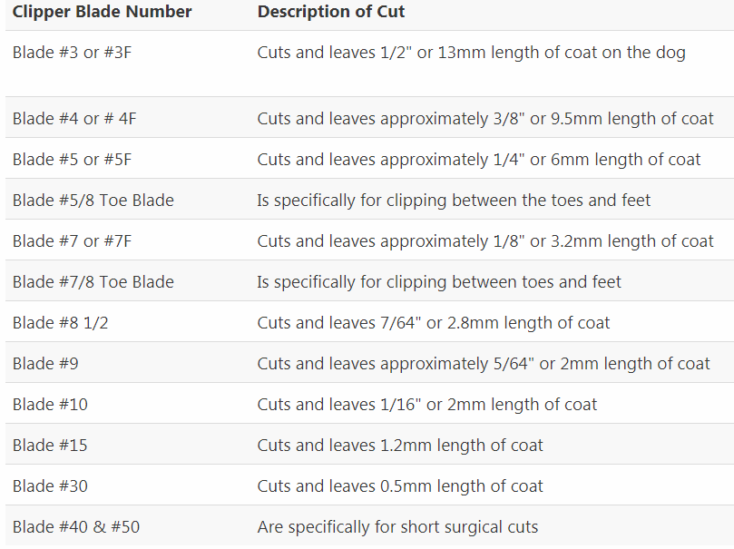
Source: diydoggrooming.com

How to Choose Pet Odor and Stain Remover

The owners of dogs and cats are happy to have their best friends around, but sometimes, when it comes to cleaning after the pet, people become really upset because of the stains and odor that are hard to get rid of.

Removing urine, vomit, and remnants of fecal matter is necessary not only for reasons of aesthetics and cleanliness. Having marked the place once, the pet decides that this is where its new toilet is now, and it will be harder to get rid of the habit later.

How to use Bubba’s pet stain and odor remover?

One of the recommended products for stain and odor elimination is Bubba's Rowdy Friends Pet Stain & Odor Terminator.

Follow these easy instructions to make the best of this experience:

- Pre-test on colorfastness on a hidden area;
- Remove the stain using an absorbent towel;
- Apply the remover to the dirty area;
- After 5-10 minutes wipe with a cloth;
- Remove all the liquid and let it dry;
- Once dried, vacuum and inspect the affected area.

How to use pet odor remover spray?

Sometimes, getting rid of the stain of the urine or vomit isn’t enough as the strong smell remains.

The experts advise using pet odor remover spray to eliminate the smell. Here are simple instructions on how to use it:

- Clean it as much as possible with a cloth that absorbs moisture;
- Shake the pet odor remover gently and spray the stain;
- Clean it with a cloth.
- If needed, repeat the spraying process until the smell disappears.

How to use pet stain odor remover carpet shampoo?

Carpet shampoos usually contain a low foaming formula that can be used with any stain cleaner or water-based carpet cleaner.

How to use carpet stain remover?

- In accordance with the type of carpet, you have to choose the appropriate detergent.
- The cleaning solution is applied to the carpet with a vacuum cleaner. Detergent and water are pumped under pressure that helps to push out pollution, washing the deepest layers of the carpet pile.
- To completely get rid of the smell of animal urine, special sprays can be used.

What is carpet stain remover made of?

Here’s the number of ingredients Bubba’s pet stain and odor remover is made of: water, advanced biological blend, non-ionic surfactant, fragrance, polystyrene.

Even though there’s not a lot of dangerous products used, the company asks to keep it out of reach of children.

How remove a built-in dirt carpet stain with eliminator for colored carpets?

If the dirt is on the floor, it is enough to wash it with any chlorine-containing agent, for instance, bleach, which also removes the smell. But if the pet has chosen the colored carpet, bleach is no longer an option as it will wash away the dye from the carpet and damage its pile.

In this case, only the professional carpet cleaning service will cope with it. Nevertheless, you can also try to do it for yourself using special equipment and strong cleaning products that are able to remove the stains.

Which carpet stain remover is more effective?
The choice of the stain remover highly depends on your particular situation - the color of the carpet, fabric, the state of the stain, the type of the dirt, however, there is still a few options of best pet stain and odor remover you can try and choose the perfect one for you.

How Big Should Crate Be For an Adult Large Dog?

It’s always hard to choose the right crate for a large dog if you’re a beginner. Therefore, below we give our recommendations on the choice of the crate.

What size of the crate do you need for a large dog?

First of all, the crate should be spacious enough so that the dog can sit freely in it, without bending down and not touching the ceiling and to lie down stretching to its full height. Also, it should let the dog change its position and turn around without problems. In other words, the dog should feel convenient in the crate.

Secondly, the crate must be strong and reliable, so the dog won’t be able to get out on its own.

But no matter how good the crate is, it still needs to be selected based on the weight, size, breed, age, and behavior of the dog. A properly selected crate will not only become your reliable assistant, but also a cozy corner for your pet.

That’s why check out the best large dog crate available on the market and choose the one that suits your needs.

What are the measurements of the large dog crate?

For large dogs like Airedale Terrier, Australian Shepherd, Bearded Collie, the crates of the size of 106 x 71 x 76 should be enough.

However, if your best friend is of these: Alaskan Malamute, Anatolian Shepherd, Bernese Mountain Dog, German Shepherd, Riesenschnauzer, Siberian Husky, Setter, Greyhound, Komondor, Rottweiler, Samoyed, choose a larger crate (122 x 76 x 84).

What are the dimensions of the extra-large dog crate?

If you’re the owner of the extra-large dogs like St. Bernard, Great Dane, Irish Wolfhound, Neapolitan Mastiff, Newfoundland, Scottish Greyhound, you should consider purchasing a giant dog crate (137 x 94 x 114).

How to fold a large dog crate?

Here are some basic instructions on how to fold up a large dog crate:

- To get started, just pull the handle on top;
- Then install the sidewalls that are fixed by a special latch;
- Usually, the crate has two doors from two adjacent ends. On each of the two doors, there are two locks. The dog should not be able to open them on their own.

