INDIVIDUAL READING
Title: Harry Potter and the Philosopher’s Stone
Author: J. K. Rowling (or Joanne Rowling)
Publisher: Bloomsbury
Category: fantasy
An abstract of the book: “Harry Potter and the Philosopher’s Stone” is a first part of a best-selling book series well-known in the four corners of the world. And it is no wonder why – you dive into the magic world as well as the boy-who-lived does. But first things first. The book began with an image of perfectly normal everyday life of the even more normal couple and, what is the point, of the doings, which we can’t call normal, even by a long shot: downpours of shooting stars, the owls swooping past in broad daylight and loads of strange looking people on the streets. The end of this day was surprising as well for this couple: they had found a little boy with a strange-looking scar on his forehead on their doorstep – it was their little nephew who had just lost his parents.
As you can understand from the title, Petunia and Vernon Dursley, main characters of the first paragraph, aren’t the main characters of this history (and to be honest, I’m not sure that the person who doesn’t know WHO is a main character exists wherever on the Earth). The story tells us about Harry Potter, about how he discovered his being a wizard, about his learning at Hogwarts, the best school of Witchcraft and Wizardry, about his friends, his adventures, to say simpler, about his life. We enter the wizard’s world slowly and very gently, we learn the rules of this world with Harry and it seems that we are that knowing-nothing little wizard or witch, learning the new spells, practicing flying on the broomstick or playing Quidditch.
Background: The series of Harry Potter, thanks to its popularity, has lots of fan-arts, head-canons, fanfiction (I even have one in print and the quality of cover is much better than one of the old original), and what’s more, fan movies! So, where am I coming from? I just want to say that the types of characters, the plot twists, the manner of storytelling and, of course, the setting are strongly popular too. And, nowadays, these magic schools, wizards, flying on broomsticks, forbidden forests where nobody should go – all of that is nothing new for us. Moreover, we meet the same types of characters in many books: the chosen one, his clever bestie, sarcastic antihero who is always a suspect, another much more attractive antihero loved by each and every female, an old mentor (for fairness, routes of this image rather came from the “Hobbit” series but it wasn’t so popular ‘till some moment) and the world’s greatest evil. But it doesn’t mean that there isn’t anything special. Now then, let’s talk in more detail.
First of all, the setting. We have a magic world, as I have already said millions of times, whose existence is a big secret for muggles. What sort of people are these muggles? Of course, you know, they are not wizards. This world has its own structure, it is a bit strange and sometimes uncertain. For example, in all magic Britain there are only Hogsmeade, Diagon alley, Gringotts, the ministry of magic and Hogwarts and so, there is a reasonable question – do wizards actually have so few places to go? Is it normal that in their world there is only one bank, one school, one place for shopping? Taking into account that Pure-blood wizards (the wizards who have never had muggles in their bloodline) mostly don’t contact the muggles world, as so with the shopping centers and especially banks. But stop criticizing! Let’s talk a bit about all these mentioned locations.
Hogsmeade – an only village where exceptionally magicians live. There are lots of funny shops like “Zonko’s Joke Shop” or “Honeydukes” – the sweet shop, and lovely cafes, “Three Broomsticks” or “Madam Puddifoot’s Tea Shop” can be the examples. It is also possible to buy all types of magic stuff here.
Diagon Alley is a great place for shopping! The choice is much better than in Hogsmeade, and here is even a hotel (what kind of infrastructure!) and pet shop – you can buy here a cat, a frog or a postal owl, yeah, these are the three most popular pets in the wizard’s world, but, by the way, they consider the frog as something moss-grown.
Gringotts – an only magical bank, whose employees are only… GOBLINS? Yes, that’s right. Wizards have their own very strange financial system, where you can’t work if you aren’t a goblin. And they are really old-fashioned: as the money they use gold and silver instead of convenient paper.
The ministry of magic. There are lots of departments, including those whose work is rather useless than the opposite, the Auror Office, which is something like our police and the magic court.
And last but not the least – Hogwarts. It is really the main place of all actions of this book, so I want to expand on this point. The location of Hogwarts is unknown, the students come there on the train which depart from the platform $9^{3/4}$. Hogwarts is a school only for wizards, where all students are distributed to 4 faculties according to their personal qualities: Gryffindor for lionhearts, Ravenclaw for eggheads, Hufflepuff for workaholics and Slytherin for dodgers or antagonists, you can choose. I’ll attach here the map of Hogwarts’ grounds not to overstay on this point:
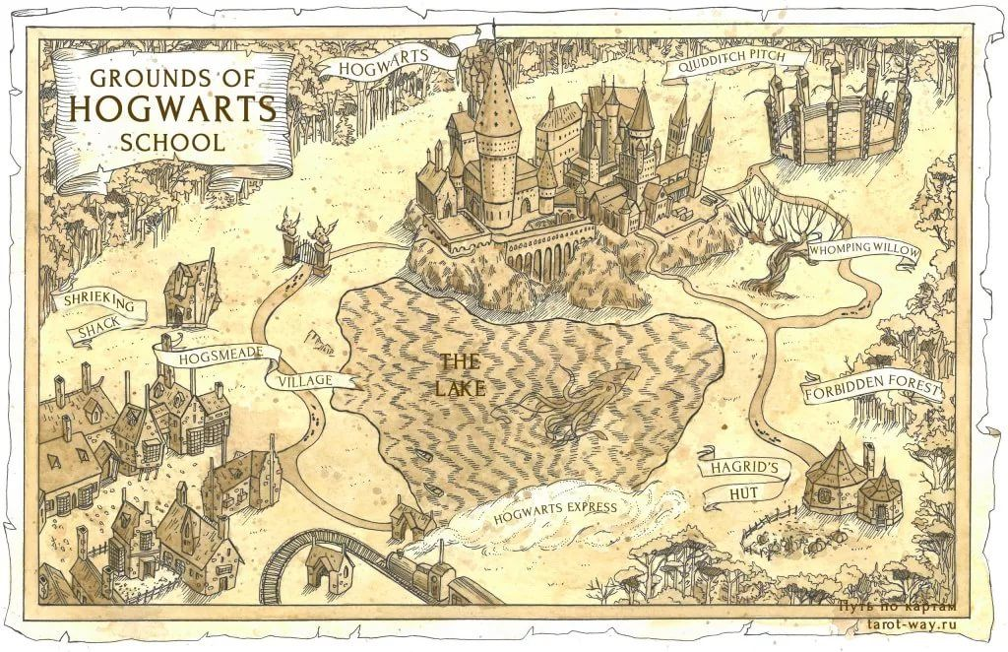
I’d like to tell you about one more thing, which is in my opinion the most unique, at least in this part. It’s Quidditch. The thing is that this is a one and only type of sport played by wizards, but it really worth the candle. The action itself happens in the air, so to take part in this game you should be capable of flying on the broomstick. Very traumatic sport, though. I’m not going to go deeper and fill your head with unnecessary rules, but there is something I ought to say: this is a team game in which victory practically always depends on one player called seeker and, oops, spoiler, it will be Harry Potter! Unbelievable, right?
And, so, Harry Potter – the youngest Quidditch player ever. What is he like? The boy who had never been loved by anyone and who out of hand discovered himself to be popular. So, he has a pronounced lifeguard complex and a predisposition to heroism. A very nice combo to be the main protagonist and the best alignment to be in Gryffindor. But, as for me, he is the one of the most stereotyped characters of this book and he gets lost in the background of minor characters. His temper is ambiguous and I prefer to follow his thoughts, but not his actions, they are always necessary for the development of the plot but not always for a good reason. But it isn’t so awful, I think it is the illness of many protagonists of a great number of books.
Except Harry, there are 2 other important characters: Ron Weasley and Hermione Granger.
Ron is a very simple boy with the simple problems: he has 5 older brothers – Bill the head boy, Charlie the captain of the school’s Quidditch team, these 2 have already graduated, Percy is the prefect, and Fred and George the twins are the favorites of the whole school. There was nothing for Ron to do to be special. He felt that he was only a shadow of his brothers. But meeting with Harry made him more confident. What’s more about Ron? He is really proud of his chess skills, we will talk about it later, and, yes, he is a real heavy eater.
And, Hermione, one of my favorite female characters of all series. She is muggle-born – her parents are regular dentists, so she hadn’t known anything about the magic world. But Hermione has an excellent pupil complex, so when she entered Hogwarts, she knew about different spells, history of magic and traditions of wizards’ world more than Ron did. But I like Hermione because she doesn’t want to simply be the best, she really likes studying and gaining new knowledge. And what’s more important, she is able to use them in real life. Hermione is anxious about following the rules, but for the friends she can violate her principles. To my mind, Hermione’s mind and devotion make the whole book to make sense. “Me! Books! And cleverness! There are more important things – friendship and bravery…”
But the charm of this book lies in the secondary characters. Two more of my favorites are the Weasley twins. Honestly, I don’t know anyone who has ever spoken badly about them. They are the soul of this book, we don’t know a lot about Fred and George from the first part, but every single moment with them made me smile.
Another gorgeous character is Neville Longbottom – he is a real symbol of the thesis that we shouldn’t judge somebody before we know him better. Neville looks like a bewildered and a bit cowardly student from whom everything falls out of hand. Throughout the book we think: “how could he be chosen for Gryffindor?” (I’ve forgotten to mention that all of the aforenamed characters belong exactly to Gryffindor). But in the end of the book Neville showed enough bravery not only to stand against his enemies, but to hold on to what he believed contrary to his friends.
We shouldn’t also forget about Draco Malfoy, who acts as an antagonist or as an antihero, it’s hard to understand. He is poor-blood, Slytherin faculty. And he was truly offended by Harry. Draco is a “silver” (one of the Slytherin’s main colors) boy who had always gotten everything he wanted. So, he wanted to be friends with Harry, Harry refused and it is how their enmity began.
From the teaching staff, we can highlight Hagrid and professor Snape. Hagrid is a very friendly huge man, who works as the keeper of the keys in Hogwarts. Despite his appearance, he is very cute and naïve, so he is an absolutely positive character. But Professor Snape is completely different. We can’t understand his motives until the end and even in the end they aren’t completely clear. From the beginning, we are forced to think that he is a bad guy, but then we discover that he always tried to save Harry Potter. But I surely can say that he isn’t too pleasant and fair with the students. All other sides of his character are in the fog and now, I’m going to explain why.
The type of narration. The story is told by an external narrator BUT we see all the characters, all the events through the prism of Harry’s perception. Couple of examples. At the beginning Harry didn’t like Hermione at all, and all that we knew about her personality was that she was annoying, arrogant and a kind of a nerd. All the fundamental qualities of her character would be known much later.
The second example is just professor Snape. He didn’t like Harry, Harry didn’t like him, and in the boy’s head it has already made him a villain. Rowling leaves some hints that it isn’t so, but it’s hard to see them in complexity. Moreover, Severus Snape is always described as a nasty character: greasy hair, piercing glance and black clothes. What can be worse?
Main points of the plot/problems dealt with in the book. The plot of this book is very childish, and at some moment, I think that I’m reading a kind of quest-book. It’s no wonder, the books were growing up together with the readers. The plot of every next book becomes crueler and the problems become more serious. The first book is more like a fairy tale where the boy who’d had nothing – got everything. But now, I’ll start from the beginning.
Harry had already been living with the Dursleys practically for 11 years. Instead of his own room, he had a cupboard under the stairs, all his clothes he wore after Dudley – his cousin – and the most he could expect for his birthday was a pair of socks. And the strange things were always happening to Harry: he could find himself on the rooftop of the school after being chased by Dudley and his band, his hair could grow overnight or he could even speak with a snake.
One day, Harry began to receive letters, letters from nowhere. Dursleys were strictly against Harry reading them and, to save from the flow of messages, the whole family had to move to the other part of the country, where they were found by Hagrid, who at last delivered the letter to Harry and said the famous phrase: “Harry, you are a wizard” or something like this. Next morning, Harry and Hagrid went to buy all Hogwarts’ staff at the Diagon Alley but before shopping they had to visit Gringotts to take the money left by Potters to their son. Yeah, Harry, now you are rich!
The next image is a platform $9^{3/4}$, from where our protagonist departs to Hogwarts. Here he makes friendship with Ron Weasley and meets Draco Malfoy, whose friendship Harry just doesn’t need. And now, wow, Hogwarts, very beautiful, very interesting, then sorting, Gryffindor, first classes, eternally disgruntled Snape, Hermione Granger irritating with her omniscience, Malfoy trying to ruin Potter’s life, flying lessons, Quidditch team and phew… something really worthwhile – Halloween.
Ron had accidentally insulted Hermione right on the holiday day, the girls said that she had been crying in the girls’ bathroom the whole day and had wanted to be left alone. But one more happenstance, in the middle of the feast, professor Quirrell broke into the main hall with the words: “Troll in the dungeons”, all students had to be evacuated in the common rooms of each faculty but Harry and Ron reminded about Hermione and as real heroes headed to save her. Somehow, and one more time accidentally, they dealt with the troll, but immediately after that the professors appeared in the room. Professor McGonagall, head of Gryffindor faculty, was in a rage with the boys’ act, but Hermione took all the blame. And from that moment, Ron and Harry had one more loyal friend, and good for them, she was smart.
One time during a night walk, this trio, running away from local caretaker Argus Filch, ACCIDENTALLY got into the forbidden room where they had found a big three-headed dog, who was guarding something. Since our heroes were still young and curious, they tried with all their might to know what the dog was warding. And, of course, they did it. It was the Philosopher’s Stone, pam-pam, surprise – the name has played! And after a million of different coincidences (if I begin to describe them, this review will last for a very long time), they found out that Snape was going to steal the stone, while Dumbledore was gone. Of course, Harry decided to save the stone, my little rescuer.
Then, after lots of barriers, where each of them had shown his strong side: Ron – his chess skills, Hermione – her logic and knowledge and Harry – his flying skills, Potter met in the last room… not Snape, but professor Quirrell! It happened, that he was a follower of Voldemort, the worst villain who had ever lived, who’d killed Harry’s parents, and Quirrell tried to steal the stone to bring him back to life! Harry protected the stone for dear life. He could even die, but, thanks God, Dumbledore, the headmaster, was in time to save him. Accidentally.
And everything finishes extremely well. The stone is destroyed, the final exams are passed, Gryffindor won the school cup and all students came home for summer holidays. Happy end.
So, what about the story is? About friendship, loyalty, justice and lots of other pleasant things. But if we dig deeper? The hidden message of the book is literally on its last pages.
“As much money and life as you could want! The two things most human beings would choose above all – the trouble is, do have a knack of choosing precisely those things that are worst for them”.
The philosopher’s stone is a legendary alchemical substance which can be used to prepare the Elixir of Life, which makes you immortal and to transform any metal into pure gold. So, the stone here is an incarnation of carnal egoistic wishes of people which lead to self-destruction. The characters of the book were able to destroy the stone, but we can’t destroy our wishes. But isn’t it hopeless?
The thing is that Harry found the stone because he didn’t want to use it for his purposes, and this is what Voldemort couldn’t do because of selfish desires. The only person, whose intentions are pure, can get the pleasure of life, the opposite one will never be satisfied with his living.
General comments. I talked about this book for so long and finally it’s time to discuss plusses and minuses, from my point of view, of course. Let’s begin with something good.
First of all, it’s the manner of narration. It’s very light and really pleasant to read. As I have already said, you dive into this world and stay there until the very end. Because of this, I didn’t even notice the minuses during the reading. And I had to analyze everything just after the book had been finished.
The second thing I like is fabulousness. So, you can meet here the unicorns, dragons, goblins, old-fashioned castles, dungeons and lots of other things. It is a kind of special atmosphere and I like it.
A great advantage of this book for me is also the presence of the professor Snape. Don’t mind, he isn’t even my favorite character, but his ambiguity is something perfect. He isn’t only black and white, there are some shades of grey in him, and no this isn’t a reference to “50 shades of grey”.
Moreover, Rowling thought over not only about blurred characters, but about a really big number of things. For example, her spells, it isn’t a new language how it was in the “Lord of the rings” but their names reflect their meaning: “alohomora” was borrowed from the Sykidi, the system of Western Afrique used for divination and it means “thief-friendly”, I should remember that it is a spell which opens the locks; or the spell “lumos” is formed from the Latin word “lumen” which means “light”, isn’t it the best name for the spell, which lights the light?
But good cannot last forever and now, minuses. Before talking about the disadvantages, I need to confess that I am the greatest fan of the Harry Potter series and I’ve read this book many times and it’s hard for me to be objective concerning its minuses. But I’ll try.
The golden rule of this book is: “If the hero doesn’t get on an adventure himself, it means everything should be done for him to do it even if it’s against the laws of logic”. As an example, I want to remember Harry’s detention, where the 11-years-old child was sent into the forbidden forest, which is forbidden because of its danger, only with a man, who cannot use magic. Funny, really? But it’s much funnier because of the fact that there were 4 children and they… splat into 2 groups. What can I say? Nice. But, apart from Harry being the center of the Universe, I can’t notice the other mistakes. With the exception of those which I have already mentioned above.
Conclusion. It wouldn’t be me if I didn’t recommend this book. Despite some little defects, it’s the best book to take a break from work or studying and to enjoy reading. You’ll read it in the same spirit, you can believe me, and you can even miss how the time has passed.

