Vancouver fashion brands
Vancouver is one of those cities where everything is developing and improving at an incredible rate, writes vancoveranka. At the same time, despite the fact that this city can rightly be classified as a modern city, it combines old and new very well. Unique historical buildings look quite harmonious against the background of modern architecture, and interesting facts from the city's history are an excellent basis for modern history.

In addition, Vancouver is a place that really attracts people. We are not talking about the local population who already love their hometown and many people know about it. We mean those people who, once they visit, want to stay there for life. This desire is quite understandable and fair. After all, Vancouver can be called a city of opportunities. There is probably no profession that cannot be developed while living in Vancouver. Representatives of information technology, science, economics, culture, and the arts are quite successful in realizing their potential as Vancouverites. Among all these areas, fashion can also be singled out. Designers and entrepreneurs, without exaggeration, feel at home in Vancouver. Comfortable tax conditions and a well-developed banking system allow them to start their business and achieve real success. Start-up businessmen don't have to worry about getting into a "debt hole" and not having time to develop their business. The Vancouver government is very loyal to newcomers in business. Therefore, the most comfortable and favorable conditions are created for them. After all, the city is also interested in the emergence of new entrepreneurs, as this will benefit the local budget in the future, among other things.

In addition, the regular holding of various fashion events provides a tremendous opportunity to develop and make a name for oneself around the world. Cooperation with the organizers of such events helps to identify new talents. It also has a very positive effect on the Vancouver fashion community and, of course, on the business environment.

In our article, with reference to vancouverandus, we will tell you about the most famous and successful Vancouver brands. They have managed to achieve incredible results and, without exaggeration, make themselves known to the whole world. They have many thousands of fans, including many famous personalities who are considered real style icons. It is these people who trust Vancouver brands and wholeheartedly wish them development, success and prosperity.

Lululemon

This brand can be considered the most famous. In 1998, Vancouver businessman Chip Wilson realized his long-held dream of having his own clothing brand for yoga. He named the brand Lululemon.

In 2000, the businessman opened a store with the same name.

Due to the fact that Vancouver is a city where a healthy lifestyle is highly valued, the brand began to gain immense popularity. Later, it began to spread across Canada.

In 2003, the first foreign Lululemon store was opened. Later, Wilson's company grew to 491 stores, which can be found in almost any country in the world, from Australia to New Zealand, England, Japan, France, etc.

Aritzia
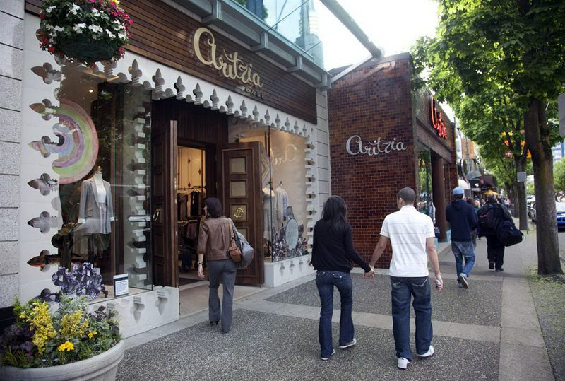

This brand, loved by many famous personalities, was also destined to appear in Vancouver in 1984. Its first location was the back room of one of the Hills stores (a family business headed by Brian Hill).

The first Aritzia store opened in the same year. The brand began to gain immense popularity, and stores began to appear in other Canadian cities.

The year 2007 is remembered for the fact that the company, which called its women's clothing line "everyday luxury," opened its first American store.

The American supermodel Kendall Jenner was very fond of Aritz's clothes. The brand has also found true fans in the person of American model Hailey Bieber, Mexican actress and singer Aisa Gonzalez, as well as actress and singer Hilary Duff.

Gradually, the Aritzia brand opened 68 stores in Canada and 33 in the United States.

Herschel

This brand can also be called very successful. Its backpacks brought it real popularity.

The company's goal was to create less boring backpacks. Production began in 2009 in Vancouver. The company was founded by brothers Lyndon and Jamie Cormack.

The brand name is associated with a small town where the brothers' ancestors moved back in 1905.

Gradually, along with classic backpacks, which are very popular among both children and adults, the brand began to produce suitcases, as well as hats, jackets, etc.

Subsequently, Herschel opened 9000 stores in 90 countries, but the location of the flagship store is, of course, Vancouver.

Smash+Tess
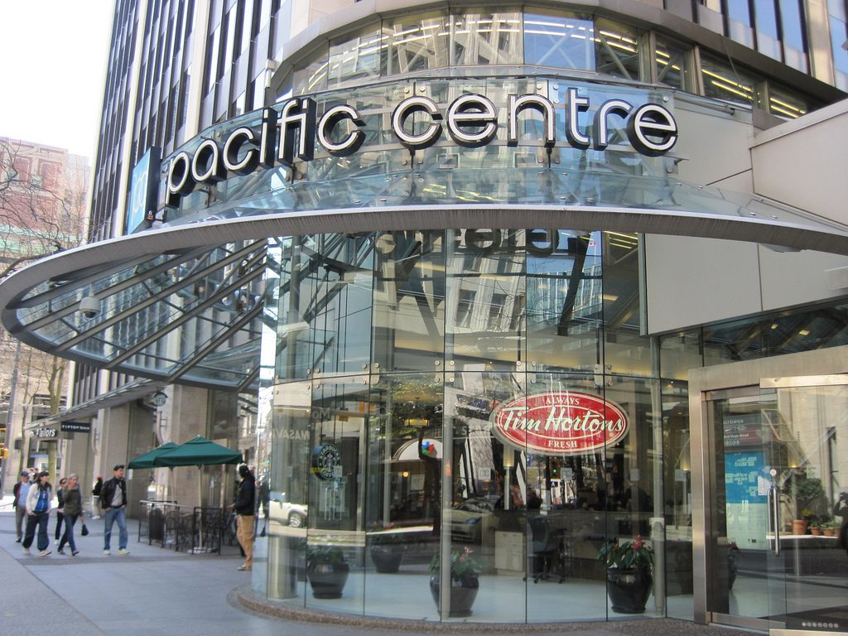

This brand was created in 2016. It was founded by a mother-daughter tandem, Teresa and Ashley Freeborn. They were assisted by their family friend Mercedes LaPorte.

The women had a goal to create comfortable clothes for women of all ages and sizes.

So the women liked the new line of clothes. It was even recognized on the pages of such a reputable fashion publication as Vogue. And according to the Globe and Mail newspaper, the company has become one of the fastest growing companies.

Reigning Champ
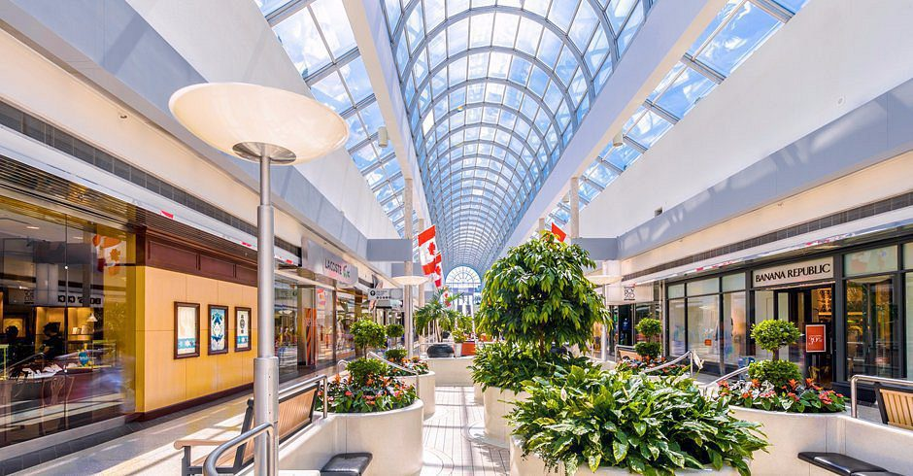

This company was founded in 2007 by Vancouver businessman Craig Atkinson.

The brand produces high-quality streetwear for women and men. It is thanks to the high quality that the company has gained a huge number of fans. In particular, the brand is very popular with the famous footballer and well-known fashion fan David Beckham.

Arc'teryx

It is about high-quality and fashionable clothes in which you can do sports. The brand was founded in 1989 by Vancouver climber Dave Lane. However, he originally named the company Rock Solid, and it was renamed when Dave started working with Jeremy Guard, who is also a famous climber.

The name of the company is related to Archaeopteryx, which is a common ancestor of birds. Gradually, the "bird" brand was able to open more than 80 stores.

Indochino

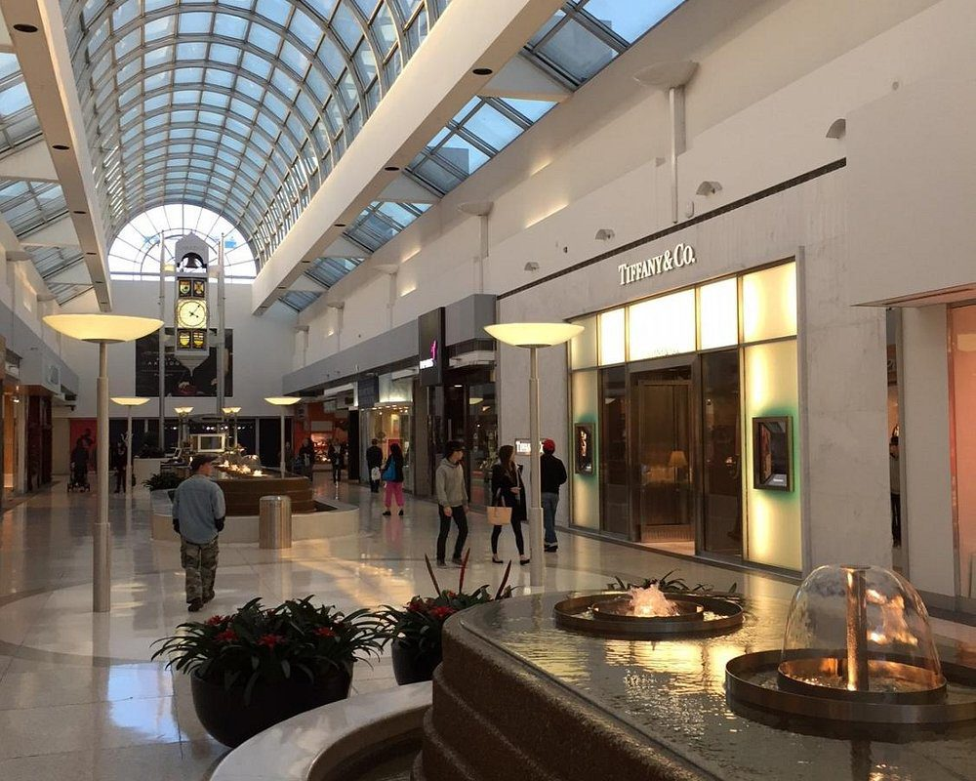
This company creates fashionable men's clothing to order. In 2007, the brand was founded by Victoria University graduates Kyle Vucko and Heikal Gani. They were convinced that quality clothing should not be too expensive.

It's worth noting that the company was lucky enough to receive a $42 million investment from China's Dayang Group. This helped to open 60 atelier stores in Canada and the United States.

8. John Fluevog
The Vancouver businessman has been involved in fashion for many years. In 1970, he founded his own shoe brand. His products are distinguished by their eccentric design.

"The Pilgrim”, a shoe with a Victorian style, has been a top seller for many years.

John managed to open 26 stores around the world. As a gift, he brought a pair of shoes for Dr. Bonnie Henry, who is a big fan of John Fluevog.

