- Incorrect button Edit photo
Preconditions:
The site https://sergneschetniy.github.io/petly-frontend/ has been opened
The user is authorized on the site https://sergneschetniy.github.io/petly-frontend/
Steps to reproduce:
- Click the "Account" button in the right corner of the header
Expected result:
- The personal account page open
- The My Information card contains the user photo + Edit photo icon
Actual result:
- The personal account page open
- The My Information card contains the user photo + Вибрати файл icon
Attachments:
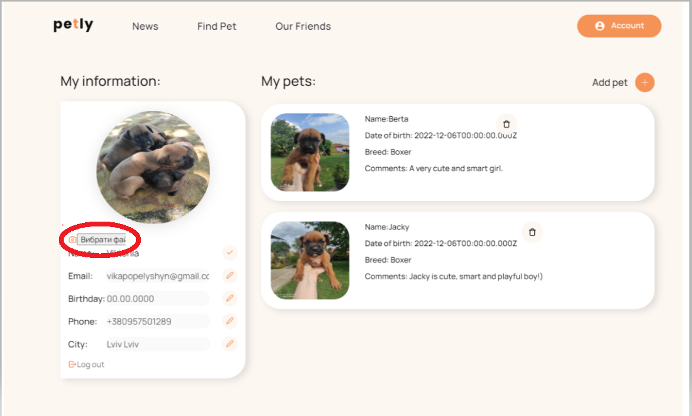

2. Name edit icon doesn’t work

Preconditions:
The site https://sergneschetniy.github.io/petly-frontend/ has been opened
The user is authorized on the site https://sergneschetniy.github.io/petly-frontend/
Steps to reproduce:
- Click the "Account" button in the right corner of the header
Expected result:
- The personal account page open
- The My Information card contains first and last names + editing icon
Actual result:
- The personal account page open
- The My Information card contains first and last names + editing icon doesn’t work
Attachments:
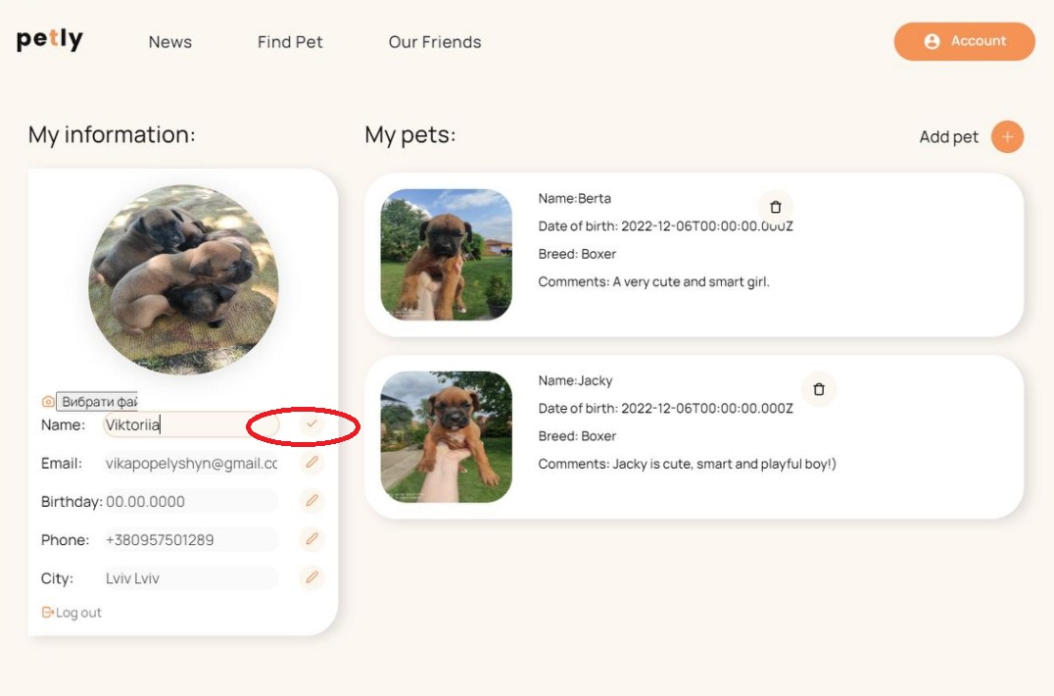

3. The email edit icon doesn’t work
Preconditions:
The site https://sergneschetniy.github.io/petly-frontend/ has been opened
The user is authorized on the site https://sergneschetniy.github.io/petly-frontend/
Steps to reproduce:
- Click the "Account" button in the right corner of the header
Expected result:
- The personal account page open
- The My Information card contains an email + editing icon
Actual result:
- The personal account page open
- The My Information card contains an email + editing icon doesn’t work
Attachments:
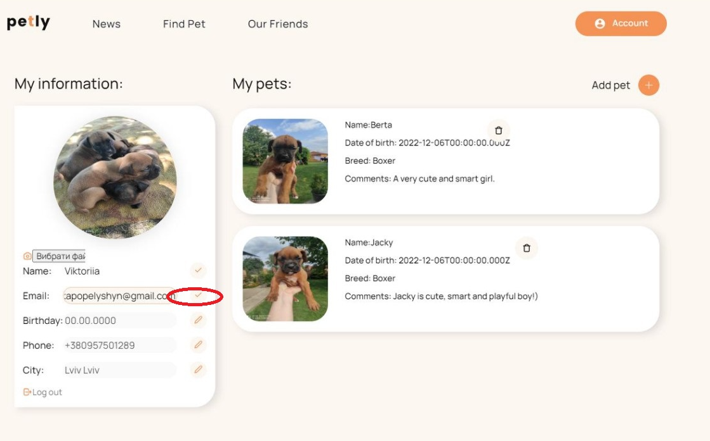

4. The birthday edit icon doesn’t work
Preconditions:
The site https://sergneschetniy.github.io/petly-frontend/ has been opened
The user is authorized on the site https://sergneschetniy.github.io/petly-frontend/
Steps to reproduce:
- Click the "Account" button in the right corner of the header
Expected result:
- The personal account page open
- The My Information card contains the date of birth + editing icon (drop-down list for choosing a date)
Actual result:
- The personal account page open
- The My Information card contains the date of birth + editing icon work but does not contain the drop-down list for choosing a date
Attachments:
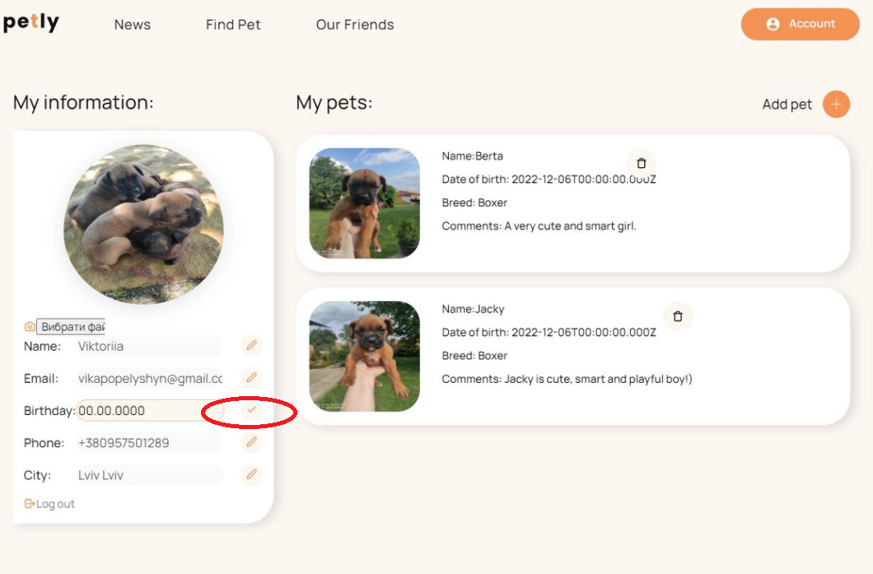

5. The phone edit icon doesn’t work
Preconditions:
The site https://sergneschetniy.github.io/petly-frontend/ has been opened
The user is authorized on the site https://sergneschetniy.github.io/petly-frontend/
Steps to reproduce:
- Click the "Account" button in the right corner of the header
Expected result:
- The personal account page open
- The My Information card contains the phone number + editing icon
Actual result:
- The personal account page open
- The My Information card contains the phone number + editing icon doesn’t work
Attachments:
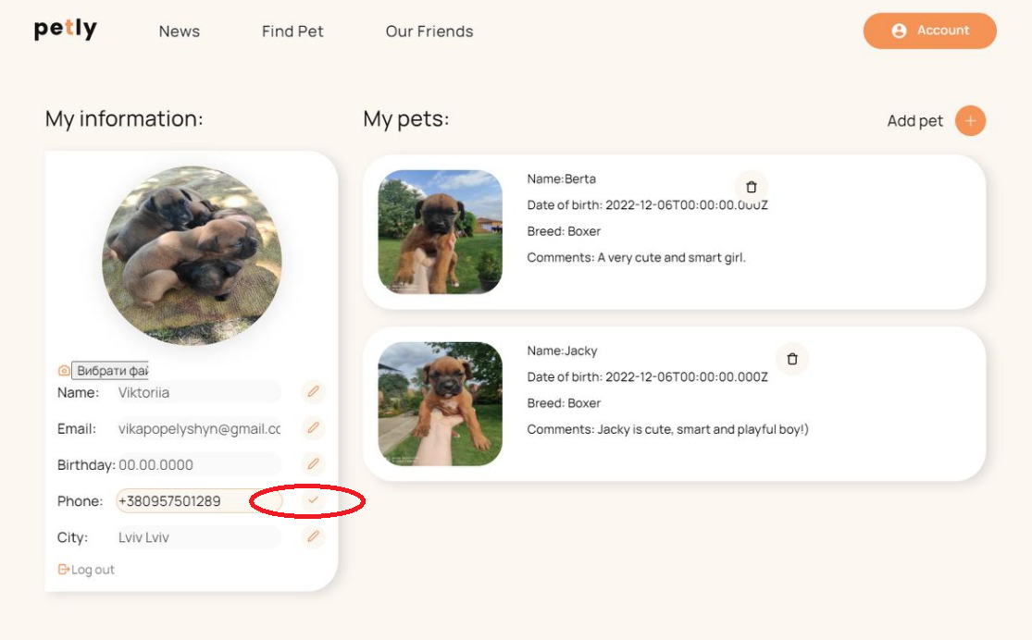

6. The city edit icon doesn’t work
Preconditions:
The site https://sergneschetniy.github.io/petly-frontend/ has been opened
The user is authorized on the site https://sergneschetniy.github.io/petly-frontend/
Steps to reproduce:
- Click the "Account" button in the right corner of the header
Expected result:
- The personal account page open
- The My Information card contains the city, region + editing icon (drop-down list for city selection)
Actual result:
- The personal account page open
- The My Information card contains city, region + editing icon doesn’t work and does not contain the drop-down list for city selection
Attachments:
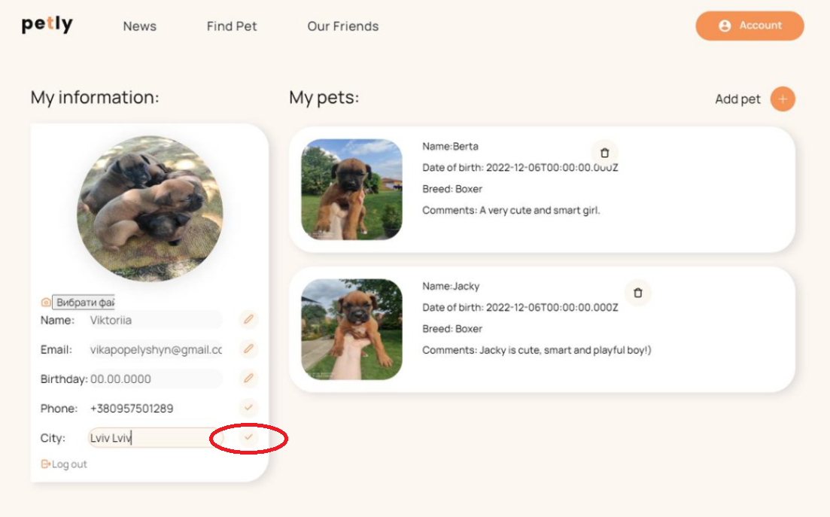

7. The delete button doesn’t work
Preconditions:
The site https://sergneschetniy.github.io/petly-frontend/ has been opened
The user is authorized on the site https://sergneschetniy.github.io/petly-frontend/
Steps to reproduce:
- Click the "Account" button in the right corner of the header
Expected result:
- The personal account page open
- The My pets card contains a Delete button
Actual result:
- The personal account page open
- The My pets card contains a Delete button but it doesn't work and closes some text
Attachments:
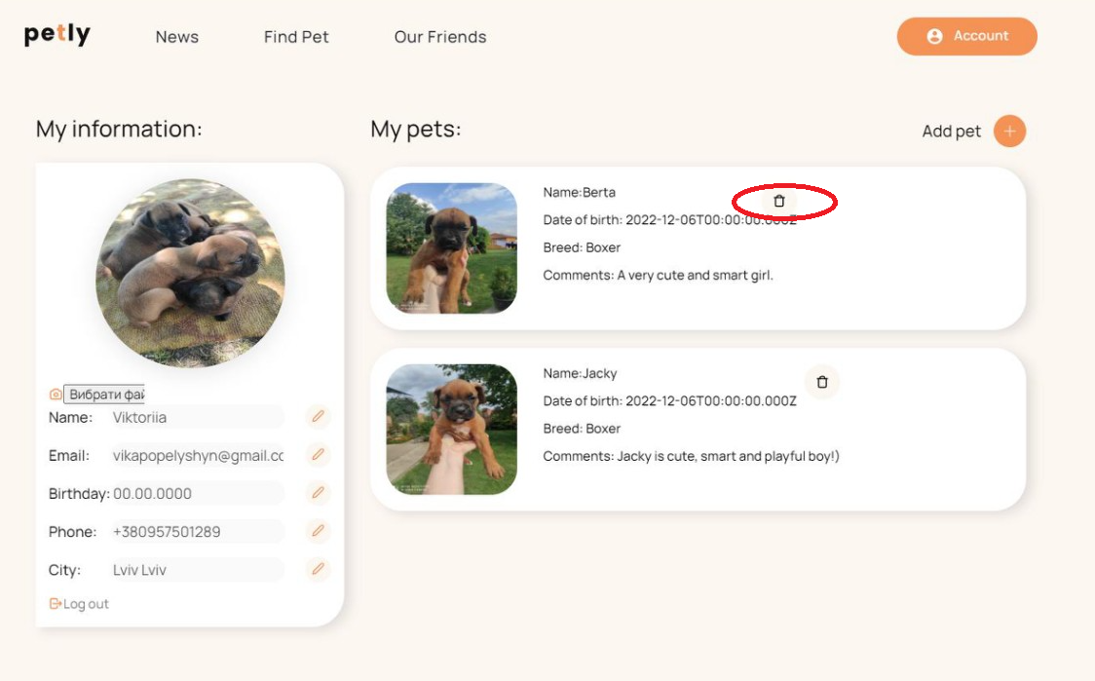

Рекомендація!
1.Змінити дизайн кнопки Log out і Edit photo в особистому кабінеті картка My information на більш приємніший;
2. Збільшити правий, лівий, нижній відступи у вікні особистого кабінету;
3. Перенести кнопку Delete у картці My pet правіше, бо вона накладається на текст опису тварини.

