Consequences of the destruction of the Kakhovka HPP
June 6, 2023, another terrorist attack against the people of Ukraine was committed in the city of Novaya Kakhovka, Kherson region.
Kakhovka HPP on the Dnieper River was built in 1955-1956. (6 hydraulic turbines, annual generation 1.4 TWh). February 24, 2022 was captured by Russian military forces during the Russian invasion of Ukraine.
The Kakhovka HPP was blown up from the inside, the explosion occurred as a result of the detonation of explosives in the engine room of the HPP building. The purpose of the undermining: to stop the counteroffensive of the Ukrainian forces.
At the moment, the HPP is completely destroyed and cannot be restored. There is a great mine danger in the occupied territory. A huge stream of water washes away minefields, and they detonate.
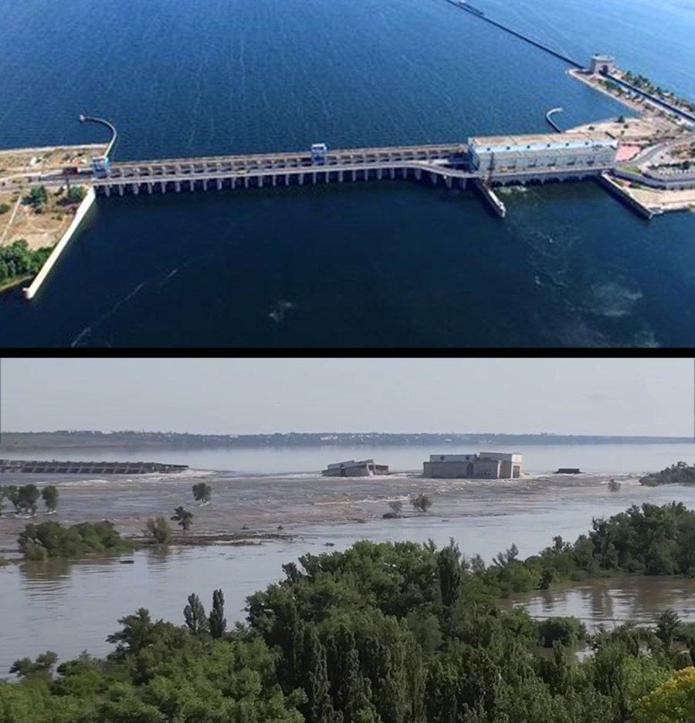
Picture 1.
Kakhovka HPP before and after destruction
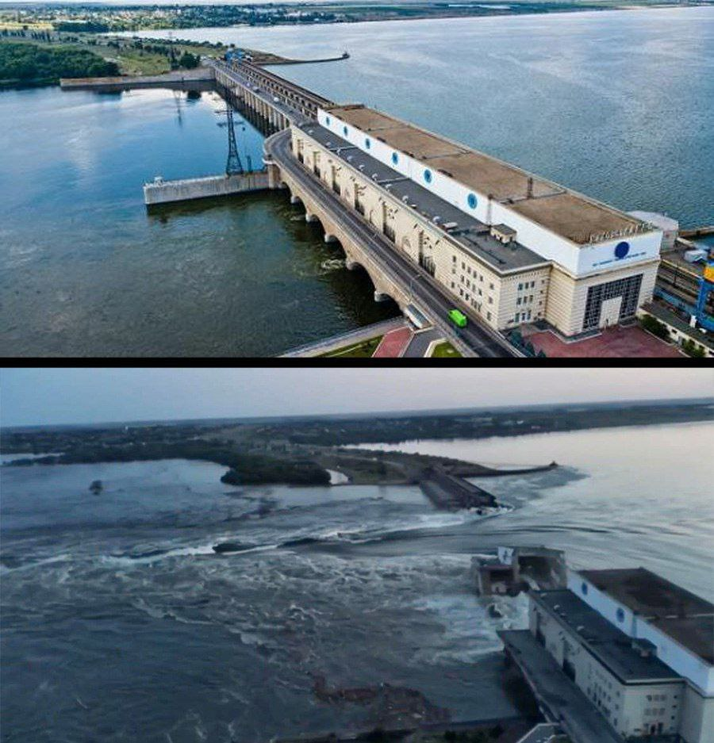
Picture 2.
Kakhovka HPP before and after destruction

Reconstruction of the Kakhovka HPP will cost up to $1 billion and will last 5 years.
The factors of such destruction are virtually identical to a nuclear explosion, except for radiation pollution:
- Evacuation of the population, destruction of enterprises and objects with harmful and toxic substances (chlorine, ammonia, oil products, etc.);
- Destruction of water supply, sewerage, electricity supply facilities, collapse of food and medical logistics;
- Pollution of a part of the Black Sea and other consequences.
What threatens the South of Ukraine due to the undermining of the Kakhovka hydroelectric power plant:
- Loss of 14% of the export potential of Ukrainian wheat due to problems with irrigation of fields in the southern regions of the country (Zaporozhye, Dnipropetrovsk and Kherson regions);
- More than 200 thousand residents will be left without drinking water;
- Ecological catastrophe. A decrease in the water level in the reservoir will lead to a decrease in rare animals, birds and insects.
- Destruction and flooding of more than 80 settlements in the Kherson region.

The most severe consequences of the flood will fall on the left bank of the Dnieper (controlled by the Russian Federation). The peak capacity of the flood is 14,000 cubic meters of water per second. For comparison, in calm conditions, the Dnieper carries 1670 m3/s cubic meters of water per second, and Niagara Falls - 2400 m3/s. In 4-5 days, the flood will cause a spill up the Bug River to Nikolaev, floods are possible in the city.
The Kakhovka HPP was part of the Dnieper cascade of hydroelectric power plants and served as a barrier to the largest Kakhovka reservoir. The water level in the reservoir was maintained to provide water and cooling for the Zaporozhye NPP.
The uncontrolled decline of water in the reservoir poses an additional threat to the occupied nuclear power plant, and also poses a nuclear threat to the entire world.
All mandatory components of nuclear safety have been violated at the Zaporozhye NPP.
- the physical integrity of the station is broken;
- malfunction of security systems;
- the staff is forced to work in difficult conditions and under constant pressure;
- power supply from external sources is broken;
- the supply system is broken;
- problems with planned radiation monitoring and implementation of emergency response measures;
- communication with the regulators is broken.
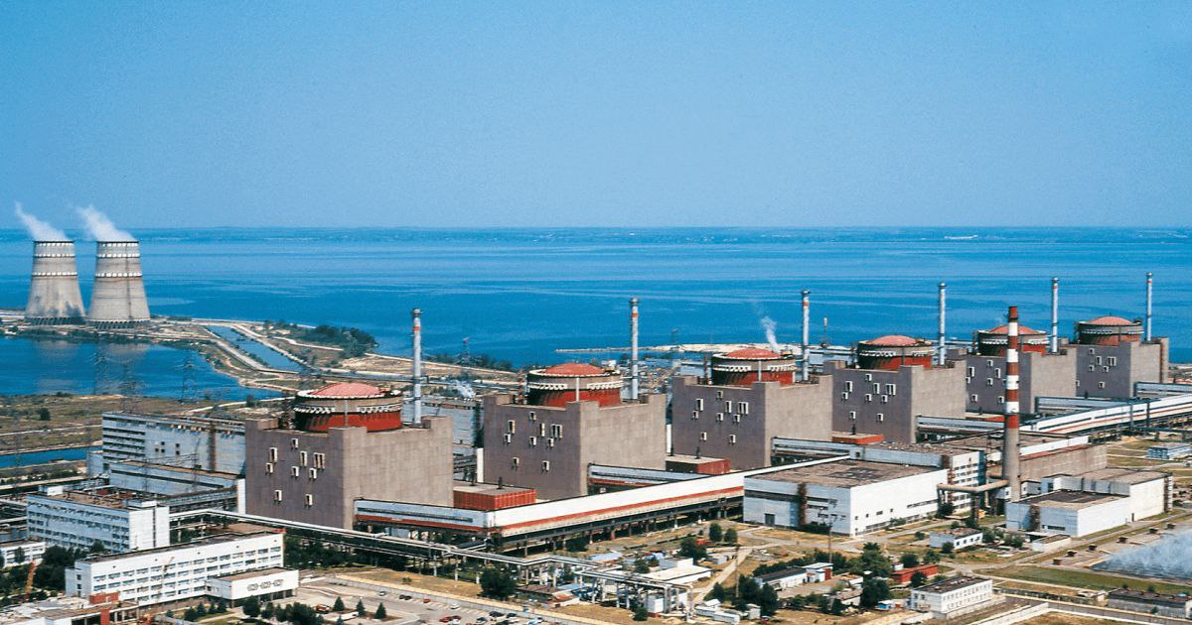
Picture 3.
Zaporozhye NPP
According to the Geneva Convention, the explosion of a dam is a war crime, which can be equated with the use of weapons of mass destruction.

It is good to have a little more information from you – for example that the explosives were in the powerhouse.
The explosives were inside powerhouse. Since the destruction that we see in the video cannot be done by artillery.
Do you have any data on the flood volume? The level/water volume in the reservoir at the time of the breach?
GENERAL INFORMATION
Kakhovka HPP raised the water level in the river Dnieper up to 16 meters and formed the Kakhovka reservoir with a volume of 18.19 km³ (almost 20,000 billion liters of water). Other parameters of the Kakhovka hydroelectric complex:
- The length of the hydroelectric facilities is 3850 m,
- Maximum head 16.5 m;
- Maximum water flow rate 21,400 m³ per second (more than
21 million liters per second!);
- The surface area of the reservoir is 2,155 km² (more than 3,000 football
fields!).
BUT YESTERDAY

on the eve of the disaster, Russia brought the water level in the Kakhovka reservoir to a critical 17.5 meters
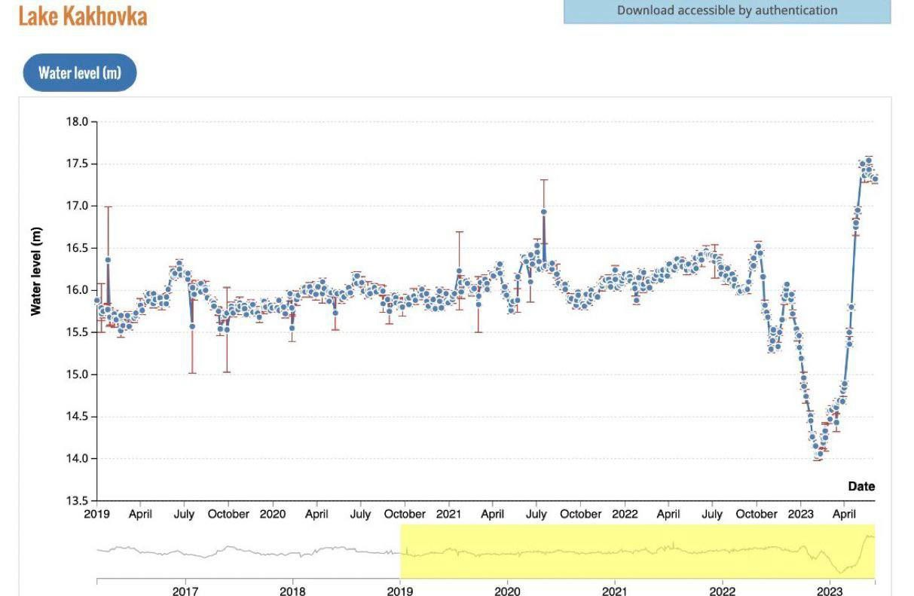

Do Ukrainian engineers have access to the dam to begin to take any measures? Or is it too dangerous.
Unfortunately, there is no access to the Kakhovskaya HPP. This is very life-threatening.
The scale of the disaster can only be assessed by video from drones or from phones
But the video and photo clearly show that monitoring is possible only after the flood stops, which is about 3-4 days. But Ukraine will not risk the lives of engineers.

Are there any other technical details about the extent of the breach.
- The most severe consequences of the flood will fall on the left bank of the Dnieper.
- Experts predicted that a wave 4-5 meters high would hit the Antonovsky bridge in Kherson approximately 19 hours after the breakthrough (that is, by the evening of June 6).
- The right tributary of the Dnieper Ingulets will burst its banks, and in 4-5 days the flood will affect the Southern Bug River in Nikolaev.
- Kherson will not be flooded for the most part, the flood will only affect the port and the dock area.
- Settlements on both banks of the Dnieper will be flooded. Casualties among residents are not ruled out. The National Security and Defense Council announced the threat of flooding of 80 settlements with a total population of 16,000 people.
- 50 hours after the dam break, the Kinburn Spit, the isthmus behind the Dnieper delta, will be completely flooded.
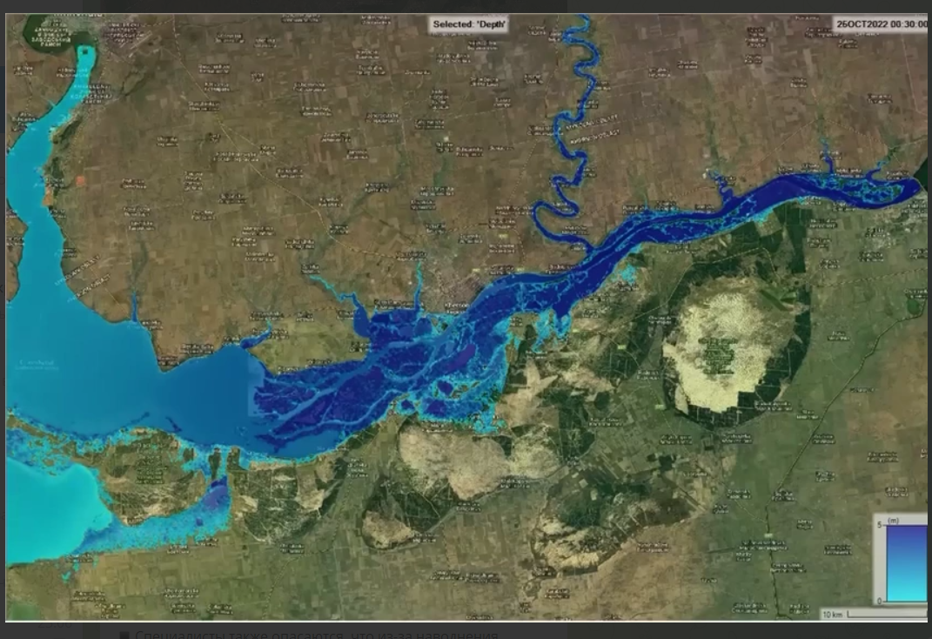
The extent of the breach.
Also, is there news of casualties? (I hope not many).
There are currently no human casualties. But there are significant animal casualties. The zoo was completely flooded and only swans and ducks could escape. The zoo no longer exists

Kind regards
Daria Popruha
Leading Engineer
PRJSC UKRHYDROPROJECT

