Silence and Confidentiality in the Office: A Guide to Choosing an Acoustic Booth.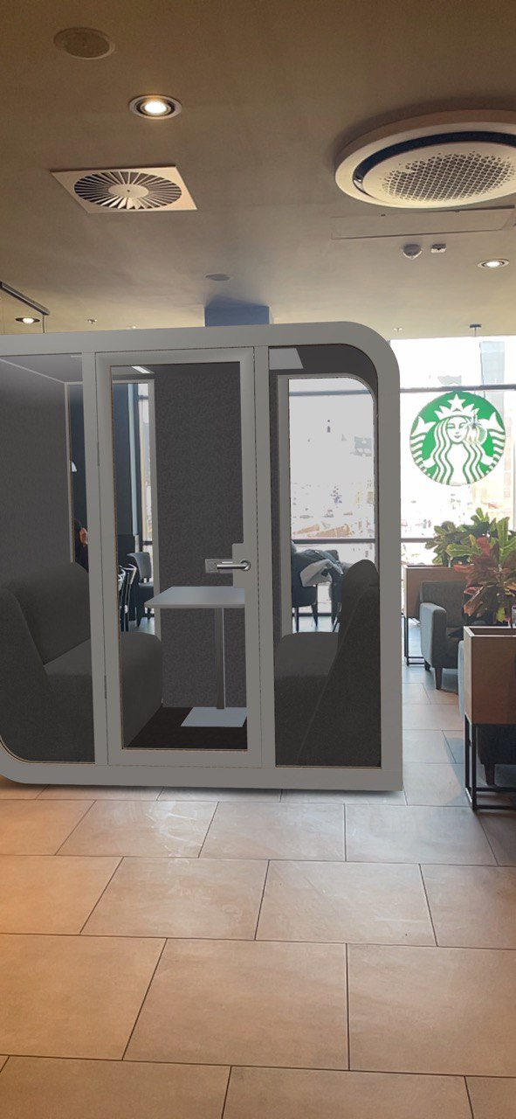

It's no secret that open-plan offices do not prioritize individuality and confidentiality for workers. They were designed to create a sense of belonging to a wider community of like-minded individuals, and to save space. According to statistics, around 70% of companies worldwide have open-plan offices.
However, in practice, open spaces have proven to be uncomfortable for productive work due to high noise levels and numerous distracting factors. Did you know that people are making more phone calls now than ever before? The emergence of email and messaging has not affected the frequency of phone conversations. It has been proven that a phone call is one of the best ways to effectively communicate with someone. And for that, two important conditions are required - confidentiality and silence.
They can be provided by standalone booths with high-quality sound insulation and sound-absorbing properties. Whether you're in the process of rearranging your office, looking to optimize available space, or needing to adapt your office space to comply with social distancing rules, acoustic booths are an excellent workspace solution. Ideal for optimizing confidentiality and limiting noise, acoustic modules offer numerous advantages in a variety of office environments.

What is an office soundproof booth?
Booths are autonomous spaces where employees can work, relax, learn, and brainstorm away from office noise and distractions. Thanks to their versatility, functionality, and convenience, more and more companies are using these modules in their offices than ever before. Essentially, they are a room within a room. Booths come in different shapes, sizes, colors, and styles, meaning that you can choose a design that complements and enhances your existing office interior. Providing a quiet, private area for workers in various industries, soundproof booths are easy to install and can be easily moved as needed.
Clive Wilkinson, the designer of Google's sprawling headquarters in Silicon Valley and the author of the new book "The Theatre of Work," believes that office soundproof booths are actually fantastic. "They fulfill the need for quiet work without great expense. And their small size allows them to be easily accommodated," he says.

What should you pay attention to when choosing booths for your office?
When choosing the appropriate soundproof booths for your office, you may face difficulties as there are many companies offering similar products today. When making a decision on which option meets all requirements, it is important to consider several factors that are essential for the quality and comfort of office booths. And the good news is that we will introduce them to you now.

1. Acoustics.
Look for: acoustic rating above 32 dB.
The main reason for purchasing soundproof booths is the desire to bring a few quiet, private square meters of happiness into the office. However, it's not necessary to search for the best sound insulation on the market if you don't need a portable sound studio in the office. When choosing a booth with good acoustic properties, look for models that isolate more than 32 dB of noise. This is a guarantee that conversations inside will remain confidential. For example, Silentbox acoustic booths isolate up to 35 dB of noise and effectively block sound waves of different frequencies and volumes.

2. Ventilation
Look for: Quiet yet efficient design

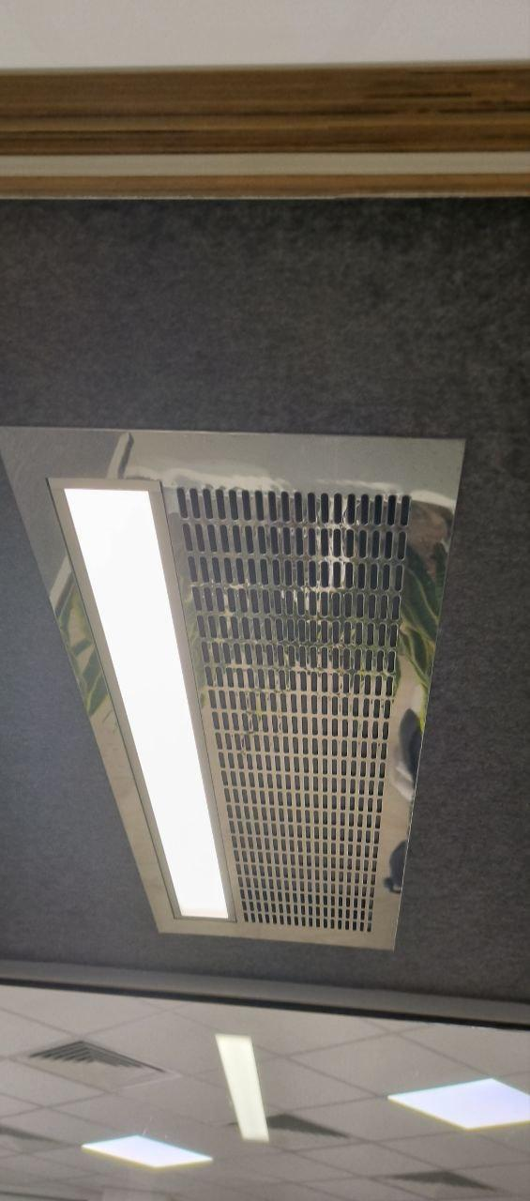
A silent working cabin is a small space where computer equipment, lighting, and the human body generate a considerable amount of heat. All of this, without proper air treatment, can create a stuffy and uncomfortable environment. Therefore, ventilation is crucial. The best way to ensure a normal microclimate inside the cabin is with a quiet fan that refreshes the air at a rate of 30 cubic meters per hour. No drafts or stagnant carbon dioxide with the mandatory preservation of the cabin's sound insulation properties.

3. Lighting
Look for: adjustable LED lighting with a color temperature of 3500-4500 Kelvin and a luminous flux of 450 Lux.
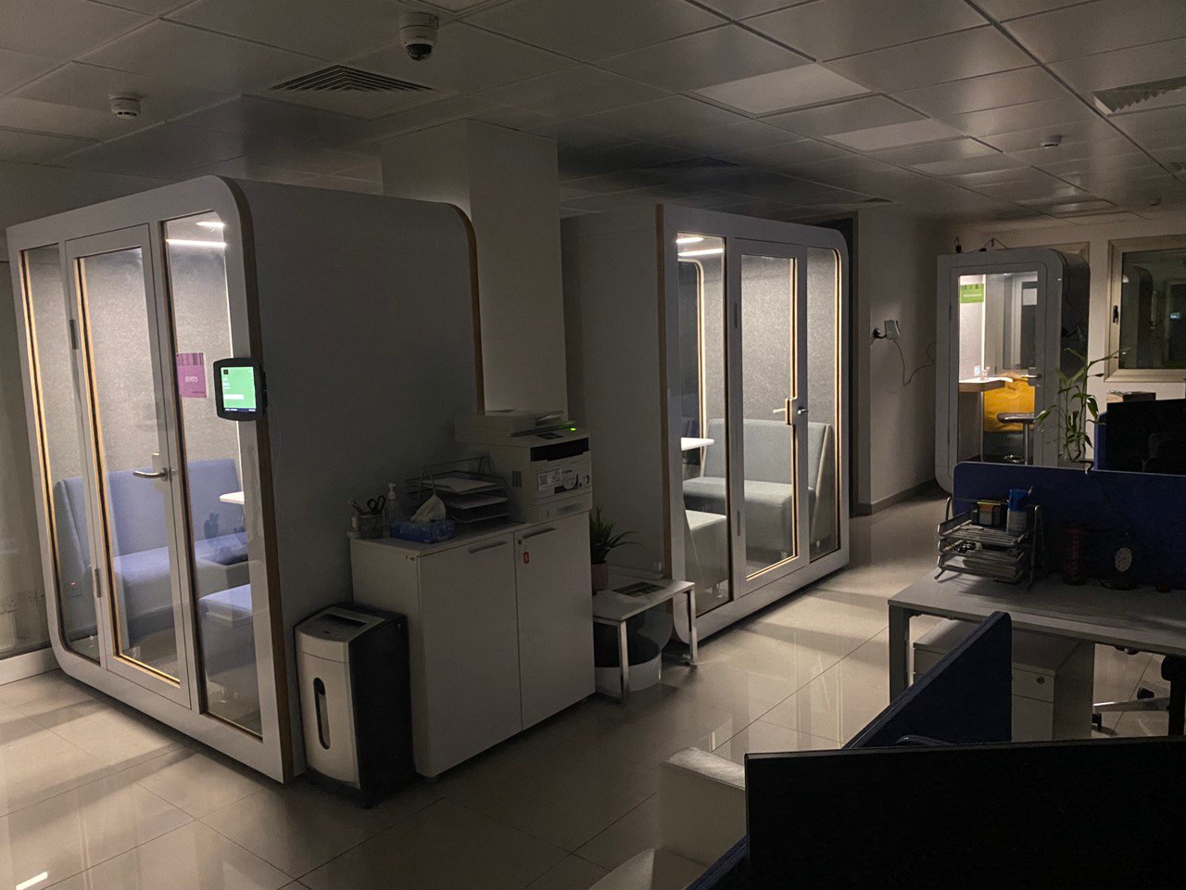
Bright light is not suitable for every occasion. During multimedia presentations, adjustable lighting helps reduce glare on screens and provides clear images for everyone.
And remember, people tend to forget to turn off the lights. Choosing a cabin with motion sensors will solve this problem. In many cases, the ventilation system is also connected to this same sensor. This saves a lot of energy when no one is inside.

4. Useful Features
Look for: multimedia tools and connectivity options to suit your needs.
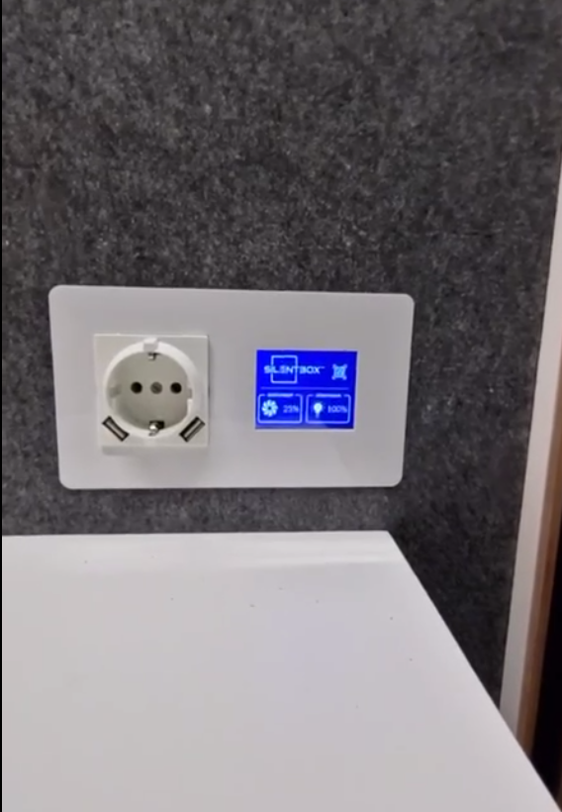
What do you need in your conference rooms? Do you frequently conduct video conferences? When choosing an office booth, select a set of built-in features that will allow you to use the space most efficiently.
Booths are typically equipped with power outlets, but you can add the necessary connectors. USB ports for charging, a wall-mounted work shelf, a hook for bags, and other equipment are all aspects that should influence your choice. Some booths even come with their own booking systems so that you can reserve meeting time.

5. Versatility
Looking for: Customization that suits your brand
Ready-made solutions are great for most companies. However, many office booths can also become another place to showcase the brand. Customization options and the ability to choose the shade of the external and internal upholstery allow you to get a booth that matches corporate colors and perfectly fits into the office interior.
This is especially relevant if clients visit your office or you want to use the booths in public places, such as exhibitions. It is important for your brand to remain recognizable.
Since the booths can be easily disassembled and moved, they are an excellent versatile solution. You can use them during job interviews, and then move them to another office or factory for efficiency testing.

6. Safety and quality of materials
look for: durable, safe and wear-resistant materials
At some point, you may think: "Can't I just ask my handy uncle to build me one?" Perhaps he has the time and tools for it, but does he use materials that meet building standards? Glass should have strength, safety, and sound insulation properties. The ideal option in this case is laminated glass. Its advantage is impact resistance, which eliminates the possibility of getting injured by glass shards if it happens to break. Materials should have wear resistance and durability characteristics. Due to the active use of cabins, this is a very important indicator. The same threshold, for example, should ideally be metallic. Choose office cabins that meet quality and safety standards, and send your favorite uncle fishing.

7. Delivery and installation
Looking for: All Inclusive Package
When ordering a soundproof booth, check if the supplier offers delivery and assembly services. Some companies include installation in the price. Another consideration is how easy it is to move or disassemble the booth if you need to relocate. Some office modules come with mobility and flexibility as standard, but you should research the process of moving the booth beforehand if the need arises.

8. Furniture
look for: functional and ergonomic furniture 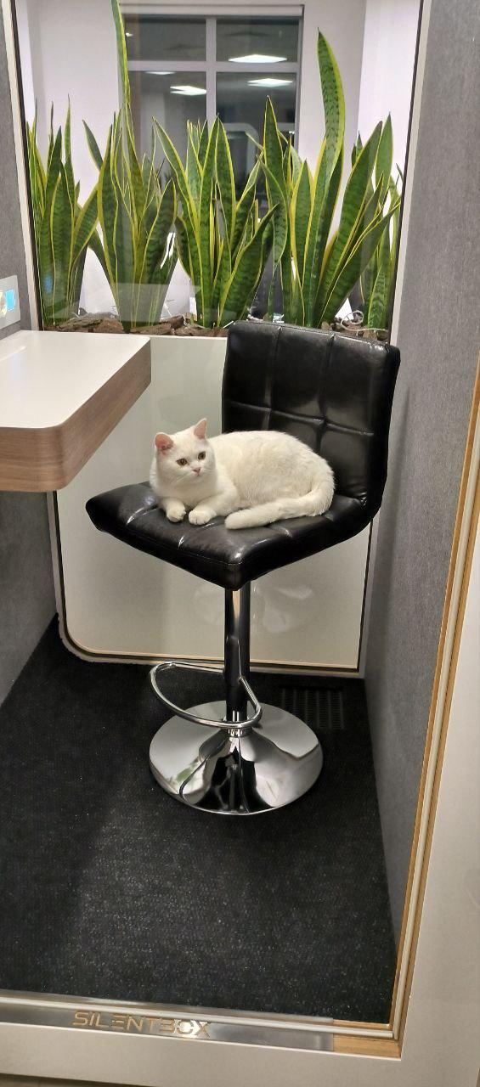

Make sure to consider the furniture that comes with the cabin. Do the available seating options, writing desk, work surface, and configurations meet the needs of your employees? Think about how easily workers can enter and exit the cabin. Photos alone can be misleading

9. Getting to know the cab
Looking for: availability of 3D visualization of the product
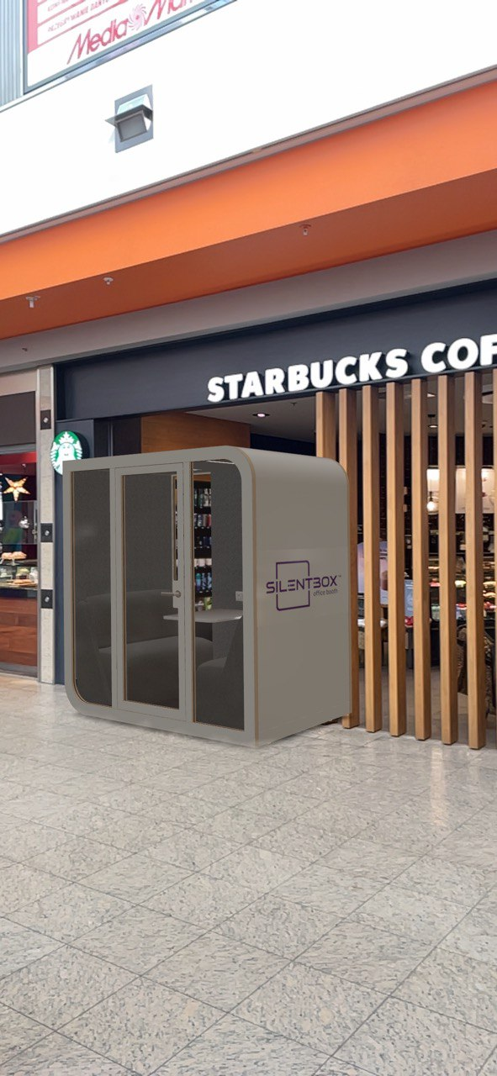
To make a final decision on choosing an acoustic booth from a particular brand, it's important to get as close to it as possible. This can be done in two ways: find the nearest showroom with the product and see it in person or, without leaving the office, test a 3D model of the preferred booth, which is much more convenient and practical. In augmented reality, you can not only examine the product details in detail but also place it in the office to evaluate how well it will fit in.

10. Price
Looking for: perfect value for money
When it comes to furnishing and decorating an office space, cost often takes the forefront. Fortunately, acoustic booths are an affordable way to create stylish and productive workspaces for employees. Their installation is much cheaper than creating new rooms and conference halls, while still dividing the office into different areas. Today, many companies offer this popular product. Manufacturers from the US and Europe have proven that even in a large noisy office, work can be carried out in complete privacy and silence. However, the cost varies among them. For example, the Silentbox Solo booth for one person costs from 4750 euros, while the widely advertised Framery O starts at 9600 euros.

Instead of an epilogue
If you need the best soundproof booth, first assess the needs of your office. After all, there are a variety of different types of booths that have their unique advantages. For example, there are spacious ones that can accommodate two or more people with maximum comfort. If you are short on space, you can order a classic model for one person who can sit or stand.
Considering that you are investing a lot of time and money into new equipment, it can be a bit difficult to decide which booth is better or, at least, suitable in your case. Perhaps we are a bit biased because we believe that our Silentbox booths are the best in terms of price-quality ratio, but ultimately the decision is up to you.
Our team of professionals will help you from the initial consultation to installation, so that your company can get the maximum benefit from the product.

