5 Essential Tips on How to Save Money Effectively
https://www.thebalance.com/providing-salary-history-to-employers-2063438
A majority of Americans are saving up to 5% each month but it is suggested to save 15% of the whole income. It is very easy and enjoyable to spend the money but much harder is to earn them and work to receive. Reality makes people to think about the future so that saving money becomes a necessary skill. As a rule, the hardest thing about saving money is getting started. The main element in realization of the savings plan is setting a goal. Sometimes it is difficult to develop the most effective ways to save money and achieve the goal.
If you have repeatedly failed when tried to save some money or even didn’t try, here are some the most important steps in the process of realization your savings plan.
- Write down your monthly income and expenses

http://www.pinoyfinancialplanning.com/whats-holding-back-financially-wealthy/
For one month, write down in detail your current income and expenses. For example, on the left side of the page note all expenses, list all purchases you make from the smallest to the biggest. You can also divide them into categories such as rent for the living, insurance, tuition, food, transport, clothes, travel and other. After count the total amount for each category and compare your income with an amount of expenses.
2. Make a Monthly Budget
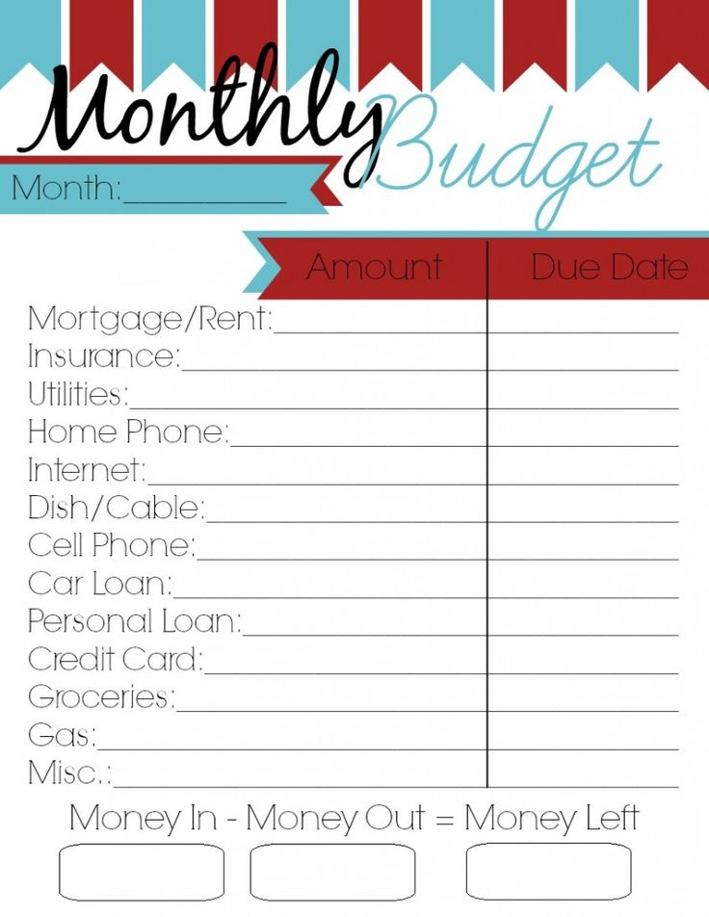
https://www.pinterest.com/explore/%D0%B5%D0%B6%D0%B5%D0%BC%D0%B5%D1%81%D1%8F%D1%87%D0%BD%D1%8B%D0%B9-%D0%B1%D1%8E%D0%B4%D0%B6%D0%B5%D1%82-920665469065/
When you have estimated an approximate amount of money you spend each month, create your budget plan for at least for the next month. Analyze what category has the status “over-spending” to be limited. Also, you can include some irregular expenses such as car tuning or Christmas celebration.
3. Saving Money Plan
http://www.ugelchanchamayo.gob.pe/blog/autorizan-pago-de-asignaci%C3%B3n-por-tiempo-de-servicios-cts-y-subsidios
Divide all expenses into 3 categories such as expenses for living (rent, food), social costs (tuition, transport, insurance), and entertainment (travel, clothes, eating out) and determine the upper limit of money you are going to spend on each of them. Create the 4th savings category which will include 10-15 percent of your income. To make savings real you will have to cut some non-essential expenses, for example, dining out or clothes.
4. Eliminate Your Debt
http://www.huffingtonpost.com/john-rampton/3-keys-to-building-a-busi_b_11664048.html
If you have any debts either in cash or for credit, start with the paying off your debt. As a rule, money you spend each month to service your debt in total make up a large amount. Besides debt, bad habits are another reason why people can’t save any money. To quit a bad habit such as smoking or alcoholism is perhaps one of the most difficult tasks but it is worth its goal.
5. Set Your Savings Goals
http://www.baretdergisi.com/ekonomi/
Savings goals are the main part of the saving plan. First, set what do you want to save money for and decide how much time it will take to reach your goal. There are short- and long-term goals. Short-term goals usually take 1-3 years to achieve. They are, for example, saving money for a vacation, to buy a new car and other. Long-term savings goals include saving money on buying a house or putting money away for child’s future education and more. Amount of money you are going to save may not match with the amount you need to achieve particular goal since you will have to earn additional money, especially, for a long-term goal. After setting savings goal create 4 accounts to divide each month income into 4 categories calculating and transferring money to these accounts.

